Breakfast
Fannett-Metal School District
Is and equal.
Opportunity Provider

Breakfast – Free Milk $0.50 without breakfast
All Meals are served with 1% or Fat Free White Milk or Chocolate Milk with Fat Free Strawberry Milk.
Menu Subject to Change.

Cinnamon Roll
Or
Cereal / Muffin
Juice
Milk

Breakfast Pizza
Or
Cereal / Muffin
Juice
Milk

Pancakes & Sausage
Or
Cereal / Muffin
Fruit
Milk

Breakfast Sandwich
Or
Cereal / Muffin
Juice
Milk

Pancake on a Stick
Or
Cereal / Muffin
Fruit
Milk

Cinnamon Roll
Or
Cereal / Muffin
Juice
Milk

Breakfast Pizza
Or
Cereal / Muffin
Juice
Milk

Pancakes & Sausage
Or
Cereal / Muffin
Fruit
Milk

Breakfast Sandwich
Or
Cereal / Muffin
Juice
Milk

SEPTEMBER 2026
Fannett-Metal MS / HS
Cinnamon Roll
Or
Cereal / Muffin
Juice
Milk

Pancake on a Stick
Or
Cereal / Muffin
Fruit
Milk
Breakfast Sandwich
Or
Cereal / Muffin
Juice
Milk

Pancakes & Sausage
Or
Cereal / Muffin
Fruit
Milk

Breakfast Pizza
Or
Cereal / Muffin
Juice
Milk

No School
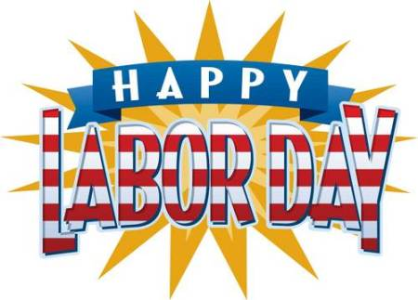
Breakfast Pizza
Or
Cereal / Muffin
Juice
Milk

Pancakes & Sausage
Or
Cereal / Muffin
Fruit
Milk
Breakfast Sandwich
Or
Cereal / Muffin
Juice
Milk
Pancakes & Sausage
Or
Cereal / Muffin
Fruit
Milk

Breakfast Sandwich
Or
Cereal / Muffin
Juice
Milk

Pancake on a Stick
Or
Cereal / Muffin
Fruit
Milk

