
Fannett-Metal School District
Is and equal.
Opportunity Provider

Breakfast – Free Milk $0.50 without breakfast
All Meals are served with 1% or Fat Free White Milk or Chocolate Milk with Fat Free Strawberry Milk.
Menu Subject to Change. Snacks Grades PK-5 $0.75

Cereal
Muffin
Fruit
Milk

Breakfast Pizza
Juice
Milk

Pancakes
Sausage
Fruit
Milk

Funnel Cake
Juice
Milk

Cereal
Muffin
Fruit
Milk

Cereal
Muffin
Fruit
Milk

Breakfast Pizza
Juice
Milk

Pancakes
Sausage
Fruit
Milk

Funnel Cake
Juice
Milk

SEPTEMBER 2026
Fannett-Metal Elementary

Cereal
Muffin
Fruit
Milk

Cereal
Muffin
Fruit
Milk

Funnel Cake
Juice
Milk

Pancakes
Sausage
Fruit
Milk

Breakfast Pizza
Juice
Milk

No School

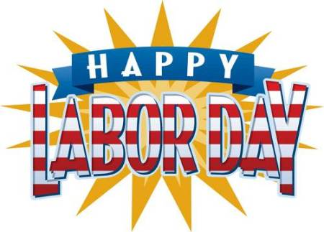

Breakfast Pizza
Juice
Milk

Pancakes
Sausage
Fruit
Milk

Funnel Cake
Juice
Milk

Pancakes
Sausage
Fruit
Milk

Funnel Cake
Juice
Milk

Cereal
Muffin
Fruit
Milk

