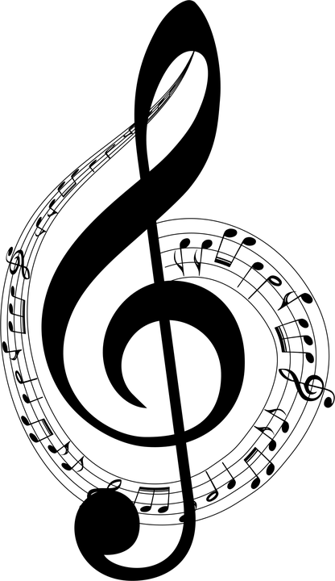
B=Band
C=Chorus

FM Music Events
2025-2026
Fall Music Dates
Oct. 3 Pep Rally at 1:30pm. (B=MS/HS)
Oct. 24 MS Songfest at Big Spring MS (C=6-9th grade)
Nov. 1 College Band Day at St. Francis University (B=FM Band students)
Nov. 7 Veteran’s Day Program 1:30pm (B and C)
Nov. 22 Youth Honors Band at Manheim Central MS (B=MS, selected students)
Dec. 6 PMEA Dist. Band Auditions Eastern York HS (B=audition day)
Dec. 15 Christmas Concert (B/C= MS/HS and 4th and 5th grade) 7pm HS Gym (students arrive @6:30)
Dec. ? TBA Senior Center performance 10-12pm. (C=up to 9 students)

Winter/Spring Music Dates
Jan. 16-17 Franklin/Fulton County Band School TBA B=MS/HS selected students)
Jan 22-24 PMEA Dist. 7 Orchestra Festival Dallastown HS
(B=selected student)
Feb. 6-7 PMEA Dist. 7 Band Festival Steelton-Highspire HS (B=student audition)
Feb. 27-28 Franklin/Fulton County Chorus James Buchanan HS (C=selected students)
Mar. 19-21 Regional Band Carlisle HS (B=students audition)
Mar. 28 PMEA Elem. Songfest (4/5 grade) Big Spring MS
Apr. 22-25 PMEA All State Band Kalahari Resort, Poconos (B=student audition)
May 18 Spring Music Concert (B and C 5th-12th)
May 22 Music in the Parks at Hersheypark (B and C)
May 24 Memorial Day Service at American Legion. (B and C: arrive 1:30pm service at 2pm)
May ? Senior Center (C 10-12noon)

