

Choice 1

Cheeseburger

Or

Chef Salad

Roll

Broccoli

Fruit / Milk

Fannett-Metal is an equal

opportunity provider

**Elementary Lunch – FREE Milk $0.50 without lunch Snacks grades K-5 $0.75**

All Meals are served with 1% or Fat Free White or Chocolate Milk and Fat Free Strawberry Milk.

**Pre-K Students 1st. choice everyday** Menu Subject to Change No Breakfast on two-hour delays.

Offer verses serve – Students must take 3 or 5 items to count as lunch and one must be a fruit or vegetable.

Choice 1

Chicken Tenders

Roll

Choice 2

Calzone

Peas

Fruit / Milk

Choice 1

Cheese Pizza

Choice 2

Cheesy Taco Tots

Baked Beans

Fruit

Milk

Choice 1

Pancakes & Bacon

Choice 2

Grilled Cheese

Hash Brown

Fruit

Milk

Choice 1

Chicken Nuggets

Roll

Choice 2

Pizza Burger

Tossed Salad

Fruit / Milk

Choice 1

Mac & Cheese

Bread Stick

Choice 2

BBQ Rib Sandwich

Peas

Fruit / Milk

Choice 1

Stuffed Crust Pizza

Choice 2

Fish Sandwich

Baked Beans

Fruit

Milk

Choice 1

Spaghetti & Meatballs

Bread Sticks

Choice 2

Turkey & Cheese

On Pretzel Roll

Broccoli

Fruit / Milk

Choice 1

Chicken Patty

Choice 2

Meatball Sub

Tossed Salad

Fruit

Milk

Choice 1

Popcorn Chicken

Roll

Choice 2

Meat Lover’s Stromboli

Baby Carrots

Fruit / Milk

Choice 1

Pepperoni Pizza Wrap

Choice 2

Fish Sticks

Roll

Tossed Salad

Fruit / Milk

Choice 1

Nacho Grande

Choice 2

Hamburger

Broccoli

Fruit

Milk

Choice 1

Walking Taco

Choice 2

Ham & Cheese

Hoagie

Refried Beans

Fruit / Milk

Choice 1

Chicken Tenders

Roll

Choice 2

Grilled Cheese Sandwich

Corn

Fruit / Milk

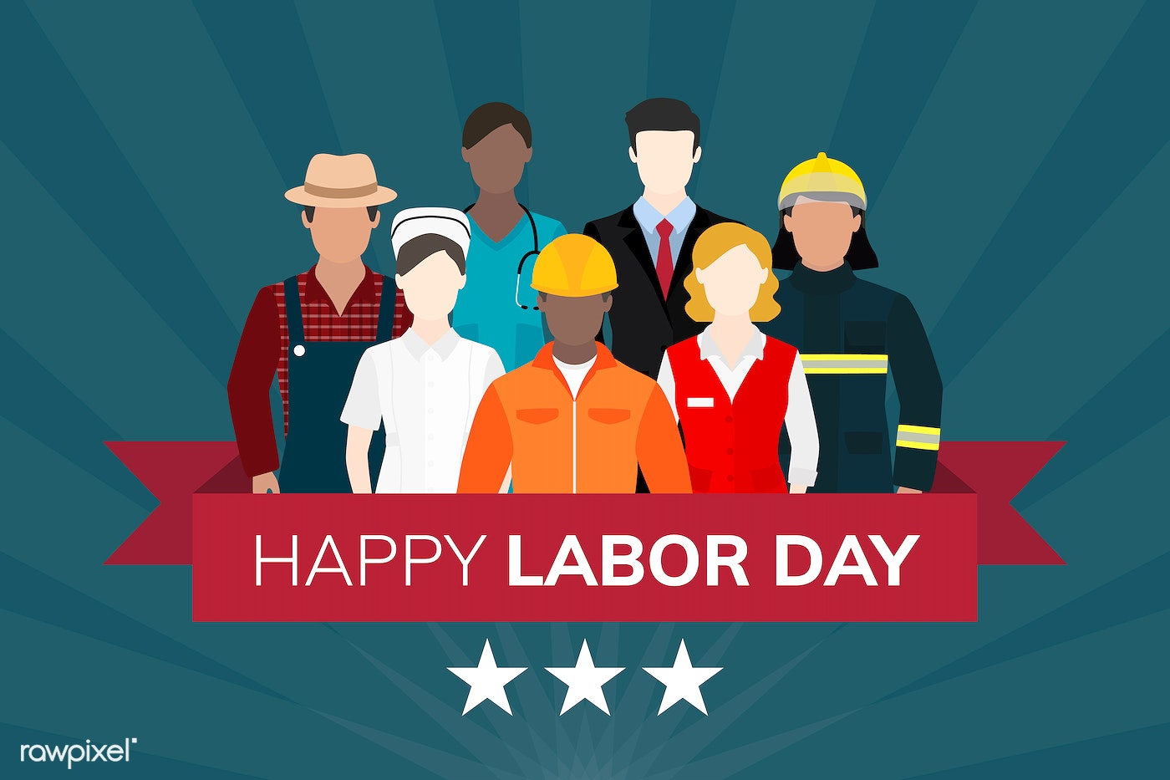

Choice 1

Cheese Pizza

Choice 2

Hot Dog

Peas

Fruit / Milk

**SEPTEMBER 2023**

Fannett-Metal Elementary School

Choice 1

Lasagna

Bread Stick

Choice 2

Ham & Cheese Hoagie

Tossed Salad

Fruit / Milk

Choice 1

Chicken Sticks

Roll

Choice 2

Cheeseburger

Baked Beans

Fruit / Milk

Choice 1

Chicken Leg

Pre – K Chicken Nuggets

Biscuit

Choice 2

Cheese Steak

Mashed Potatoes

Fruit / Milk

Choice 1

Pepperoni Pizza

Choice 2

Fish Sticks

Broccoli

Fruit / Milk

Choice 1

Cheesy Bread Sticks

Choice 2

Cheese Steak

Peas

Fruit

Milk