Fannett-Metal School District – Elementary School March 2023

Lunch Menu

Fannett-Metal is an equal opportunity provider

SUNDAY | MONDAY | TUESDAY | WEDNESDAY | THURSDAY | FRIDAY | SATURDAY
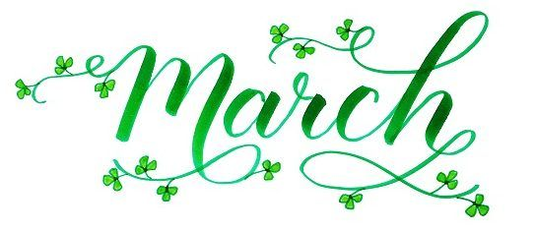 | Elementary  Lunch- FREE  EXTRA  Milk - $0.50  Snacks -$0.75 |  | March 1  Pork Chop  Roll  Or  Ham & Cheese Hoagie  Mashed Potatoes  Fruit  Milk | March 2  Chicken Patty  Or  Chicken Cheese Steak  Peas  Fruit  Milk | March 3  Pepperoni Pizza  Or  Fish Sticks  Roll  Cheesy Broccoli  Fruit  Milk | Offer verses serve -  Students must take  3 of 5 items to count as a lunch & one must be a fruit or vegetable.
No breakfast on two-hour delays | March 6  Chicken Nuggets  Roll  Or  BBQ Rib Sandwich  Broccoli  Fruit  Milk | March 7  Chicken Patty  Or  Cheese Steak  Smiley Fries  Fruit  Milk | March 8  Chicken & Waffles  W / Gravy  Or  Pulled Pork Sandwich  Peas  Fruit  Milk | March 9  Chicken Tenders  Roll  Or  Turkey & Cheese Hoagie  Steamed Carrots  Fruit  Milk | March 10  Mario Day  Mario’s Spaghetti & Meatballs / Roll  Or  Luigi’s Calzone  Tossed Salad  Fruit / Milk
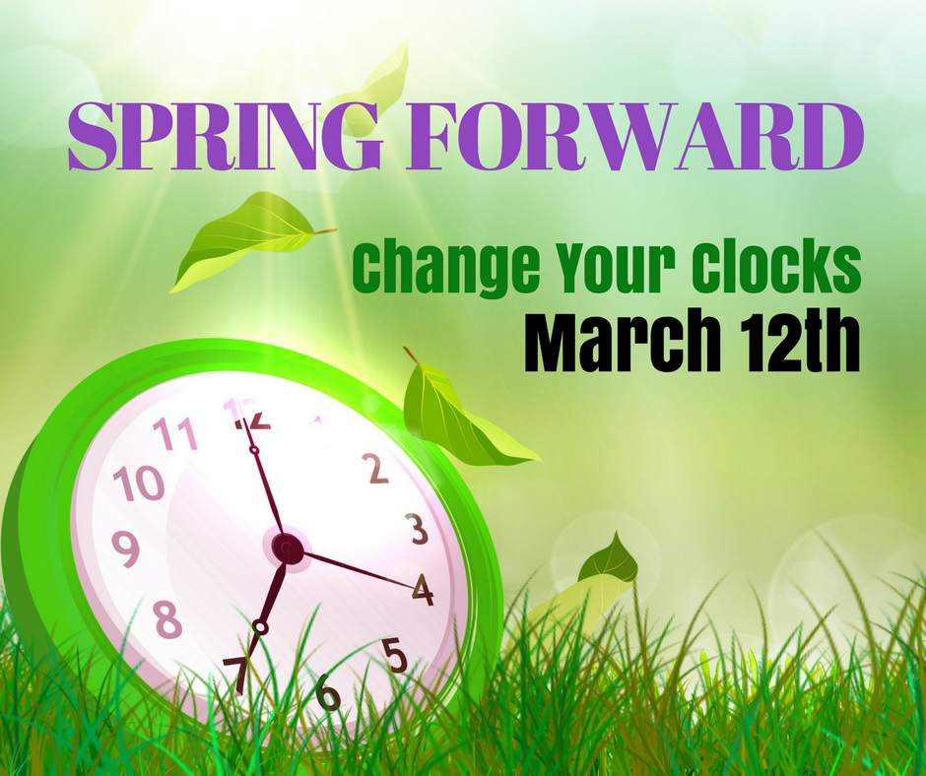  This Photo by Unknown Author is licensed under CC BY-NC-ND | March 13  Walking Taco  Or  Turkey & Cheese  Wrap  Refried Beans  Fruit  Milk | March 14  French Bread Pizza  Or  Meatball Sub  Carrots  Fruit  Milk | March 15  Cheeseburger  Or  Turkey & Cheese  Hoagie  Corn  Fruit  Milk | March 16  Tomato Soup  Grilled Cheese Sandwich  Or  BBQ Rib Sandwich  Peas  Fruit  Milk | March 17  St. Patty’s Day  *Green Butter Noodles  W/ Meatballs / Roll  Or  Ham & Cheese Bagel  Broccoli  Fruit / Milk
 | March 20  Nacho Grande  Or  Pulled Pork Sandwich  Corn  Fruit  Milk | March 21  Grilled Chicken Sandwich  Or  Cheese Steak Wrap  Baked Beans  Fruit  Milk | March 22  Chicken Patty  Or  Calzone  Peas  Fruit  Milk | March 23  Pancakes & Sausage  Or  Cheese Steak  Carrots  Fruit  Milk | March 24  Pizza  Or  Fish Sandwich  Broccoli  Fruit  Milk | *Green Noodles are made with Green Food Coloring
All Meals are  served with 1% milk, fat free chocolate, fat free vanilla, fat free strawberry | March 27  Soft Shell Taco  Or  Calzone  Peas  Fruit  Milk | March 28  Lasagna  Roll  Or  BBQ Rib Sandwich  Tossed Salad  Fruit  Milk | March 29  Chicken Tenders  Roll  Or  Ham & Cheese Hoagie  Green Beans  Fruit  Milk | March 30  Chicken Patty  Or  Chicken Cheese Steak  Broccoli  Fruit  Milk | March 31  Pizza  Or  Fish Sticks  Roll  Steamed Carrots  Fruit  Milk | 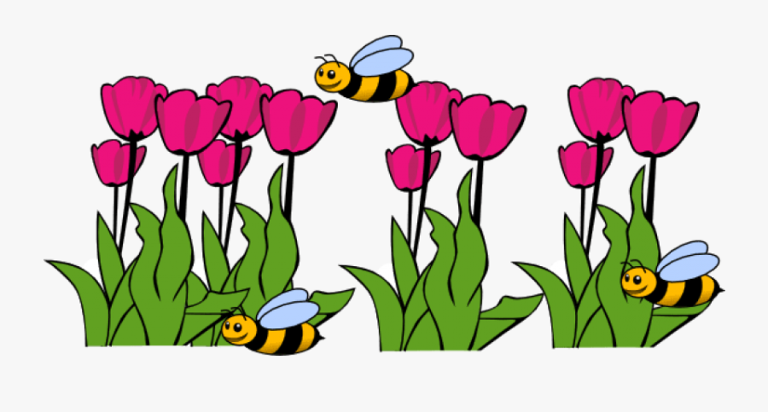
Menu Subject to Change

