Fannett-Metal School District – High School - Middle School March 2023

Breakfast Menu

Fannett-Metal is an equal opportunity provider

SUNDAY | MONDAY | TUESDAY | WEDNESDAY | THURSDAY | FRIDAY | SATURDAY
 |  |  | March 1  Pop Tarts  Fruit  Milk | March 2  Breakfast Pizza  Juice  Milk | ^{March 3}  Cinnamon Roll  Fruit  Milk | Offer verses serve -  Students must take  3 of 5 items to count as a lunch & one must be a fruit or vegetable.
 | March 6  French Toast  Fruit  Milk | March 7  Breakfast Sandwich  Juice  Milk | March 8  Pop Tarts  Fruit  Milk | March 9  Breakfast Pizza  Juice  Milk | March 10  Cinnamon Roll  Fruit  Milk | 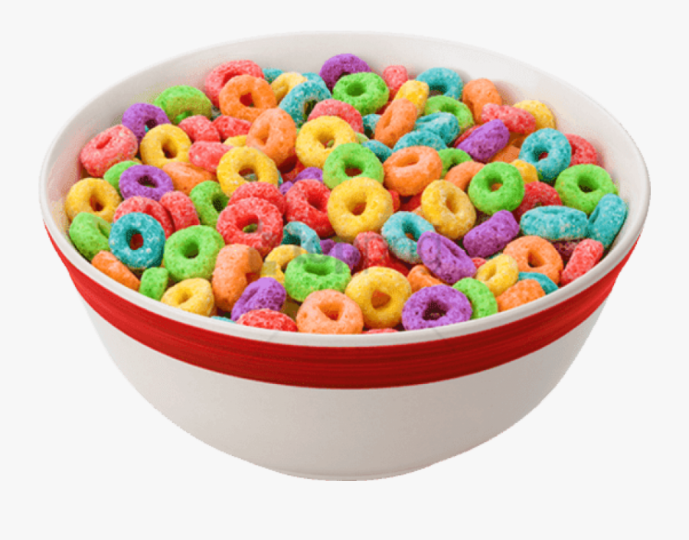
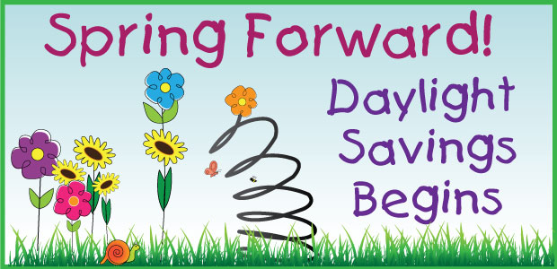 | March 13  French Toast  Fruit  Milk | March 14  Breakfast Sandwich  Juice  Milk | March 15  Pop Tarts  Fruit  Milk | March 16  Breakfast Pizza  Juice  Milk | March 17  Cinnamon Roll  Fruit  Milk | High/Middle School  Breakfast - FREE  Milk - .50
 | March 20  French Toast  Fruit  Milk | March 21  Breakfast Sandwich  Juice  Milk | March 22  Pop Tarts  Fruit  Milk | March 23  Breakfast Pizza  Juice  Milk | March 24  Cinnamon Roll  Fruit  Milk | All Meals are  served with 1% milk, fat free chocolate, fat free vanilla, fat free strawberry
 | March 27  French Toast  Fruit  Milk | March 28  Breakfast Sandwich  Juice  Milk | March 29  Pop Tarts  Fruit  Milk | March 30  Breakfast Pizza  Juice  Milk | March 31  Cinnamon Roll  Fruit  Milk | No breakfast on two-hour delays
Menu Subject to Change

