Fannett-Metal School District – Middle High School March 2023

Lunch Menu

Fannett-Metal is an equal opportunity provider.

SUNDAY | MONDAY | TUESDAY | WEDNESDAY | THURSDAY | FRIDAY | SATURDAY
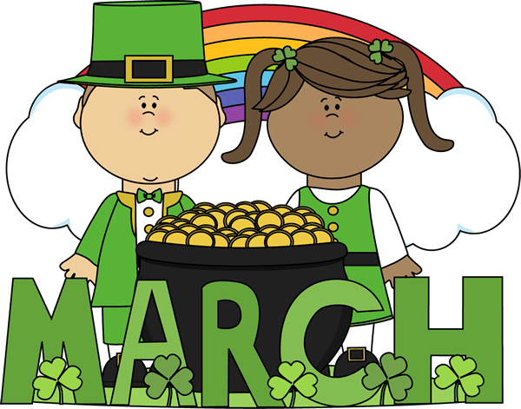 |  |  | March 1  Popcorn Chicken  Roll  Or  Pizza Bagel  Baby Carrots  Fruit  Milk | March 2  General Tso’s Chicken  Roll  Or  Ham & Cheese Flatbread  Broccoli  Fruit / Milk | ^{March 3}  Pepperoni Pizza  Or  Fish Sticks / Roll  Baked Beans  Fruit  Milk | Offer verses serve -  Students must take  3 of 5 items to count as a lunch & one must be a fruit or vegetable.
 | March 6  Spicy Chicken Patty  Or  Meatball Sub  Scalloped Potatoes  Fruit  Milk | March 7  Cheeseburger Bowl  Roll  Or  Ham & Cheese  Bagel  Peas  Fruit / Milk | March 8  Chicken Tenders  Roll  Or  Egg & Sausage  Sandwich  Cheesy Broccoli  Fruit / Milk | March 9  Grilled Chicken  Sandwich  Or  Turkey Club Wrap  Baby Carrots  Fruit / Milk | March 10  Pepperoni Pizza  Or  Fish Sandwich  Peas  Fruit  Milk | High School  Lunch- FREE  EXTRA  Milk - $0.50  Snacks -$0.75
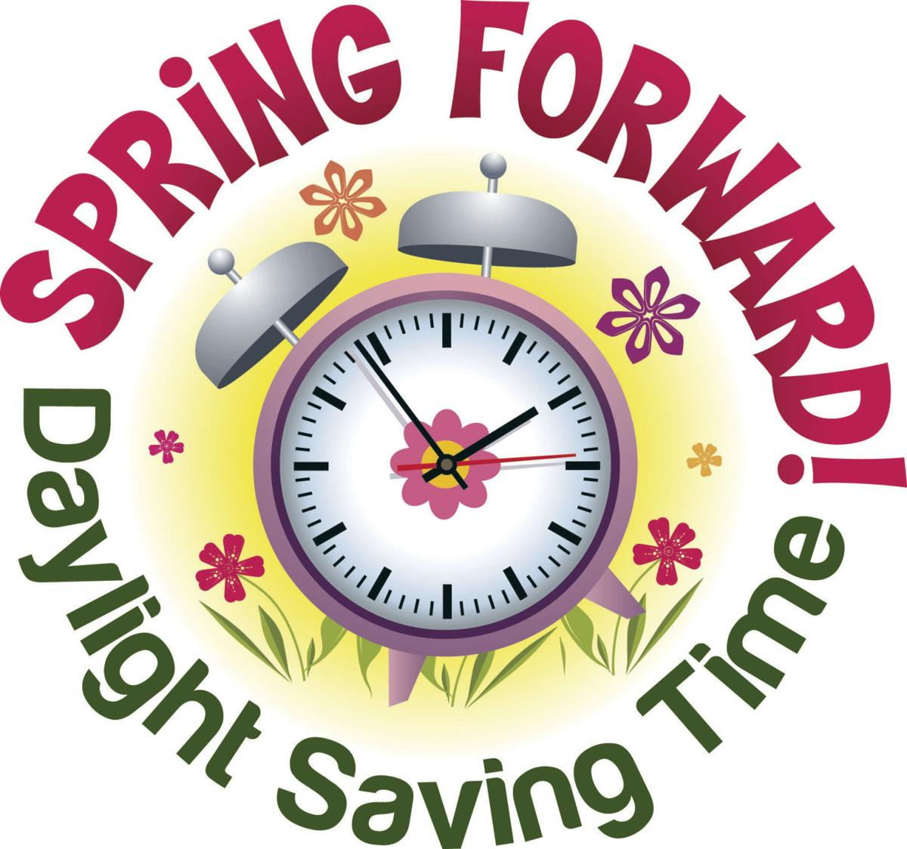 | March 13  Nacho Grande  Or  Pulled Pork  Sandwich  Broccoli  Fruit  Milk | March 14  Pancakes & Sausage  Or  Turkey & Cheese Hoagie  Hash Brown  Fruit  Milk | March 15  Cheeseburger  Or  BBQ Rib Sandwich  Baked Beans  Fruit  Milk | March 16  Buffalo Chicken  on Flatbread  Or  Hot Dog  Peas  Fruit  Milk | March 17  Chicken Patty  Or  Fish Sticks / Roll  Baby Carrots  Fruit  Milk
 | March 20  Chicken Tender  Wrap  Or  Turkey & Cheese  Pretzel Roll  Tossed Salad  Fruit / Milk | March 21  Tomato Soup  Grilled Cheese Sandwich  Or  Meatball Sub  Peas  Fruit  Milk | March 22  Cheese Steak Pierogies  Or  Calzone  Green Beans  Fruit  Milk | March 23  Walking Taco  Or  Spicy Chicken Patty  Baby Carrots  Fruit  Milk | March 24  Pepperoni Pizza  Or  Fish Sandwich  Broccoli  Fruit  Milk | All Meals are  served with 1% milk, fat free chocolate, fat free vanilla, fat free strawberry
No breakfast on two-hour delays | March 27  Cheeseburger  Or  Pizza Bagel  Baby Carrots  Fruit  Milk | March 28  Chicken Alfredo  Bread Stick  Or  Turkey & Cheese  Flatbread  Peas  Fruit / Milk | March 29  Mac & Cheese  Roll  Or  Calzone  Tossed Saad  Fruit  Milk | March 30  Soft Shell Taco  Roll  Or  BBQ Rib Sandwich  Broccoli  Fruit  Milk | March 31  Pepperoni Pizza  Or  Fish Sticks  Roll  Green Beans  Fruit  Milk
Menu Subject to Change

