Fannett-Metal School District – Elementary School October 2022

Lunch Menu

Fannett-Metal is an equal opportunity provider

SUNDAY | MONDAY | TUESDAY | WEDNESDAY | THURSDAY | FRIDAY | SATURDAY
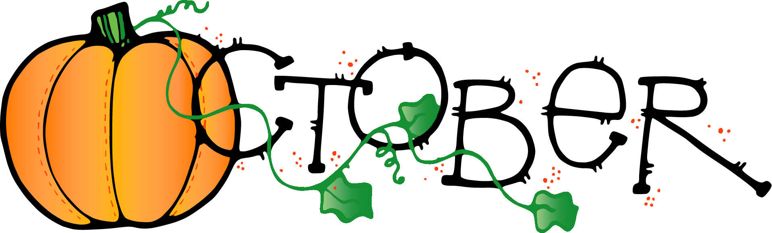 | October 3  Cheeseburger  Or  Hot Dog  Baked Beans  Fruit  Milk | October 4  Ham & Cheese  Sliders  Or  Calzone  Tossed Salad  Fruit  Milk | October 5  Popcorn Chicken  Roll  Or  BBQ Rib Sandwich  Cheese Fries  Fruit  Milk | October 6  Lasagna  Bread Stick  Or  Turkey & Cheese Wrap  Peas  Fruit  Milk | ^{October 7}  Pizza  Or  Fish Sandwich  Corn  Fruit  Milk | Offer verses serve -  Students must take  3 of 5 items to count as a lunch & one must be a fruit or vegetable.
 | October 10  No School | October 11  Mac & Cheese  Roll  Or  Fish Nuggets / Roll  Broccoli  Fruit  Milk | October 12  Grilled Chicken Salad  Roll  Or  Pulled Pork Sandwich  Peas  Fruit  Milk | October 13  Hot Turkey Sandwich  Or  Ham & Cheese Wrap  Steamed Carrots  Fruit  Milk | October 14  Pizza  Or  Hamburger  Baked Beans  Fruit  Milk | 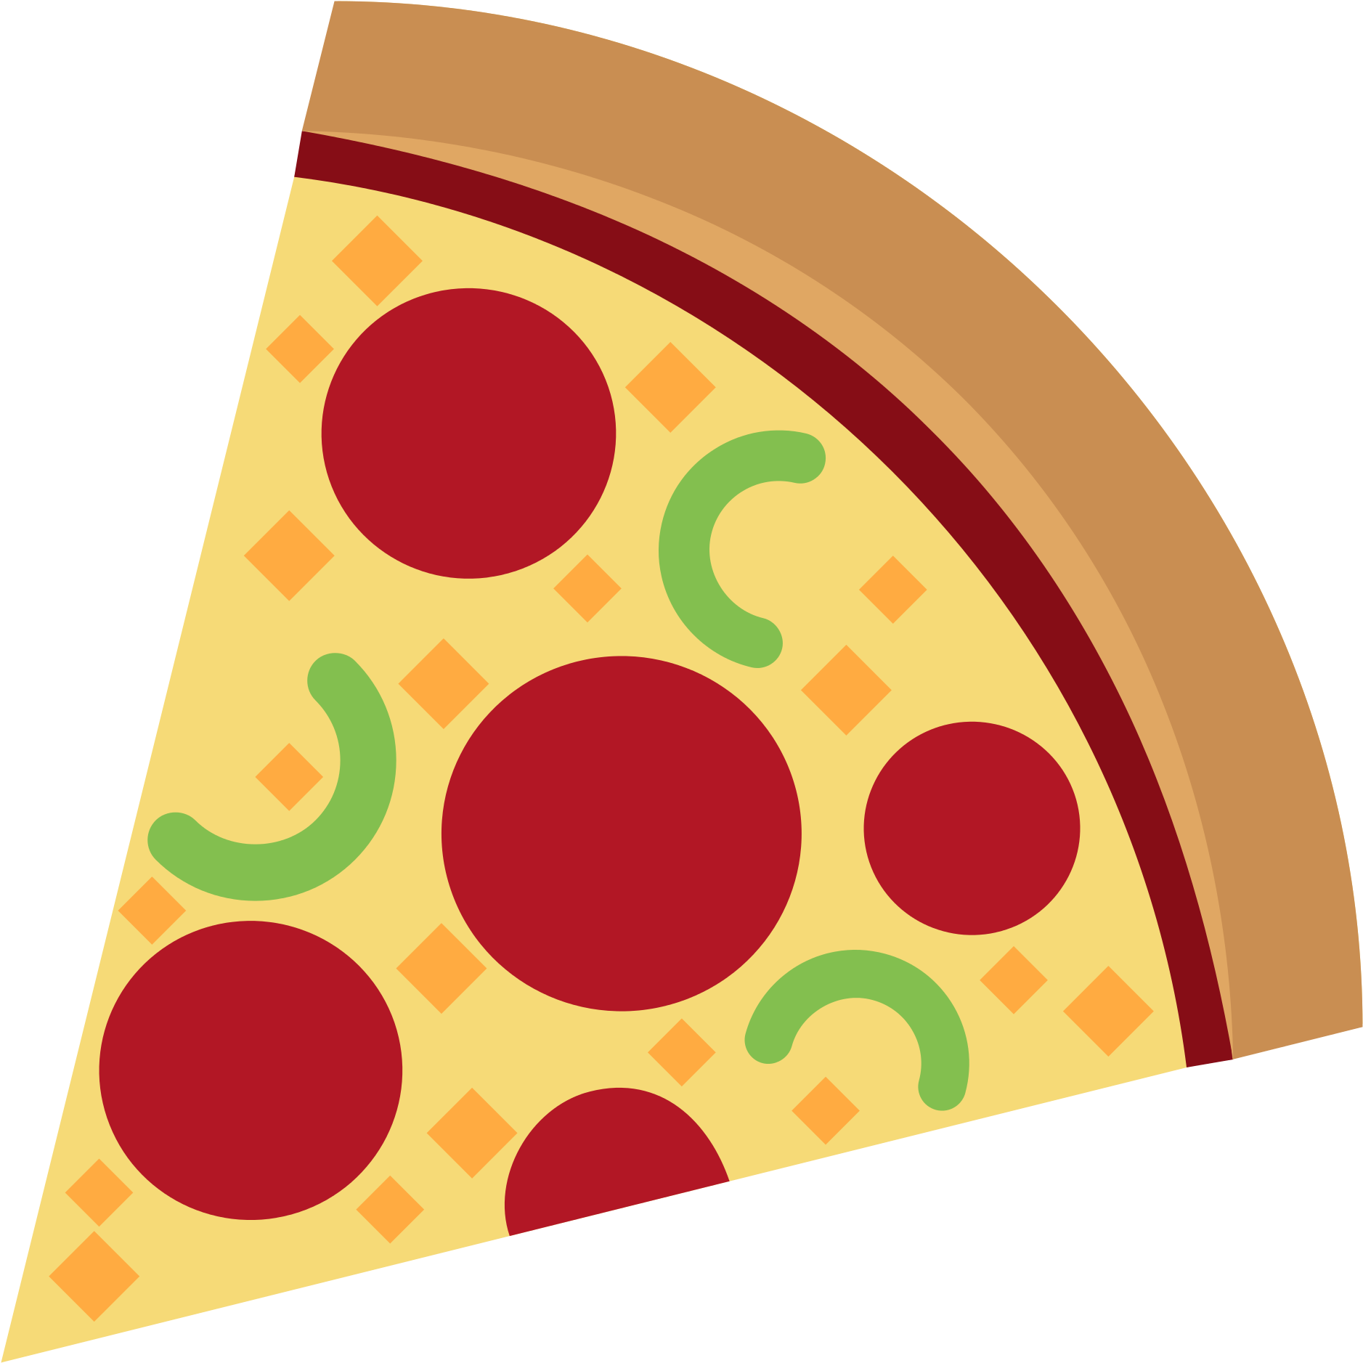
 | October 17  Soft Shell Taco  Or  Cheeseburger  Baby Carrots  Fruit  Milk | October 18  Tomato Soup  Grilled Cheese Sandwich  Or  Turkey & Cheese Hoagie  Broccoli  Fruit  Milk | October 19  Chicken Tenders  Goldfish Crackers  Or  BBQ Rib Sandwich  Peas  Fruit  Milk | October 20  Stuffed Shells  Roll  Or  Cheese Steak  Tossed Salad  Fruit  Milk | October 21  Pepperoni Pizza  Or  Fish Sandwich  Potato Wedges  Fruit  Milk
All Meals are  served with 1% milk, fat free chocolate, fat free vanilla, fat free strawberry | October 24  Mashed Potato Bowl  Roll  Or  Fish Nuggets / Roll  Corn  Fruit  Milk | October 25  Chicken Noodle Soup  Grilled Chicken Sandwich  Or  Turkey & Cheese Wrap  Broccoli / Fruit  Milk | October 26  Breaded Pork Chop  Roll  Or  Chicken Cheese Steak  Scalloped Potatoes  Fruit  Milk | October 27  Rotini w/ Meat Sauce  Roll  Or  Hot Dog  Tossed Salad  Fruit  Milk | October 28  Chicken Nuggets  Roll  Or  Grilled Turkey & Cheese  Broccoli  Fruit  Milk | Elementary  Lunch- FREE  EXTRA  Milk - $0.50  Snacks -$0.75
No breakfast on two-hour delays | October 31  Walking Taco  Or  Turkey & Cheese Wrap  Refried Beans  Fruit  Milk | November 1  Chicken Alfredo  Roll  Or  Calzone  Broccoli  Fruit  Milk | November 2  Nacho Grande  Or  Fish Nuggets  Roll  Peas  Fruit  Milk | November 3  Chicken & Waffles  W/ Gravy  Or  Pulled Pork Sandwich  Tossed Salad  Fruit  Milk | November 4  Cheese Pizza  Or  BBQ Rib Sandwich  Broccoli  Fruit  Milk
Menu Subject to Change

