Fannett-Metal School District – High School & Middle School October 2022

Lunch Menu

Fannett-Metal is an equal opportunity provider

SUNDAY | MONDAY | TUESDAY | WEDNESDAY | THURSDAY | FRIDAY | SATURDAY
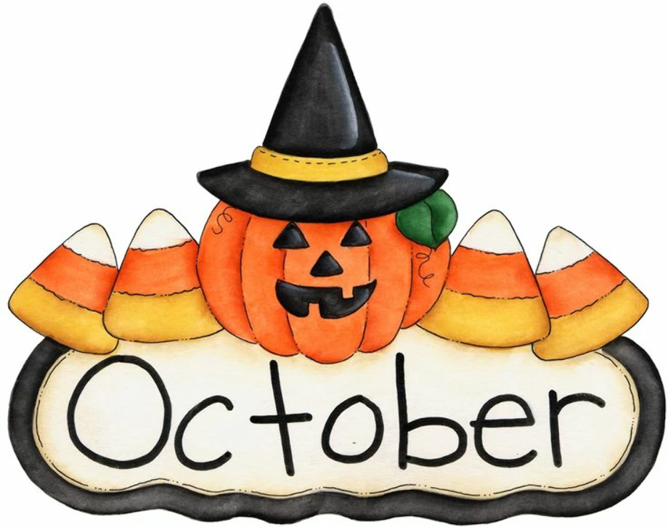 | October 3  Tomato Soup  Grilled Cheese Sandwich  Or  Turkey & Cheese Hoagie  Baby Carrots  Fruit  Milk | October 4  General Tso’s Chicken  Roll  Or  Calzone  Broccoli  Fruit  Milk | October 5  Popcorn Chicken  Roll  Or  Meatball Sub  Peas  Fruit  Milk | October 6  Walking Taco  Or  Ham & Cheese  Wrap  Refried Beans  Fruit  Milk | ^{October 7}  Pepperoni Pizza  Or  BBQ Rib Sandwich  Corn  Fruit  Milk | Offer verses serve -  Students must take  3 of 5 items to count as a lunch & one must be a fruit or vegetable.
 | October 10  No School | October 11  Spicy Chicken Patty  Or  Pizza Burger  Peas  Fruit  Milk | October 12  Cheeseburger  Or  Chef Salad  Roll  Broccoli  Fruit  Milk | October 13  Mac & Cheese  Roll  Or  Chicken Cheese Steak  Green Beans  Fruit  Milk | October 14  Pulled Pork Fries  Or  Ham & Cheese Hoagie  Baby Carrots  Fruit  Milk
 | October 17  Chicken Patty  Or  Ham & Cheese Flatbread  Corn  Fruit  Milk | October 18  Chicken Alfredo  Roll  Or  Turkey Bacon Wrap  Tossed Salad  Fruit  Milk | October 19  Chicken Tenders  Roll  Or  BBQ Rib Sandwich  Peas  Fruit  Milk | October 20  Cheese Steak Fries  Or  Calzone  Baked Beans  Fruit  Milk | October 21  Pepperoni Pizza  Or  Fish Sandwich  Broccoli  Fruit  Milk | Peanut Butter & Jelly Sandwich served everyday depending on availability
All Meals are  served with 1% milk, fat free chocolate, fat free vanilla, fat free strawberry | October 24  Chicken Tenders  Roll  Or  BBQ Rib Sandwich  Baked Beans  Fruit  Milk | October 25  Tomato Soup  Grilled Cheese Sandwich  Or  Turkey & Cheese Hoagie  Peas  Fruit  Milk | October 26  Taco Salad  Doritos  Or  Pulled Pork Sandwich  Baby Carrots  Fruit  Milk | October 27  Hot Turkey Sandwich  Or  Hot Dog  French Fries  Fruit  Milk | October 28  Pepperoni Pizza  Or  Calzone  Broccoli  Fruit  Milk | High School  Lunch- FREE  Milk - .50
No breakfast on two-hour delays | October 31  Chicken Patty  Or  Cheese Steak  Scalloped Potatoes  Fruit  Milk | November 1  Walking Taco  Or  Ham & Cheese  Wrap  Broccoli  Fruit  Milk | November 2  Nacho Grande  Or  Spicy Chicken Patty  Tossed Salad  Fruit  Milk | November 3  Ham & Cheese Sliders  Or  Chicken Cheese Steak  Baked Beans  Fruit  Milk | November 4  Pizza  Or  Egg & Sausage  Sandwich  Baby Carrots  Fruit  Milk
Menu Subject to Change

