Fannett-Metal School District – Elementary School October 2022

Breakfast Menu

Fannett-Metal is an equal opportunity provider

SUNDAY | MONDAY | TUESDAY | WEDNESDAY | THURSDAY | FRIDAY | SATURDAY
 | October 3  French Toast Sticks  Juice  Milk | October 4  Pancake on a Stick  Fruit  Milk | October 5  Waffles & Sausage  Juice  Milk | October 6  Breakfast Pizza  Fruit  Milk | ^{October 7}  Cereal & Muffin  Juice  Milk | Offer verses serve -  Students must take  3 of 5 items to count as a lunch & one must be a fruit or vegetable.
 | October 10  No School | October 11  Pancake on a Stick  Fruit  Milk | October 12  Waffles & Sausage  Juice  Milk | October 13  Breakfast Pizza  Fruit  Milk | October 14  Cereal & Muffin  Juice  Milk | 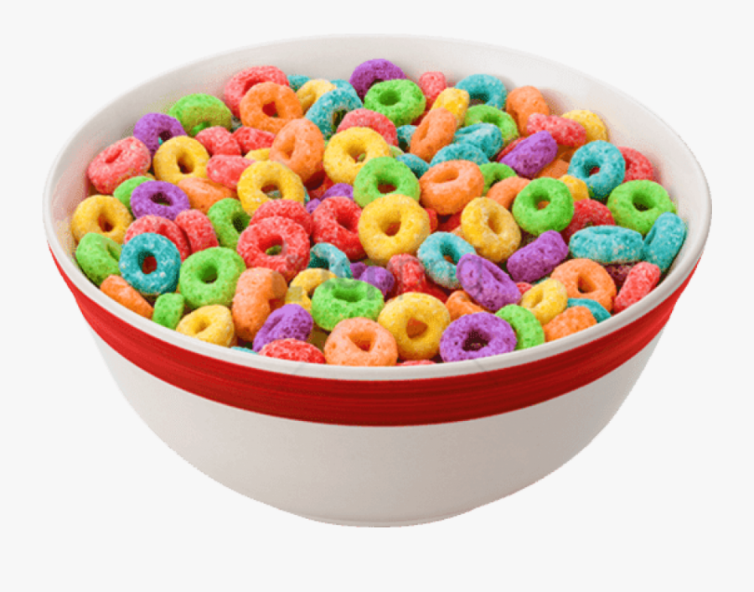
 | October 17  French Toast Sticks  Juice  Milk | October 18  Pancake on a Stick  Fruit  Milk | October 19  Waffles & Sausage  Juice  Milk | October 20  Breakfast Pizza  Fruit  Milk | October 21  Cereal & Muffin  Juice  Milk
All Meals are  served with 1% milk, fat free chocolate, fat free vanilla, fat free strawberry | October 24  French Toast Sticks  Juice  Milk | October 25  Pancake on a Stick  Fruit  Milk | October 26  Waffles & Sausage  Juice  Milk | October 27  Breakfast Pizza  Fruit  Milk | October 28  Cereal & Muffin  Juice  Milk | Elementary  Breakfast - FREE  Milk - .50  Snacks - .75
No breakfast on two-hour delays | October 31  French Toast Sticks  Juice  Milk | November 1  Pancake on a Stick  Fruit  Milk | November 2  Waffles & Sausage  Juice  Milk | November 3  Breakfast Pizza  Fruit  Milk | November 4  Cereal & Muffin  Juice  Milk | 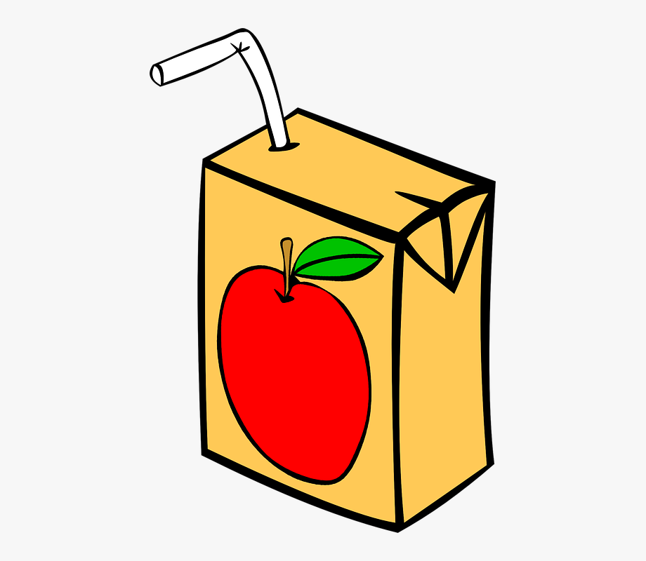
Menu Subject to Change

