Fannett-Metal School District – Elementary School November 2022

Lunch Menu

Fannett-Metal is an equal opportunity provider
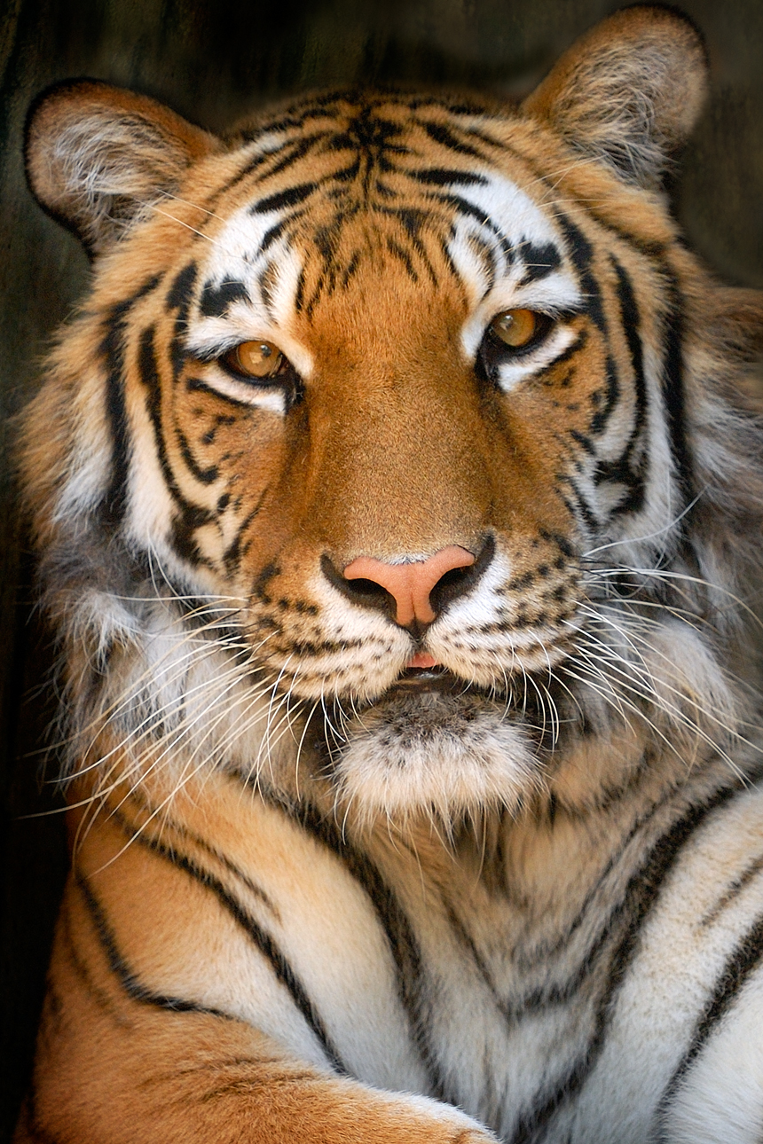

SUNDAY | MONDAY | TUESDAY | WEDNESDAY | THURSDAY | FRIDAY | SATURDAY
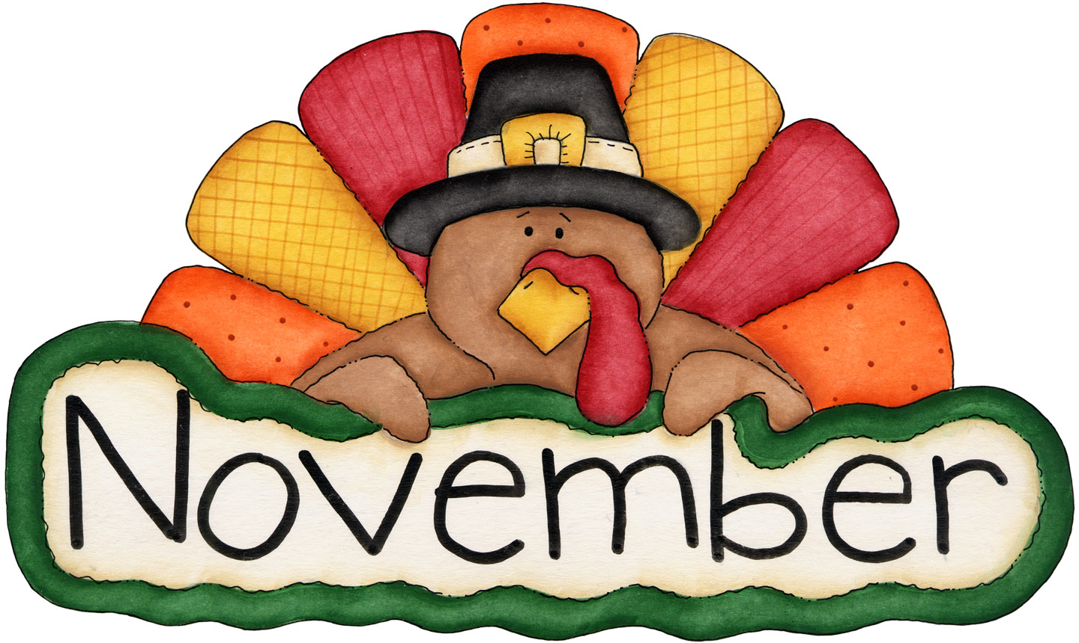 |  | November 1  Chicken Alfredo  Roll  Or  Calzone  Broccoli  Fruit  Milk | November 2  Nacho Grande  Or  Fish Nuggets  Roll  Peas  Fruit  Milk | November 3  Chicken & Waffles  W/ Gravy  Or  Pulled Pork Sandwich  Tossed Salad  Fruit  Milk | November 4  Cheese Pizza  Or  BBQ Rib Sandwich  Corn  Fruit  Milk | Offer verses serve -  Students must take  3 of 5 items to count as a lunch & one must be a fruit or vegetable.
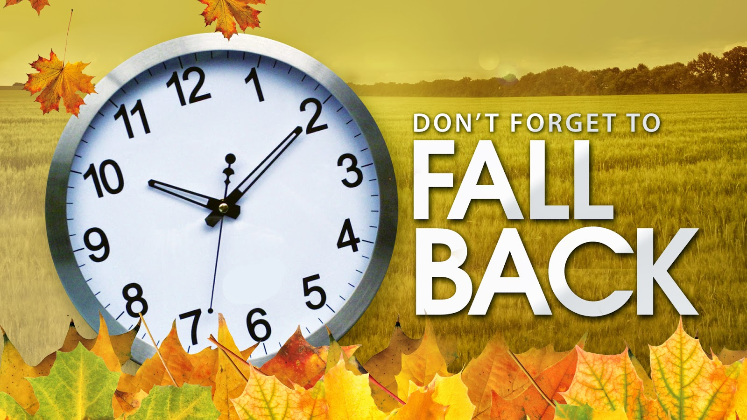 | November 7  Pancakes & Bacon  Or  Turkey & Cheese Hoagie  Hash Browns  Fruit  Milk | November 8  Mac & Cheese  Roll  Or  Hamburger  Broccoli  Fruit  Milk | November 9  Cheese Steak  Or  Grilled Chicken Salad  Roll  Peas  Fruit  Milk | November 10  No School | November 11  NO SCHOOL  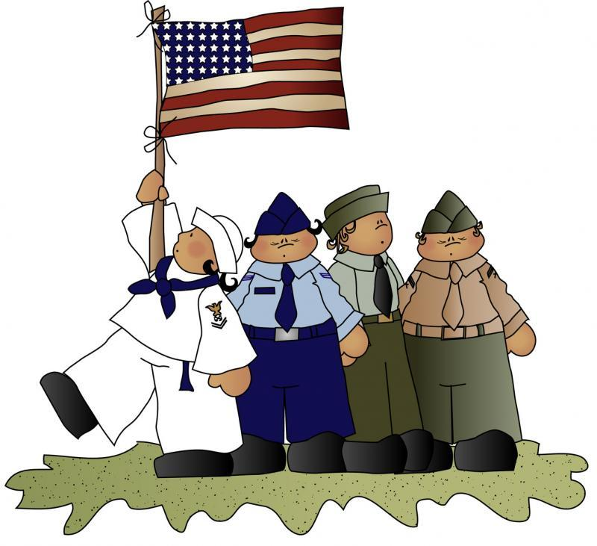
 | November 14  Tacos  Or  Turkey Bacon Wrap  Baby Carrots  Fruit  Milk | November 15  Tomato Soup  Grilled Cheese Sandwich  Or  Calzone  Broccoli  Fruit  Milk | November 16  Chicken Tenders  Goldfish Crackers  Or  BBQ Rib Sandwich  Peas  Fruit  Milk | November 17  Roast Turkey  w/ Gravy  or  Ham & Cheese Wrap  Mashed potatoes  Fruit  Milk | November 18  Pepperoni Pizza  Or  Fish Sticks  Roll  Green Beans  Fruit  Milk
All Meals are  served with 1% milk, fat free chocolate, fat free vanilla, fat free strawberry | November 21  Cheeseburger  Roll  Or  Chicken Cheese Steak  Corn  Fruit  Milk | November 22  Chicken Noodle Soup  Grilled Ham & Cheese Sandwich  Or  Turkey & Cheese Hoagie  Broccoli / Fruit  Milk | November 23  Breaded Pork Chop  Roll  Or  Fish Sticks / Roll  Scalloped Potatoes  Fruit  Milk | November 24  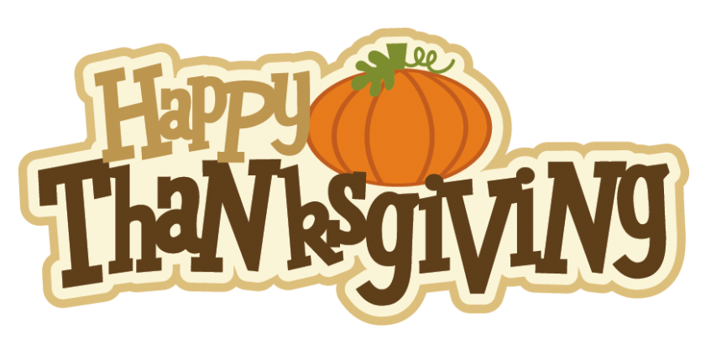 | November 25  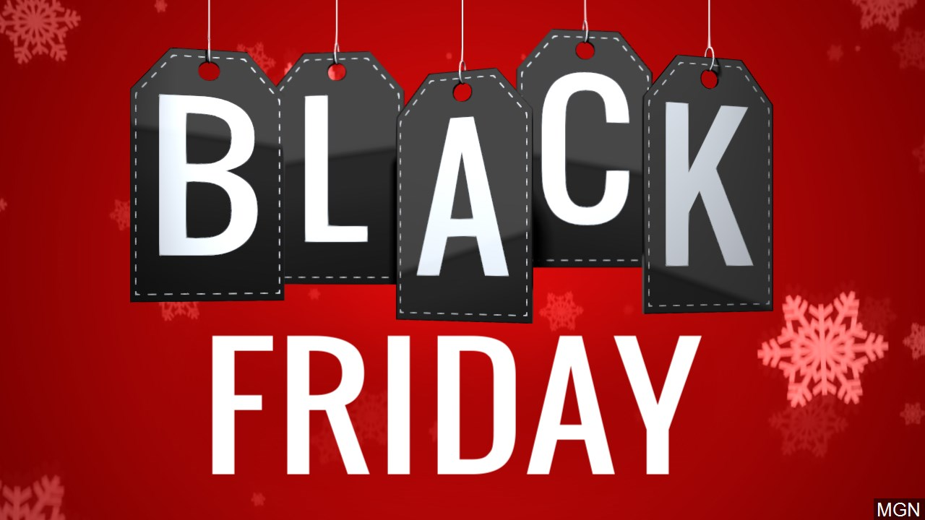 | Elementary  Lunch- FREE  EXTRA  Milk - $0.50  Snacks -$0.75
No breakfast on two-hour delays | November 28  No School | November 29  No School | November 30  Cheeseburger  Or  Meatball Sub  Peas  Fruit  Milk | December 1  Chicken Patty  Or  Grilled Chicken Sandwich  Tossed Salad  Fruit / Milk | December 2  Cheese Pizza  Or  BBQ Rib Sandwich  Broccoli  Fruit  Milk
Menu Subject to Change

