Fannett-Metal School District – High School - Middle School November 2022

Breakfast Menu

Fannett-Metal is an equal opportunity provider

SUNDAY | MONDAY | TUESDAY | WEDNESDAY | THURSDAY | FRIDAY | SATURDAY
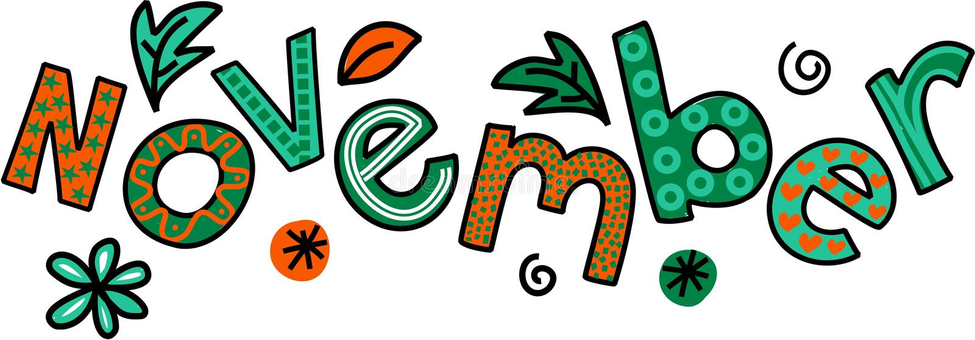 |  | November 1  Breakfast Sandwich  Juice  Milk | November 2  Waffles & Sausage  Juice  Milk | November 3  Breakfast Pizza  Juice  Milk | ^{November 4}  Cinnamon Bun  Juice  Milk | Offer verses serve -  Students must take  3 of 5 items to count as a lunch & one must be a fruit or vegetable.
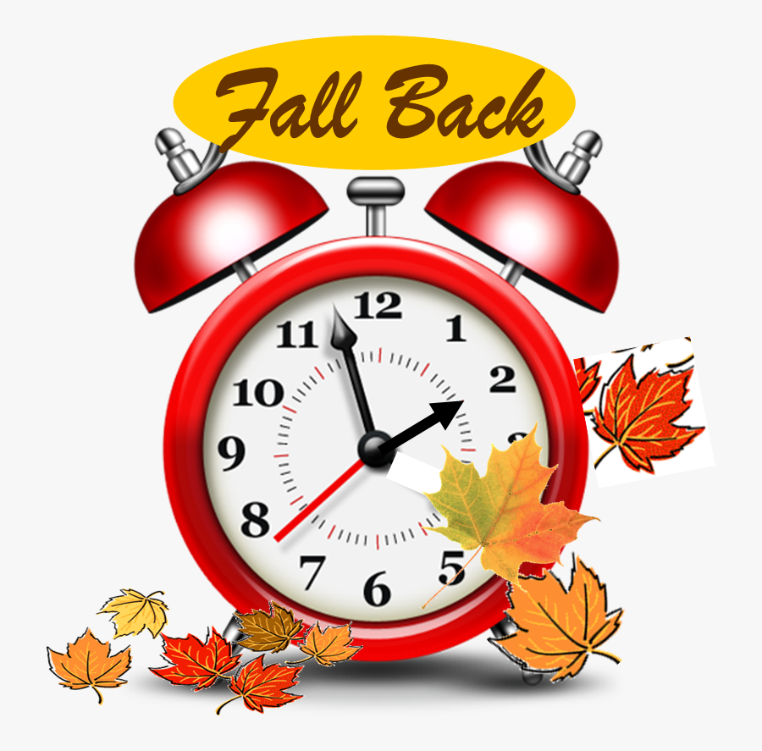 | November 7  French Toast Sticks  Juice  Milk | November 8  Breakfast Sandwich  Juice  Milk | November 9  Waffles & Sausage  Juice  Milk | November 10  No School | November 11 | 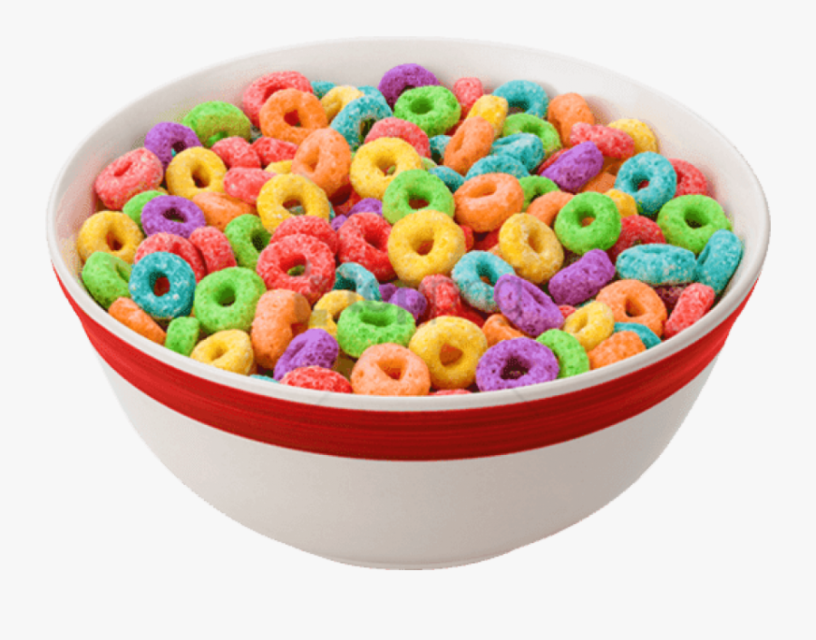
 | November 14  French Toast Sticks  Juice  Milk | November 15  Breakfast Sandwich  Juice  Milk | November 16  Waffles & Sausage  Juice  Milk | November 17  Breakfast Pizza  Juice  Milk | November 18  Cinnamon Bun  Juice  Milk
All Meals are  served with 1% milk, fat free chocolate, fat free vanilla, fat free strawberry | November 21  French Toast Sticks  Juice  Milk | November 22  Breakfast Sandwich  Juice  Milk | November 23  Waffles & Sausage  Juice  Milk | November 24  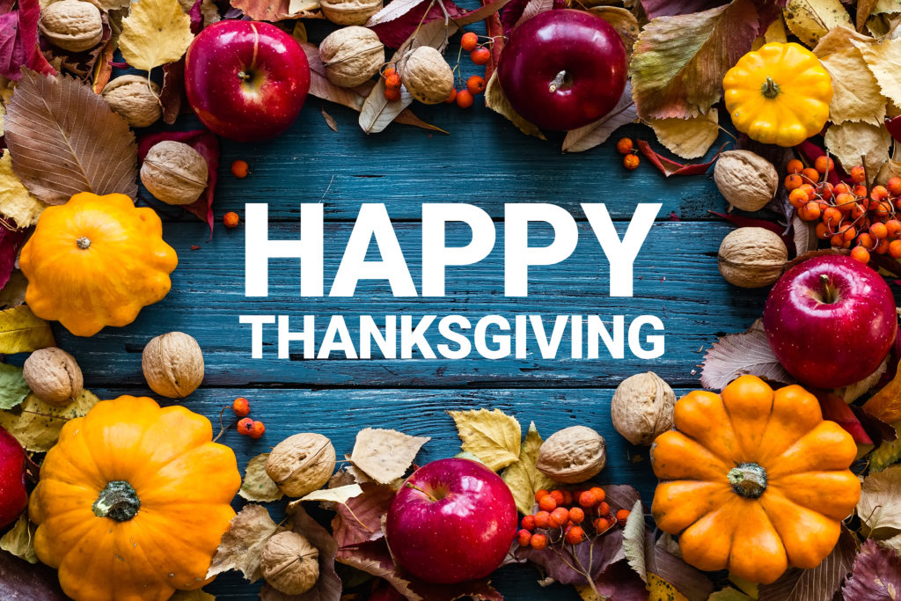 | November 25 | High/Middle School  Breakfast - FREE  Milk - .50
No breakfast on two-hour delays | November 28  No School | November 29  No School | November 30  Waffles & Sausage  Juice  Milk | December 1  Breakfast Pizza  Juice  Milk | December 2  Cinnamon Bun  Juice  Milk | 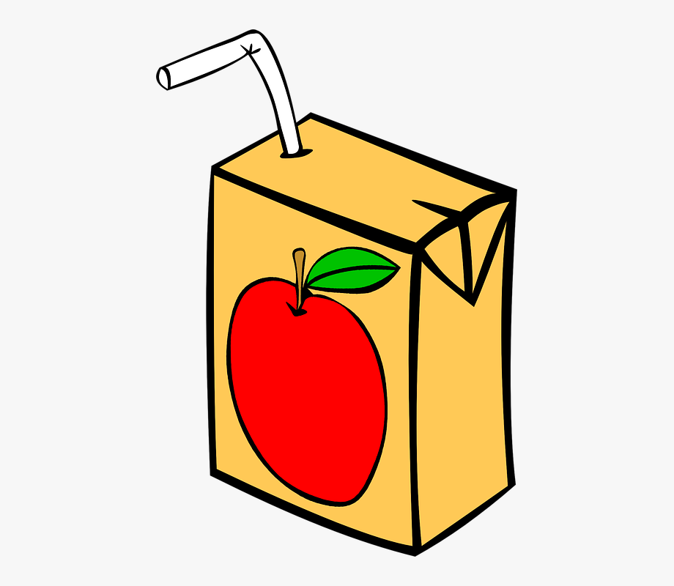
Menu Subject to Change

