Fannett-Metal School District – Middle High School November 2022

Lunch Menu

Fannett-Metal is an equal opportunity provider

SUNDAY | MONDAY | TUESDAY | WEDNESDAY | THURSDAY | FRIDAY | SATURDAY
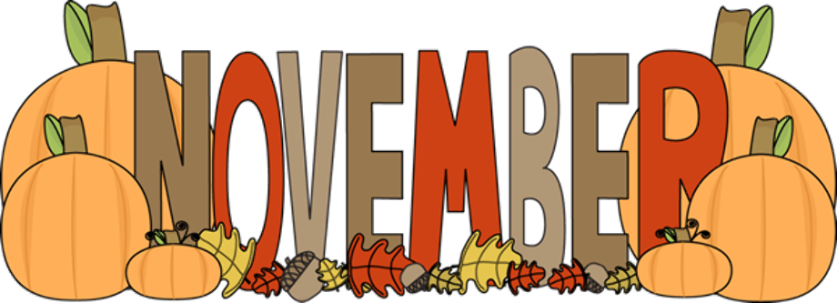 |  | November 1  Walking Taco  Or  Ham & Cheese  Wrap  Broccoli  Fruit  Milk | November 2  Nachos Grande  Or  Spicy Chicken Patty  Tossed Salad  Fruit  Milk | November 3  Ham & Cheese  Sliders  Or  Chicken Cheese Steak  Baked Beans  Fruit  Milk | ^{November 4}  Pizza  Or  Egg & Sausage Sandwich  Baby Carrots  Fruit / Milk | Offer verses serve -  Students must take  3 of 5 items to count as a lunch & one must be a fruit or vegetable.
 | November 7  Cheeseburger  Or  Cheese Steak  Steamed Carrots  Fruit  Milk | November 8  Mac & Cheese Bowl  Roll  Or  Fish Sandwich  Broccoli  Fruit  Milk | November 9  Pulled Pork Fries  Or  Ham & Cheese  Hoagie  Peas  Fruit  Milk | November 10  No School | November 11  No School
 | November 14  Chicken Patty  Or  Turkey Bacon Wrap  Peas  Fruit  Milk | November 15  Chicken Alfredo  Bread Stick  Or  Fish Sandwich  Broccoli  Fruit  Milk | November 16  Chicken Tenders  Roll  Or  Pizza Bagels  Baby Carrots  Fruit  Milk | November 17  Roast Turkey  W/ Gravy  Or  Hot Dog  Mashed Potato  Fruit  Milk | November 18  Pepperoni Pizza  Or  Chicken Cheese Steak  Corn  Fruit  Milk
All Meals are  served with 1% milk, fat free chocolate, fat free vanilla, fat free strawberry | November 21  Cheese Steak  Fries  Or  Calzone  Tossed Salad  Fruit  Milk | November 22  Mashed Potato Bowl  Roll  Or  Pulled Pork Sandwich  Corn  Fruit  Milk | November 23  Popcorn Chicken  Roll  Or  Meatball Sub  Peas  Fruit  Milk | November 24 | November 25  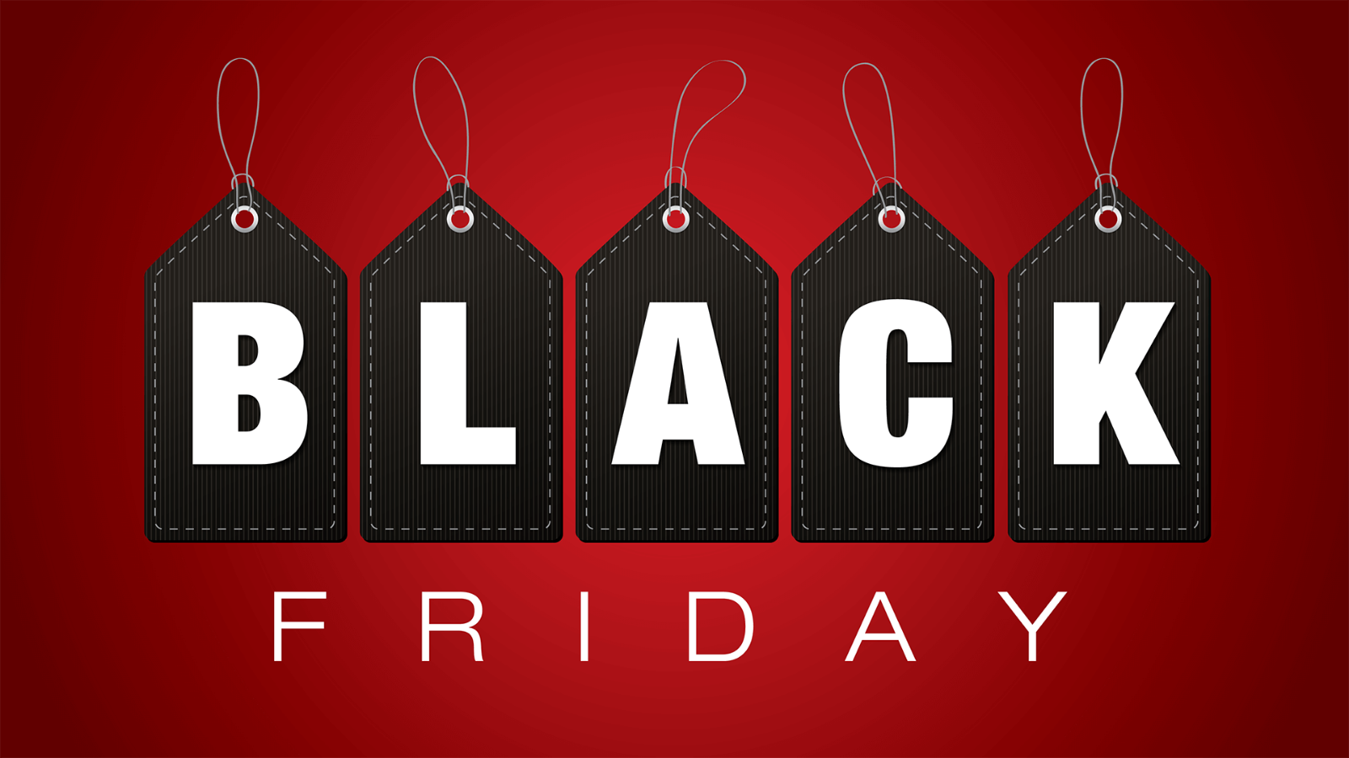 | Elementary  Lunch- FREE  EXTRA  Milk - $0.50  Snacks -$0.75
No breakfast on two-hour delays | November 28  No School | November 29  No School | November 30  Nacho Grande  Or  Fish Nuggets  Roll  Peas  Fruit  Milk | December 1  General Tso’s Chicken  Roll  Or  Ham & Cheese Wrap  Tossed Salad  Fruit  Milk | December 2  Cheese Pizza  Or  BBQ Rib Sandwich  Broccoli  Fruit  Milk
Menu Subject to Change

