Fannett-Metal School District – Elementary School September 2022

Lunch Menu

Fannett-Metal is an equal opportunity provider

SUNDAY | MONDAY | TUESDAY | WEDNESDAY | THURSDAY | FRIDAY | SATURDAY
 | August 29 | August 30 | August 31 | September 1  Spaghetti & Meatballs  Roll  Or  Chicken Cheese Steak  Tossed Salad  Fruit  Milk | ^{September 2}  Cheese Pizza  Or  BBQ Rib Sandwich  Peas  Fruit  ^{Milk} | Offer verses serve -  Students must take  3 of 5 items to count as a lunch & one must be a fruit or vegetable.
 | September 5  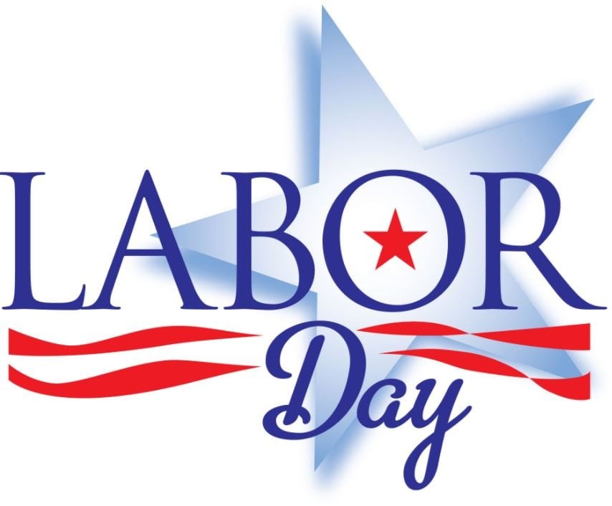 | September 6  Cheeseburger  Or  Hot Dog  Baked Beans  Fruit  Milk | September 7  Popcorn Chicken  Roll  Or  Meatball Sub  Broccoli  Fruit  Milk | September 8  Pancakes & Bacon  Or  BBQ Rib Sandwich  Hash Brown  Fruit  Milk | September 9  Chicken Patty  Or  Calzone  Peas  Fruit  Milk
 | September 12  Chicken Nuggets  Roll  Or  Ham & Cheese  Hoagie  Corn  Fruit / Milk | September 13  Mac & Cheese  Roll  Or  Chicken Cheese Steak  Steamed Carrots  Fruit  Milk | September 14  Cheeseburger  Or  Grilled Ham & Cheese  Peas  Fruit  Milk | September 15  Hot Turkey Sandwich  Or  Cheese Steak  Mashed Potatoes  Fruit  Milk | September 16  Pepperoni Pizza  Or  Hamburger  Broccoli  Fruit  Milk
All Meals are  served with 1% milk, fat free chocolate, fat free vanilla, fat free strawberry | September 19  Soft Shell Taco  Or  Pulled Pork Sandwich  Refried Beans  Fruit  Milk | September 20  Tomato Soup  Grilled Cheese Sandwich  Or  Turkey & Cheese Hoagie  Baby Carrots  Fruit  Milk | September 21  Chicken Tenders  Roll  Or  BBQ Rib Sandwich  Peas  Fruit  Milk | September 22  Chicken Patty  Or  Hot Dog  Corn  Fruit  Milk | September 23  Pepperoni Pizza  Or  Cheeseburger  Broccoli  Fruit  Milk | Elementary  Lunch- FREE  EXTRA  Milk - $0.50  Snacks -$0.75
No breakfast on two-hour delays | September 26  Walking Taco  Or  Ham & Cheese  Wrap  Refried Beans  Fruit  Milk | September 27  Chicken Alfredo  Roll  Or  Cheese Steak  Broccoli  Fruit  Milk | September 28  Nacho Grande  Or  Calzone  Peas  Fruit  Milk | September 29  Spaghetti & Meatballs  Roll  Or  Chicken Cheese Steak  Tossed Salad  Fruit  Milk | September 30  Cheese Pizza  Or  BBQ Rib Sandwich  Broccoli  Fruit  Milk
Menu Subject to Change

