Fannett-Metal School District – Elementary School September 2022

Breakfast Menu

Fannett-Metal is an equal opportunity provider

SUNDAY | MONDAY | TUESDAY | WEDNESDAY | THURSDAY | FRIDAY | SATURDAY
 | August 29 | August 30 | August 31 | September 1  Breakfast Pizza  Juice  Milk | ^{September 2}  Cereal  Muffin  Juice  Milk | Offer verses serve -  Students must take  3 of 5 items to count as a lunch & one must be a fruit or vegetable.
 | September 5  French Toast Sticks  Juice  Milk | September 6  Cereal  Muffin  Juice  Milk | September 7  Waffles & Sausage  Juice  Milk | September 8  Breakfast Pizza  Juice  Milk | September 9  Cereal  Muffin  Juice  Milk | 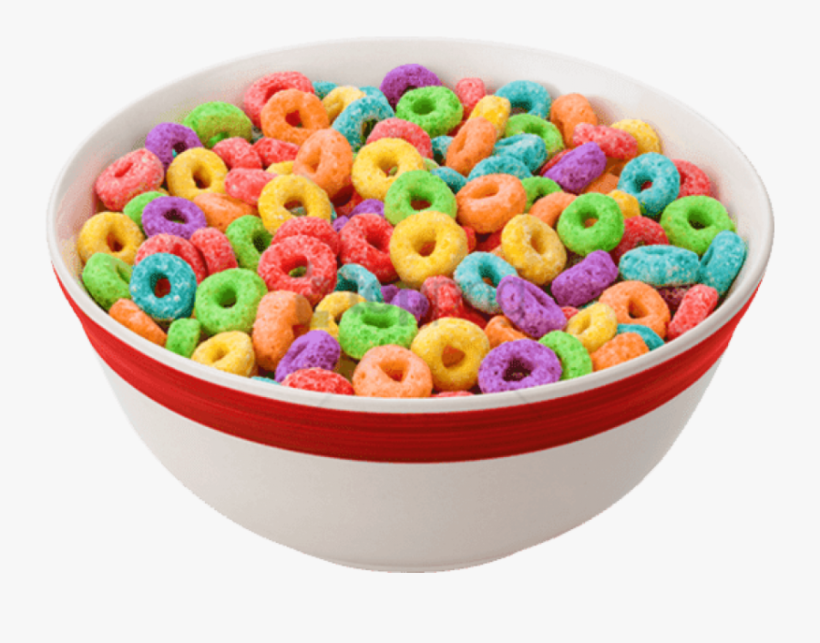
 | September 12  French Toast Sticks  Juice  Milk | September 13  Cereal  Muffin  Juice  Milk | September 14  Waffles & Sausage  Juice  Milk | September 15  Breakfast Pizza  Juice  Milk | September 16  Cereal  Muffin  Juice  Milk
All Meals are  served with 1% milk, fat free chocolate, fat free vanilla, fat free strawberry | September 19  French Toast Sticks  Juice  Milk | September 20  Cereal  Muffin  Juice  Milk | September 21  Waffles & Sausage  Juice  Milk | September 22  Breakfast Pizza  Juice  Milk | September 23  Cereal  Muffin  Juice  Milk | Elementary  Breakfast - FREE  Milk - .50  Snacks - .75
No breakfast on two-hour delays | September 26  French Toast Sticks  Juice  Milk | September 27  Cereal  Muffin  Juice  Milk | September 28  Waffles & Sausage  Juice  Milk | September 29  Breakfast Pizza  Juice  Milk | September 30  Cereal  Muffin  Fruit  Milk
Menu Subject to Change

