Fannett-Metal School District – Elementary School August 2022

Lunch Menu

Fannett-Metal is an equal opportunity provider

SUNDAY | MONDAY | TUESDAY | WEDNESDAY | THURSDAY | FRIDAY | SATURDAY
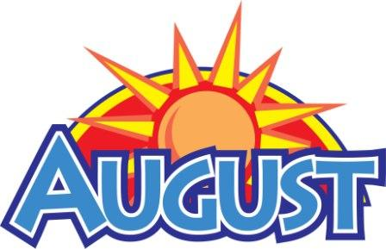 | August 1 | August 2 | August 3 | August 4 | ^{August 5} | Offer verses serve -  Students must take  3 of 5 items to count as a lunch & one must be a fruit or vegetable.
 | August 8 | August 9 | August 10 | August 11 | August 12
 | August 15 | August 16 |  | August 18 | August 19
All Meals are  served with 1% milk, fat free chocolate, fat free vanilla, fat free strawberry | August 22 | August 23 | August 24 | August 25  Cheeseburger  Or  Fish Sandwich  Corn  Fruit  Milk | August 26  Chicken Nuggets  Roll  Or  Turkey & Cheese  Hoagie  Baked Beans  Fruit / Milk | Elementary  Lunch- FREE  Milk - .50  Snacks - .75
No breakfast on two-hour delays | August 29  Chicken Patty  Or  Cheese Steak  Green Beans  Fruit  Milk | August 30  Meatball Sub  Or  Fish Nuggets  Broccoli  Fruit  Milk | August 31  Walking Tacos  Or  Ham & Cheese Wrap  Refried Beans  Fruit  Milk | September 1  Spaghetti & Meatballs  Roll  Or  Chicken Cheese Steak  Tossed Salad  Fruit  Milk | September 2  Cheese Pizza  Or  BBQ Rib Sandwich  Peas  Fruit  Milk
Menu Subject to Change

