Fannett-Metal School District - Elementary School May 2022

Lunch Menu

Fannett-Metal is an equal opportunity provider

SUNDAY | MONDAY | TUESDAY | WEDNESDAY | THURSDAY | FRIDAY | SATURDAY
 | May 2  Chicken Nuggets  Roll  Or  Calzone  Steamed Carrots  Fruit  Milk | May 3  Chicken Stir Fry  Roll  Or  Pulled Pork Sandwich  Green Beans  Fruit  Milk | May 4  Popcorn Chicken  Roll  Or  Fish Nuggets  Baked Beans  Fruit  Milk | May 5  Cheeseburger  Or  Turkey & Cheese Wrap  Broccoli  Fruit  Milk | ^{May 6}  Cheese Pizza  Or  Cheese Steak  Peas  Fruit  Milk | Offer verses serve -  Students must take  3 of 5 items to count as a lunch & one must be a fruit or vegetable.
 | May 9  Lasagna / Roll  Or  Shrimp Poppers / Roll  Or  BBQ Rib Sandwich  Corn  Fruit / Milk | May 10  Roast Turkey w/ Gravy  Roll  Or  Ham & Cheese Hoagie  Mashed Potatoes  Fruit  Milk | May 11  Walking Taco  Or  Calzone  Peas  Fruit  Milk | May 12  Chicken Nuggets  Roll  Or  Ham & Cheese Wrap  Baked Beans  Fruit / Milk | May 13  Pizza  Or  Fish Nuggets  Roll  Broccoli  Fruit  Milk
 | May 16  Chicken Patty  Or  Stuffed Shells  Roll  Broccoli  Fruit  Milk | May 17  Nacho Grande  Or  BBQ Rib Sandwich  Peas  Fruit  Milk | May 18  Popcorn Chicken  Roll  Or  Fish Nuggets / Roll  Baked Beans  Fruit  Milk | May 19  Pizza Burger  Or  Turkey & Cheese  Hoagie  Steamed Carrots  Fruit  Milk | May 20  Pizza  Or  Calzone  Corn  Fruit  Milk
All Meals are  served with 1% milk, fat free chocolate, fat free vanilla, fat free strawberry | May 23  Cheese Steak  Or  Fish Sandwich  Green Beans  Fruit  Milk | May 24  Hamburger  Or  Chicken Cheese Steak  Peas  Fruit  Milk | May 25  Grilled Ham & Cheese  Sandwich  Or  Meatball Sub  Corn  Fruit  Milk | 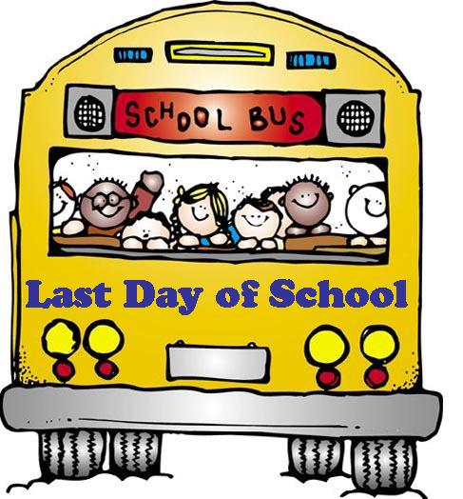 |  | Elementary  Lunch- FREE  Milk - .50
No breakfast on two-hour delays | 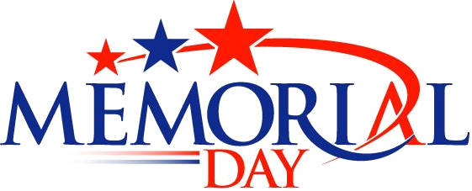
Menu Subject to Change

