Fannett-Metal School District – Middle – High School May 2022
USDA Nondiscrimination Statement and Complaint Procedure
The U.S Department of Agriculture prohibits discrimination against its customers, employees, and applicants for employment on the bases of race, color, national origin, age, disability, sex, gender identity, religion, reprisal, and where applicable, political beliefs, marital status, familial or parental status, sexual orientation, or if all or part of an individual's income is derived from any public assistance program, or protected genetic information in employment or in any program or activity conducted or funded by the Department. (Not all prohibited bases will apply to all programs and/or employment activities.)
If you wish to file a Civil Rights program complaint of discrimination, complete the USDA Program Discrimination Complaint Form, found online at http://www.ascr.usda.gov/complaint_filing_cust.html, or at any USDA office, or call (866) 632-9992 to request the form. You may also write a letter containing all of the information requested in the form. Send your completed complaint form or letter to us by mail at U.S. Department of Agriculture, Director, Office of Adjudication, 1400 Independence Avenue, S.W., Washington, D.C. 20250-9410, by fax (202) 690-7442 or email at program.intake@usda.gov .
Individuals who are deaf, hard of hearing or have speech disabilities may contact USDA through the Federal Relay Service at (800) 877-8339; or (800) 845-6136 (Spanish
Fannett-Metal is an equal opportunity provider

SUNDAY | MONDAY | TUESDAY | WEDNESDAY | THURSDAY | FRIDAY | SATURDAY
 | May 2  Grilled Ham & Cheese  Or  Pizza Burger  Broccoli  Fruit  Milk | May 3  Chicken Patty  Or  Meatball Sub  Peas  Fruit  Milk | May 4  Cheeseburger  Or  Turkey & Cheese  Flatbread  Green Beans  Fruit  Milk | May 5  Popcorn Chicken  Roll  Or  Hot Dog  Corn  Fruit  Milk | May 6  Chef Salad  Roll  Or  Ham & Egg Sandwich  Carrots  Fruit  Milk | Offer verses serve -  Students must take  3 of 5 items to count as a lunch & one must be a fruit or vegetable.
 | May 9  Spicy Chicken Patty  Or  Cheese Steak Fries  Tossed Salad  Fruit  Milk | May 10  Walking Taco  Or  Fish Nuggets  Roll  Peas  Fruit  Milk | May 11  Mashed Potato Bowl  Roll  Or  Hot Dog  Corn  Fruit  Milk | May 12  Steak Fries  Or  Turkey & Cheese Hoagie  Broccoli  Fruit  Milk | May 13  Popcorn Chicken  Roll  Or  Turkey Club Wrap  Baked Beans  Fruit  Milk | All Meals are  served with 1% milk, fat free chocolate
 | May 16  Pancakes & Sausage  Or  Chicken Tenders  Roll  Carrots  Fruit  Milk | May 17  Chicken Alfredo  Roll  Or  Fish Nuggets  Roll  Peas  Fruit / Milk | May 18  Pulled Pork Fries  Or  Ham & Cheese Hoagie  Baked Beans  Fruit  Milk | May 19  Hot Turkey Sandwich  Or  Cheese Steak  Mashed Potatoes  Fruit  Milk | May 20  Pizza  Or  Ham & Cheese Flatbread  Broccoli  Fruit  Milk
3rd Choice Everyday  Peanut Butter  And Jelly  Sandwich | May 23  Mac & Cheese  Roll  Or  Chef’s Choice  Vegetable  Fruit  Milk | May 24  Cheeseburger  Or  Chef’s Choice  Vegetable  Fruit  Milk | May 25  Pizza  Or  Chef’s Choice  Vegetable  Fruit  Milk | 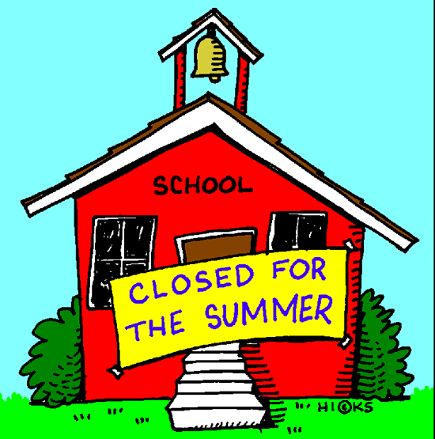  This Photo by Unknown Author is licensed under CC BYNC-ND |  | High School Lunch-  FREE  Milk - .50
Menu subject to change | 