Fannett-Metal School District - May 2022

Breakfast Menu

Fannett-Metal is an equal opportunity provider

SUNDAY | MONDAY | TUESDAY | WEDNESDAY | THURSDAY | FRIDAY | SATURDAY
May | May 2  French Toast  Sticks  Fruit  Milk | May 3  Pancake  on a Stick  Juice  Milk | May 4  Pancakes  Sausage  Fruit  Milk | May 5  Breakfast Pizza  Fruit  Milk | May 6  Cereal  Muffin  Fruit  Milk | Elementary & MS/HS  Breakfast - FREE  Milk -$.50
 | May 9  French Toast  Sticks  Fruit  Milk | May 10  Pancake  on a Stick  Juice  Milk | May 11  Pancakes  Sausage  Fruit  Milk | May 12  Breakfast Pizza  Fruit  Milk | May 13  Cereal  Muffin  Fruit  Milk | 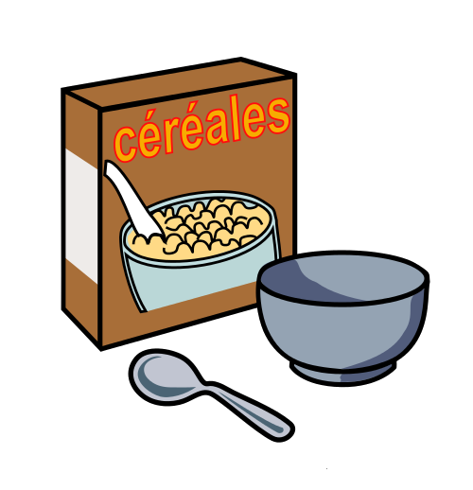
 | May 16  French Toast  Sticks  Fruit  Milk | May 17  Pancake  on a Stick  Juice  Milk | May 18  Pancakes  Sausage  Fruit  Milk | May 19  Breakfast Pizza  Fruit  Milk | May 20  Cereal  Muffin  Fruit  Milk | Breakfast items could change due to food storages.
 | May 23  Breakfast  Variety  Juice  Milk | May 24  Breakfast  Variety  Juice  Milk | May 25  Breakfast  Variety  Juice  Milk
 | May 31 |  |  |  |  | All Meals are  served with 1% milk, fat free chocolate, fat free vanilla, fat free strawberry
To manage accounts: www.myschoolaccount.com No breakfast on 2 hour delays *Menu Subject to Change

