FANNETT-METAL SCHOOL DISTRICT – January 2022 Breakfast Menu

Fannett-Metal School District is an equal opportunity provider
SUNDAY | MONDAY | TUESDAY | WEDNESDAY | THURSDAY | FRIDAY | SATURDAY
 | January 3  French Toast  Sticks  Fruit  Milk | January 4  Funnel Cake  Juice  Milk | January 5  Pancakes & Sausage  Fruit  Milk | January 6  Breakfast  Pizza  Juice  Milk | January 7  Cereal  Muffin  Juice  Milk | 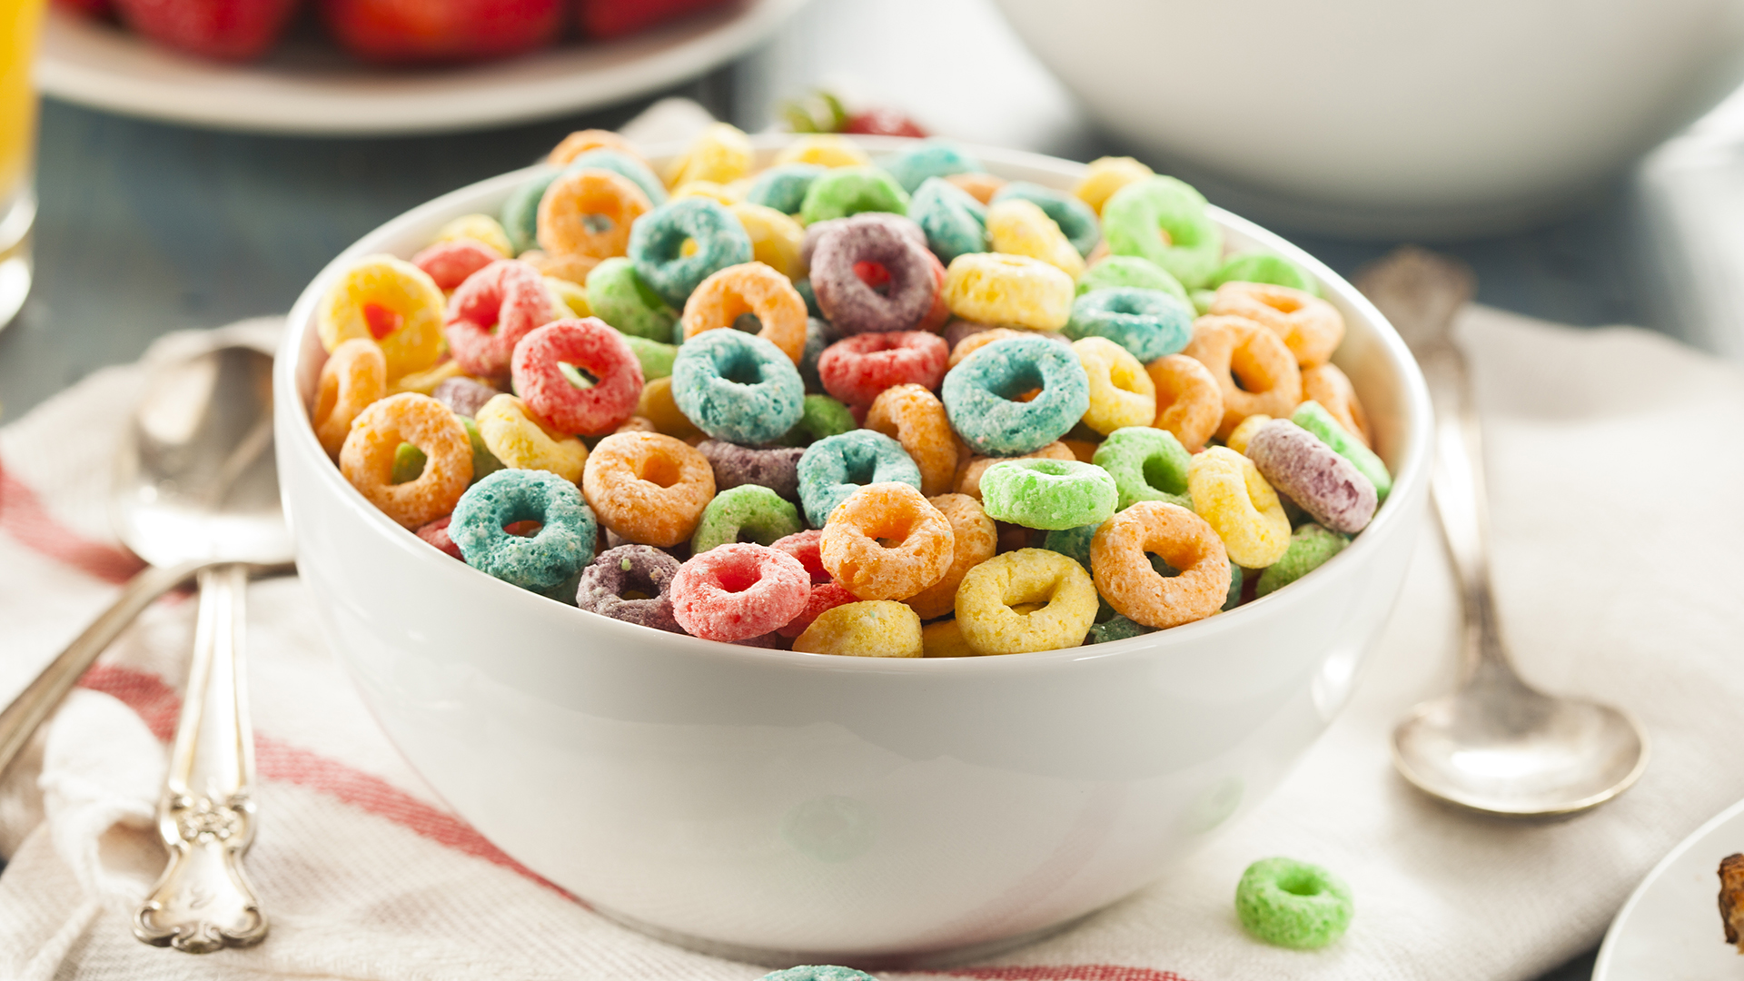
 | January 10  French Toast  Sticks  Fruit  Milk | January 11  Funnel Cake  Juice  Milk | January 12  Pancakes & Sausage  Fruit  Milk | January 13  Breakfast  Pizza  Juice  Milk | January 14  No School | Elementary & MS/HS  Free  Milk -$.50 – without buying breakfast meal
All Meals are  served with 1% milk, fat free chocolate, fat free vanilla, fat free strawberry and skim | January 17  No School | January 18  Funnel Cake  Juice  Milk | January 19  Pancakes & Sausage  Fruit  Milk | January 20  Breakfast  Pizza  Juice  Milk | January 21  Cereal  Muffin  Juice  Milk
 | January 24  French Toast  Sticks  Fruit  Milk | January 25  Funnel Cake  Juice  Milk | January 26  Pancakes & Sausage  Fruit  Milk | January 27  Breakfast  Pizza  Juice  Milk | January 28  Cereal  Muffin  Juice  Milk
 | January 31  French Toast  Sticks  Fruit  Milk | February 1  Funnel Cake  Juice  Milk | February 2  Pancakes & Sausage  Fruit  Milk | February 3  Breakfast  Pizza  Juice  Milk | February 4  Cereal  Muffin  Juice  Milk
To manage accounts: www.myschoolaccount.com No breakfast on 2 hour delays *Menu Subject to Change

