Fannett-Metal School District – Middle – High School January 2022
USDA Nondiscrimination Statement and Complaint Procedure
The U.S Department of Agriculture prohibits discrimination against its customers, employees, and applicants for employment on the bases of race, color, national origin, age, disability, sex, gender identity, religion, reprisal, and where applicable, political beliefs, marital status, familial or parental status, sexual orientation, or if all or part of an individual's income is derived from any public assistance program, or protected genetic information in employment or in any program or activity conducted or funded by the Department. (Not all prohibited bases will apply to all programs and/or employment activities.)
If you wish to file a Civil Rights program complaint of discrimination, complete the USDA Program Discrimination Complaint Form, found online at http://www.ascr.usda.gov/complaint_filing_cust.html, or at any USDA office, or call (866) 632-9992 to request the form. You may also write a letter containing all of the information requested in the form. Send your completed complaint form or letter to us by mail at U.S. Department of Agriculture, Director, Office of Adjudication, 1400 Independence Avenue, S.W., Washington, D.C. 20250-9410, by fax (202) 690-7442 or email at program.intake@usda.gov .
Individuals who are deaf, hard of hearing or have speech disabilities may contact USDA through the Federal Relay Service at (800) 877-8339; or (800) 845-6136 (Spanish
Fannett-Metal is an equal opportunity provider

SUNDAY | MONDAY | TUESDAY | WEDNESDAY | THURSDAY | FRIDAY | SATURDAY
 | January 3  Cheeseburger  Or  Lasagna  Roll  Broccoli  Fruit  Milk | January 4  Walking Taco  Or  Turkey Club Wrap  Refried Beans  Fruit  Milk | January 5  Mac & Cheese  Roll  Or  Ham & Cheese Flatbread  Corn  Fruit / Milk | January 6  Hot Turkey Sandwich  Gravy  Or  Cheese Steak  Mashed Potatoes  Fruit  Milk | ^{January 7}  Meat Lover’s Pizza  Or  Buffalo Chicken Wrap  Baked Beans  Fruit  Milk | Offer verses serve -  Students must take  3 of 5 items to count as a lunch & one must be a fruit or vegetable.
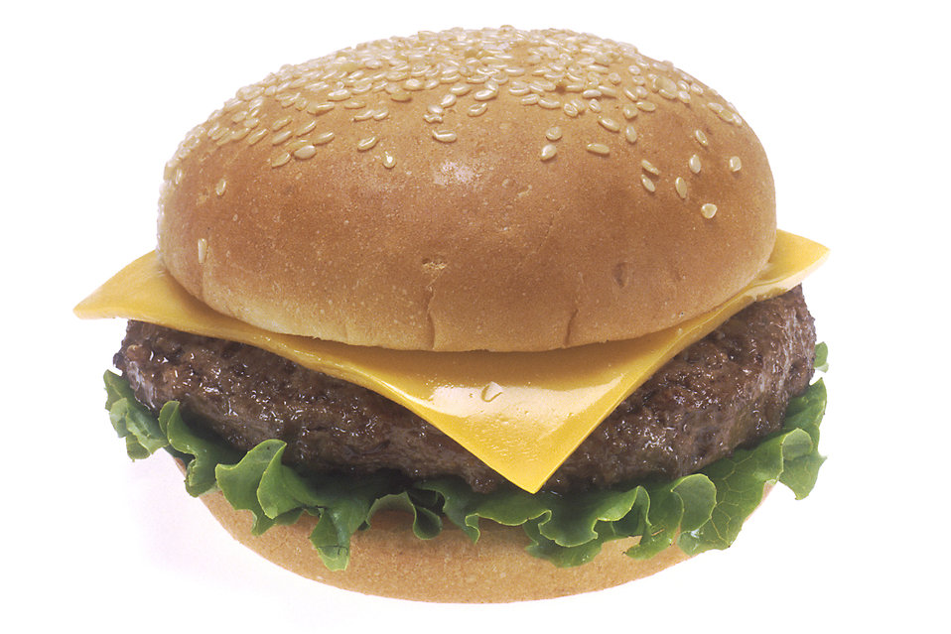 | January 10  Nacho Grande  Or  Meatball Sub  Corn  Fruit  Milk | January 11  Chicken Patty  Or  Calzone  Baby Carrots  Fruit  Milk | January 12  Chicken Cheese Steak  Or  Tuna Melt Sandwich  Baked Beans  Fruit  Milk | January 13  Baked Spaghetti  Bread Stick  Or  Fish Sandwich  Tossed Salad  Fruit / Milk | January 14  No School | Menu subject to change
All Meals are  served with 1% milk, fat free chocolate, fat free vanilla, fat free strawberry and skim | January 17  No School | January 18  Pepperoni Pizza  Or  Cheeseburger Sub  Baked Beans  Fruit  Milk | January 19  General Tso Chicken  Rice / Roll  Or  Pulled Pork Fries  Broccoli  Fruit  Milk | January 20  Mashed Potato Bowl  Roll  Or  BBQ Rib Sandwich  Corn  Fruit  Milk | January 21  Cheeseburger  Or  Fish Sandwich  Peas  Fruit  Milk | High School Lunch-  Free  Milk - .50 – without buying a school lunch
No breakfast on two hour delays | January 24  Tomato Soup  Grilled Cheese Sandwich  Or  Hamburger  Baby Carrots  Fruit  Milk | January 25  Salisbury Steak / Roll  Or  Chef Salad  Roll  Scalloped Potatoes  Fruit  Milk | January 26  Waffles & Sausage  Or  Cheese Steak  Tatar Tots  Fruit  Milk | January 27  Chicken Alfredo  Bread Stick  Or  Turkey & Cheese  Flatbread  Broccoli  Fruit / Milk | January 28  Pepperoni Pizza  Or  Ham and Cheese Wrap  Corn  Fruit  Milk
 | January 31  Cheeseburger  Or  Lasagna  Roll  Broccoli  Fruit  Milk | February 1  Walking Taco  Or  Turkey Club Wrap  Refried Beans  Fruit  Milk | February 2  Mac & Cheese  Roll  Or  Ham & Cheese Flatbread  Tossed Salad  Fruit / Milk | February 3  Chicken & Waffles  Or  Calzone  Baby Carrots  Fruit  Milk | February 4  Meat Lover’s Pizza  Or  Buffalo Chicken Wrap  Baked Beans  Fruit  Milk | 