Fannett-Metal School District – Elementary January 2022
USDA Nondiscrimination Statement and Complaint Procedure
The U.S Department of Agriculture prohibits discrimination against its customers, employees, and applicants for employment on the bases of race, color, national origin, age, disability, sex, gender identity, religion, reprisal, and where applicable, political beliefs, marital status, familial or parental status, sexual orientation, or if all or part of an individual's income is derived from any public assistance program, or protected genetic information in employment or in any program or activity conducted or funded by the Department. (Not all prohibited bases will apply to all programs and/or employment activities.)
If you wish to file a Civil Rights program complaint of discrimination, complete the USDA Program Discrimination Complaint Form, found online at http://www.ascr.usda.gov/complaint_filing_cust.html, or at any USDA office, or call (866) 632-9992 to request the form. You may also write a letter containing all of the information requested in the form. Send your completed complaint form or letter to us by mail at U.S. Department of Agriculture, Director, Office of Adjudication, 1400 Independence Avenue, S.W., Washington, D.C. 20250-9410, by fax (202) 690-7442 or email at program.intake@usda.gov .
Individuals who are deaf, hard of hearing or have speech disabilities may contact USDA through the Federal Relay Service at (800) 877-8339; or (800) 845-6136 (Spanish
Fannett-Metal is an equal opportunity provider

SUNDAY | MONDAY | TUESDAY | WEDNESDAY | THURSDAY | FRIDAY | SATURDAY
 | January 3  Chicken Tenders  Roll  Or  Fish Nuggets / Roll  Baked Beans  Fruit  Milk | January 4  Chicken Patty  Or  Ham & Cheese Wrap  Peas  Fruit  Milk | January 5  Spaghetti & Meatballs  Roll  Or  Chicken Cheese Steak  Baby Carrots  Fruit / Milk | January 6  Chicken Alfredo  Roll  Or  Calzone  Broccoli  Fruit  Milk | ^{January 7}  Pepperoni Pizza  Or  Turkey & Cheese  Hoagie  Grape Tomatoes  Fruit / Milk | Offer verses serve -  Students must take  3 of 5 items to count as a lunch & one must be a fruit or vegetable.
 | January 10  Tomato Soup  Grilled Cheese Sandwich  Or  Shrimp Poppers / Roll  Baby Carrots  Fruit  Milk | January 11  Walking Taco  Or  Fish Nuggets  Roll  Refried Beans  Fruit  Milk | January 12  Mac & Cheese  Roll  Or  Cheese Steak  Grape Tomatoes  Fruit  Milk | January 13  Cheeseburger  Or  Chef Salad / Roll  Peas  Fruit  Milk | January 14  No School | Elementary Lunch-  Free  Milk - .50 – without buying a school lunch
All Meals are  served with 1% milk, fat free chocolate, fat free vanilla, fat free strawberry | January 17  No School | January 18  Cheeseburger  or  Fish Sandwich  Baked Beans  Fruit  Milk | January 19  Chicken Patty  Or  Chicken Cheese Steak  Tossed Salad  Fruit  Milk | January 20  Soft Shell Taco  Or  Meatball Sub  Grape Tomatoes  Fruit  Milk | January 21  Pizza  Or  Fish Nuggets / Roll  Baby Carrots  Fruit  Milk
No breakfast on two hour delays | January 24  Lasagna  Roll  Or  Cheese Steak  Tossed Salad  Fruit  Milk | January 25  Salisbury Steak / Roll  Or  BBQ Rib Sandwich  Peas  Fruit  Milk | January 26  Cheeseburger Sub  Or  Grilled Cheese Sandwich  Baby Carrots  Fruit  Milk | January 27  Chicken Patty  Or  Turkey & Cheese  Hoagie  Tossed Salad  Fruit / Milk | January 28  Pizza  Or  Calzone  Grape Tomatoes  Fruit  Milk
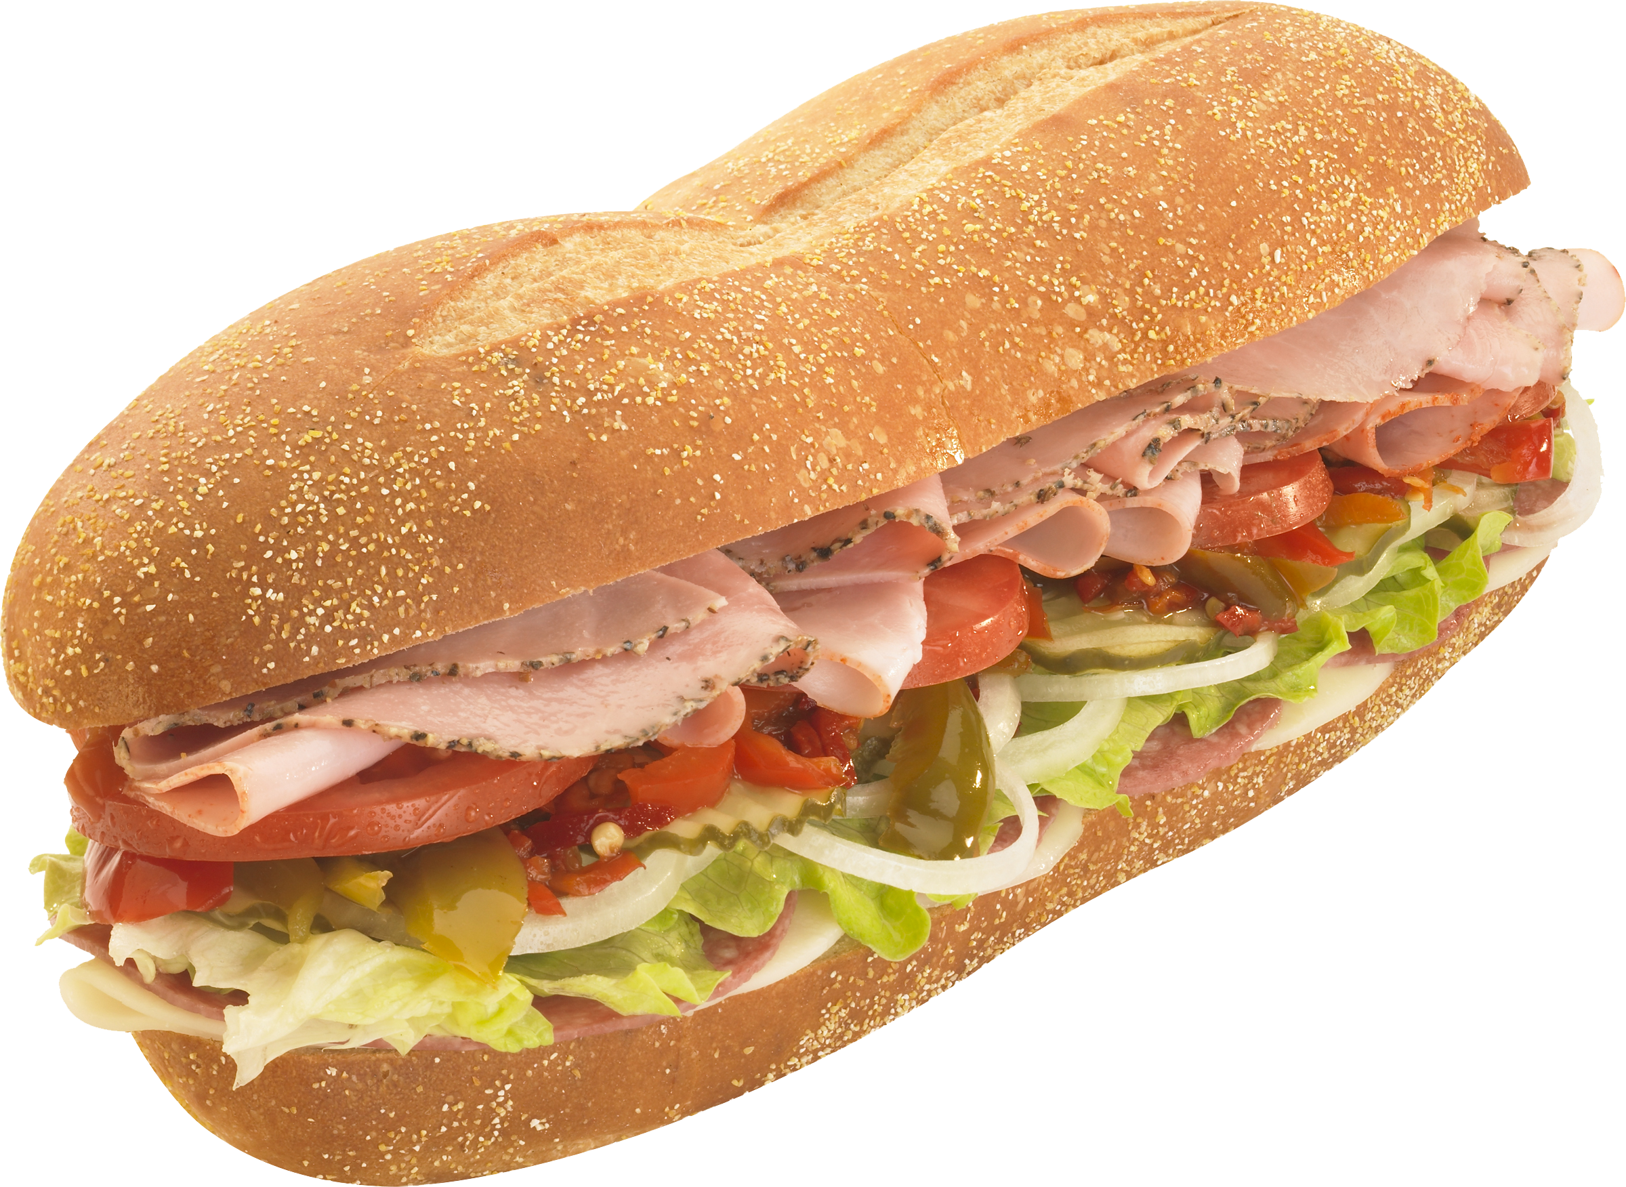 | January 31  Chicken Nuggets  Roll  Or  BBQ Rib Sandwich  Baked Beans  Fruit  Milk | February 1  Mashed Potato Bowl  Roll  Or  Ham & Cheese Wrap  Corn  Fruit  Milk | February 2  Spaghetti & Meatballs  Roll  Or  Chicken Cheese Steak  Baby Carrots  Fruit / Milk | February 3  Chicken Alfredo  Roll  Or  Meatball Sub  Broccoli  Fruit  Milk | February 4  French Bread Pizza  Or  Chef Salad  Peas  Fruit  Milk | 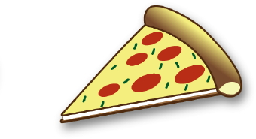
Menu Subject to Change

