Fannett-Metal School District – Elementary November 2021
USDA Nondiscrimination Statement and Complaint Procedure
The U.S Department of Agriculture prohibits discrimination against its customers, employees, and applicants for employment on the bases of race, color, national origin, age, disability, sex, gender identity, religion, reprisal, and where applicable, political beliefs, marital status, familial or parental status, sexual orientation, or if all or part of an individual's income is derived from any public assistance program, or protected genetic information in employment or in any program or activity conducted or funded by the Department. (Not all prohibited bases will apply to all programs and/or employment activities.)
If you wish to file a Civil Rights program complaint of discrimination, complete the USDA Program Discrimination Complaint Form, found online at http://www.ascr.usda.gov/complaint_filing_cust.html, or at any USDA office, or call (866) 632-9992 to request the form. You may also write a letter containing all of the information requested in the form. Send your completed complaint form or letter to us by mail at U.S. Department of Agriculture, Director, Office of Adjudication, 1400 Independence Avenue, S.W., Washington, D.C. 20250-9410, by fax (202) 690-7442 or email at program.intake@usda.gov .
Individuals who are deaf, hard of hearing or have speech disabilities may contact USDA through the Federal Relay Service at (800) 877-8339; or (800) 845-6136 (Spanish
Fannett-Metal is an equal opportunity provider

SUNDAY | MONDAY | TUESDAY | WEDNESDAY | THURSDAY | FRIDAY | SATURDAY
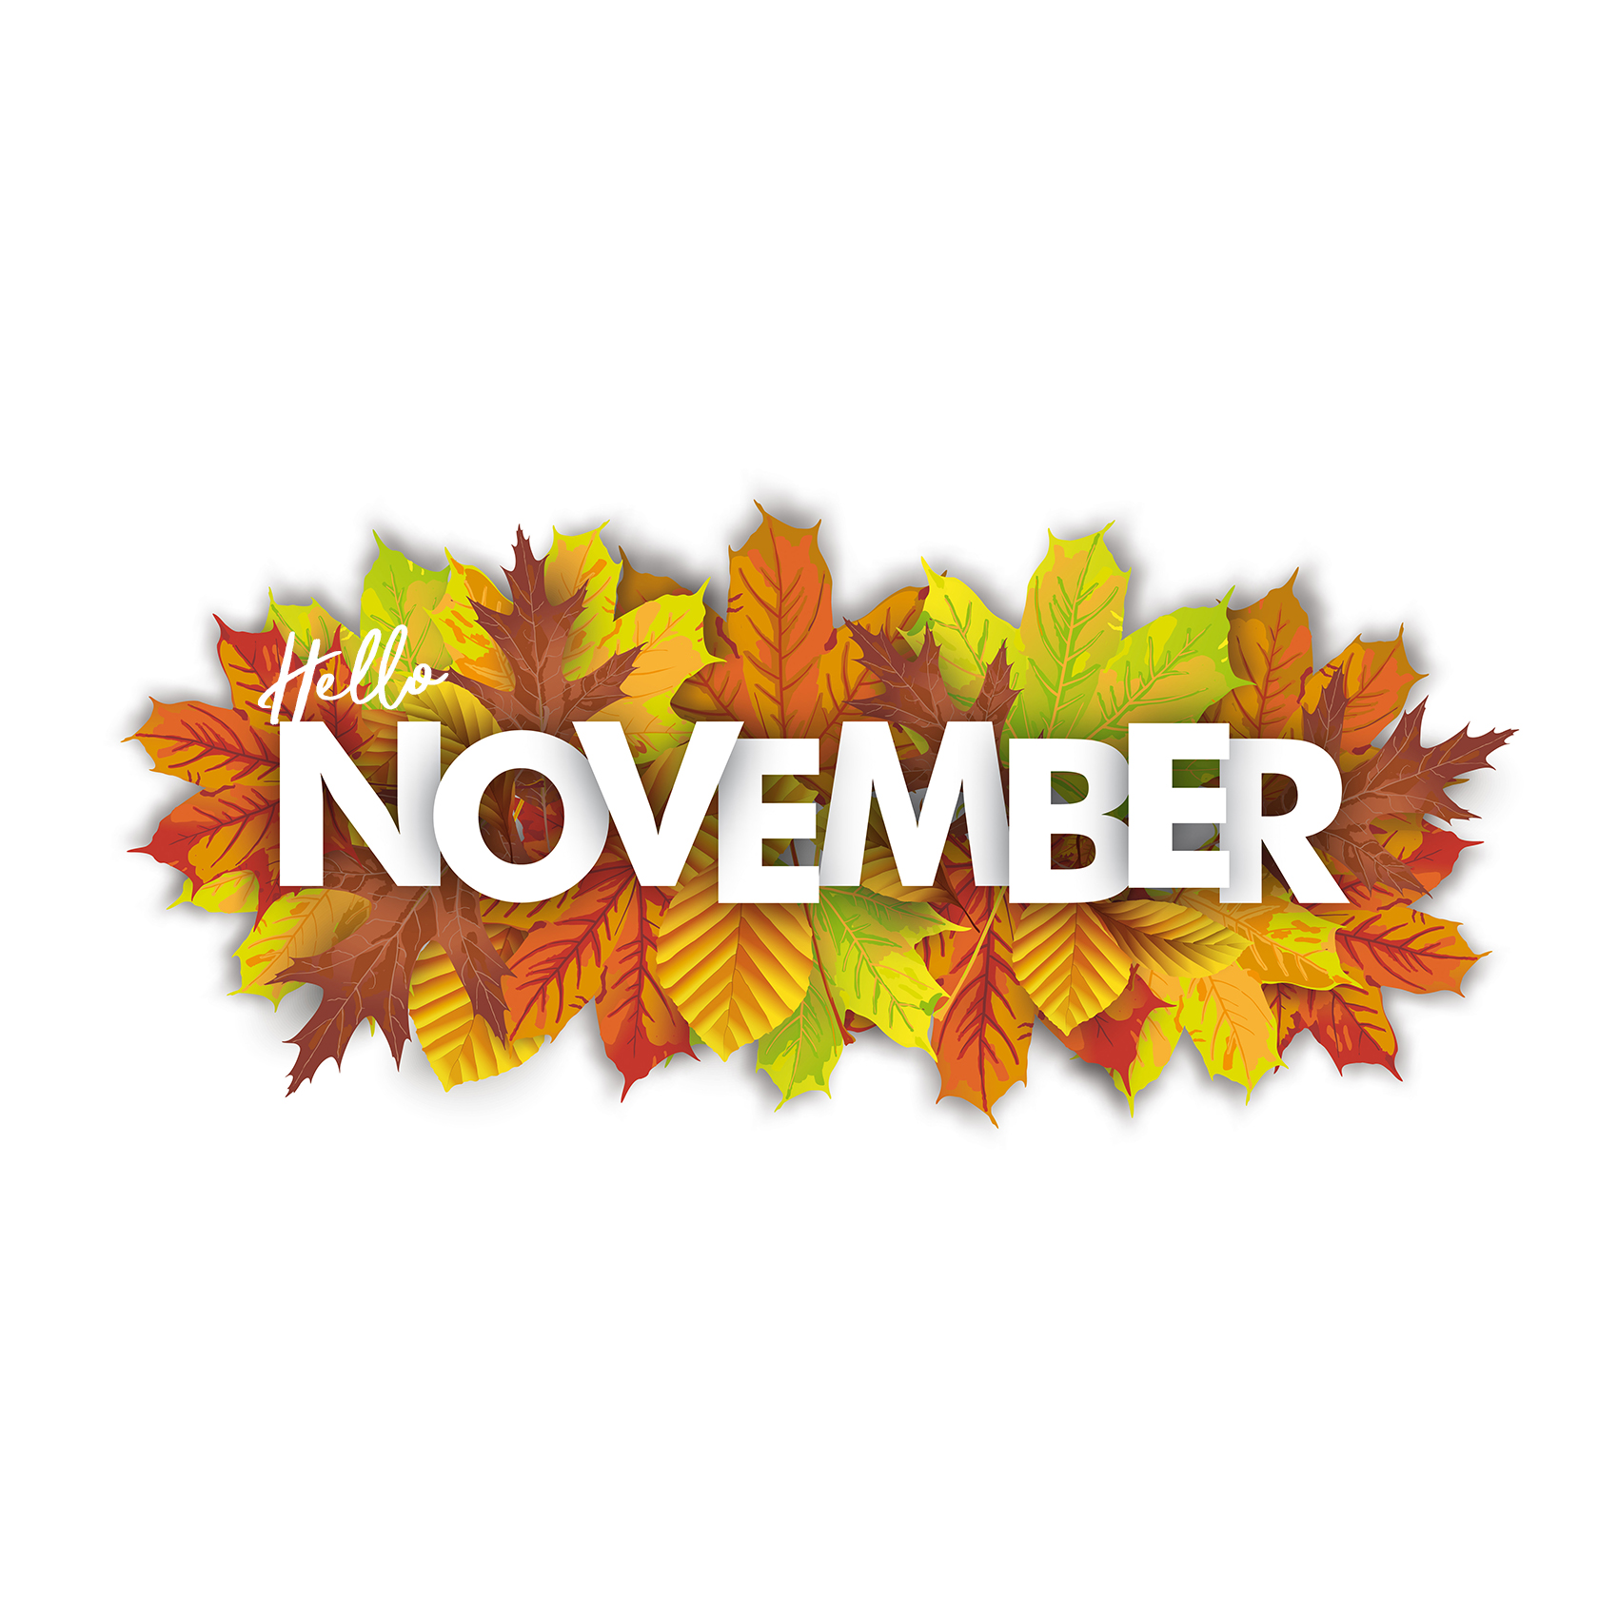 | November 1  Chicken Tenders  W/ Roll  Or  Grilled Cheese Sandwich  Corn  Fruit  Milk | November 2  Walking Taco  Or  Calzone  Refried Beans  Fruit  Milk | November 3  Mac & Cheese  Bread Stick  Or  Chef Salad  Bread Stick  Broccoli  Fruit / Milk | November 4  Meatballs with Noodles  And Gravy / Roll  Or  Ham & Cheese Wrap  Peas  Fruit  Milk | November 5  French Bread Pizza  Or  Chicken Cheese Steak  Baby Carrots  Fruit  Milk | Offer verses serve -  Students must take  3 of 5 items to count as a lunch & one must be a fruit or vegetable.
 | November 8  Chicken Nuggets  Roll  Or  BBQ Rib Sandwich  Steamed Carrots  Fruit  Milk | November 9  Chicken Patty  Or  Cheese Steak  Cheesy Broccoli  Fruit  Milk | November 10  Roast Turkey  Gravy / Stuffing  Or  Calzone  Mashed Potato  Fruit  Milk | November 11 | November 12  Pizza  Or  Fish Nuggets  Roll  Corn  Fruit  Milk
All Meals are  served with 1% milk, fat free chocolate, fat free vanilla, fat free strawberry and skim | November 15  Salisbury Steak  Roll  Or  Ham & Cheese Hoagie  Mashed Potatoes  Fruit  Milk | November 16  Shrimp Poppers  Roll  Or  Pancake on a Stick  Baby Carrots  Fruit  Milk | November 17  Chicken Nuggets  Roll  Or  Sloppy Joe  Corn  Fruit  Milk | November 18  October 21  Spaghetti & Meat Sauce  Bread Stick  Or  Fish Sandwich  Peas  Fruit  Milk | November 19  Chicken Sticks  Roll  Or  Grilled Cheese Sandwich  Cheesy Broccoli  Fruit  Milk
No breakfast on two hour delays | November 22  Stuffed Shells  Roll  Or  Fish Nuggets / Roll  Corn  Fruit  Milk | November 23  Chicken Patty  Or  Chef Salad  Roll  Cheesy Broccoli  Fruit  Milk | November 24  Soft Shell Taco  Or  BBQ Rib Sandwich  Refried Beans  Fruit  Milk | November 25  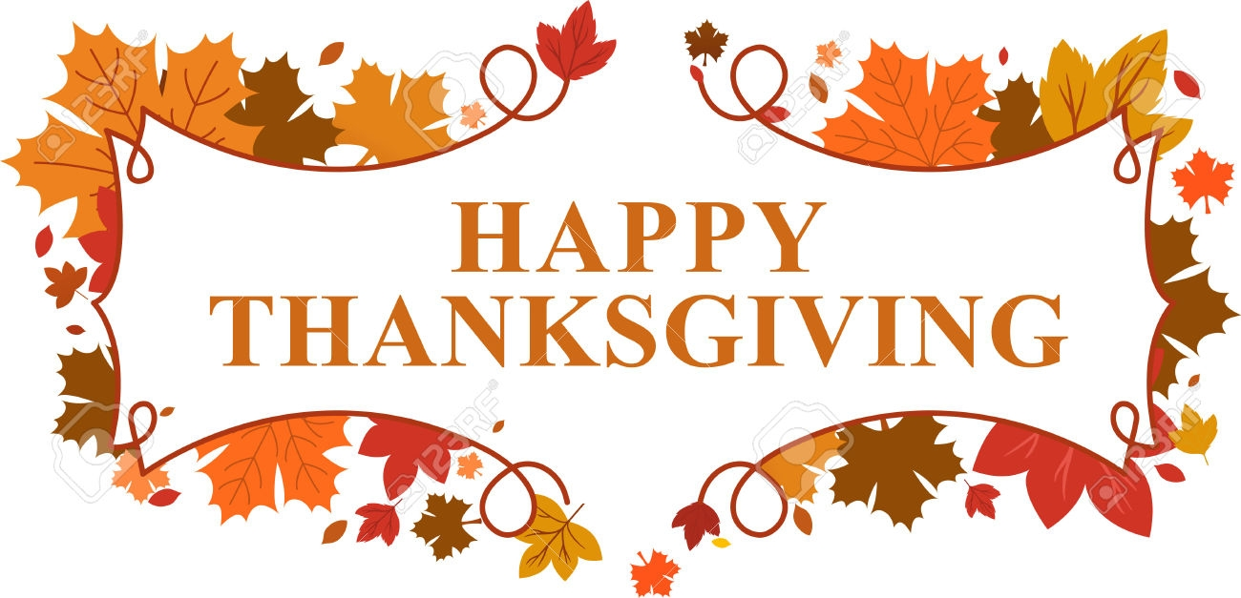 | November 26  No School | Elementary Lunch-  Free  Milk - .50 – without buying a school lunch
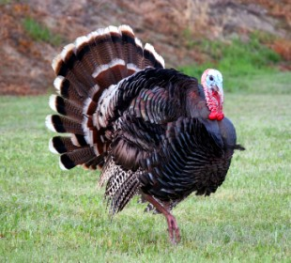 | November 29  No School | November 30  Lasagna  Roll  Or  Grilled Cheese Sandwich  Carrots  Fruit  Milk | December 1  Soft Shell Taco  Or  Chicken Cheese Steak  Refried Beans  Fruit  Milk | December 2  Chicken Alfredo  Roll  Or  Calzone  Broccoli  Fruit  Milk | December 3  Chicken Patty  Or  Turkey & Cheese  Hoagie  Grape Tomatoes  Fruit  Milk | Menu subject to change

