FANNETT-METAL SCHOOL DISTRICT – November 2021 Breakfast Menu

Fannett-Metal School District is an equal opportunity provider
SUNDAY | MONDAY | TUESDAY | WEDNESDAY | THURSDAY | FRIDAY | SATURDAY
 | November 1  French Toast  Sticks  Fruit  Milk | November 2  Funnell Cake  Juice  Milk | November 3  Egg, Cheese &  Sausage  Sandwich  Fruit  Milk | November 4  Breakfast  Pizza  Juice  Milk | November 5  Cereal  Muffin  Juice  Milk | 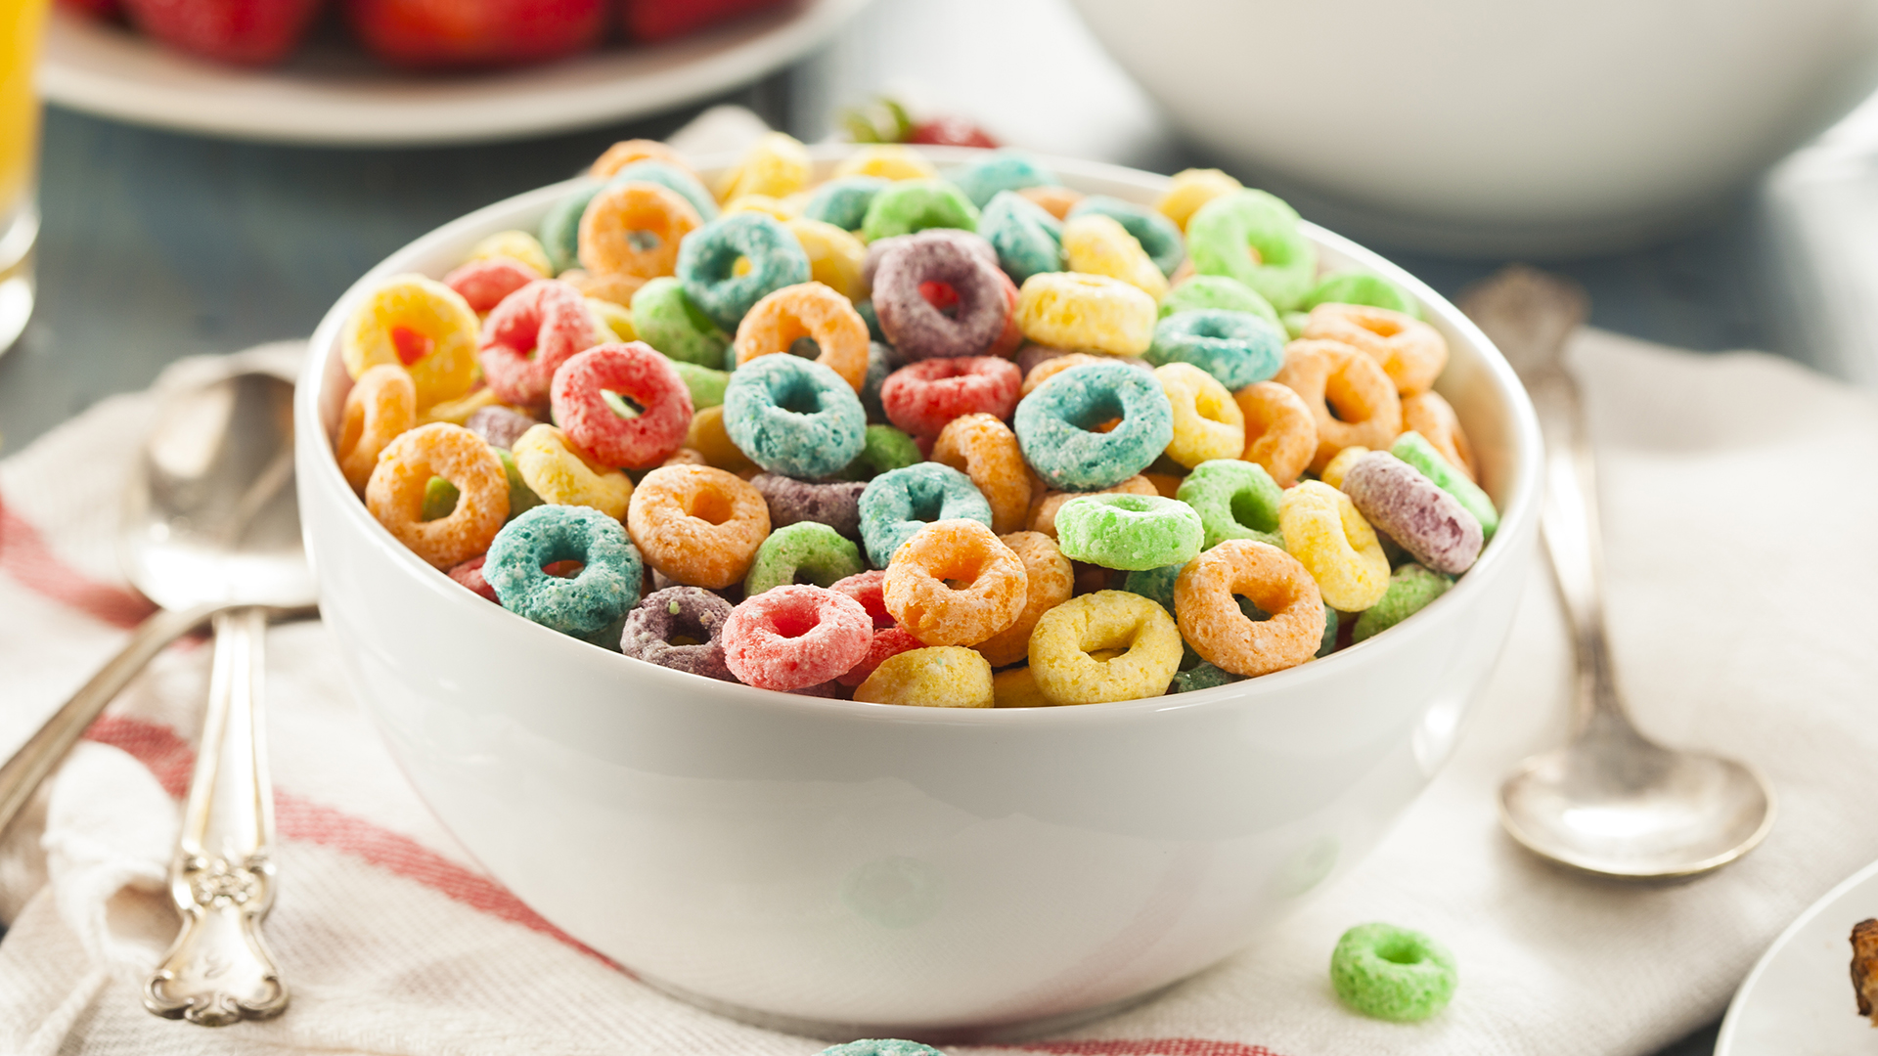
 | November 8  French Toast  Sticks  Fruit  Milk | November 9  Funnel Cake  Juice  Milk | November 10  Egg, Cheese &  Sausage  Sandwich  Fruit  Milk | November 11  No School | November 12  Cereal  Muffin  Juice  Milk
All Meals are  served with 1% milk, fat free chocolate, fat free vanilla, fat free strawberry and skim | November 15  French Toast  Sticks  Fruit  Milk | November 16  Funnel Cake  Juice  Milk | November 17  Egg, Cheese &  Sausage  Sandwich  Fruit  Milk | November 18  Breakfast  Pizza  Juice  Milk | November 19  Cereal  Muffin  Juice  Milk
 | November 22  French Toast  Sticks  Fruit  Milk | November 23  Funnel Cake  Juice  Milk | November 24  Egg, Cheese &  Sausage  Sandwich  Fruit  Milk | November 25  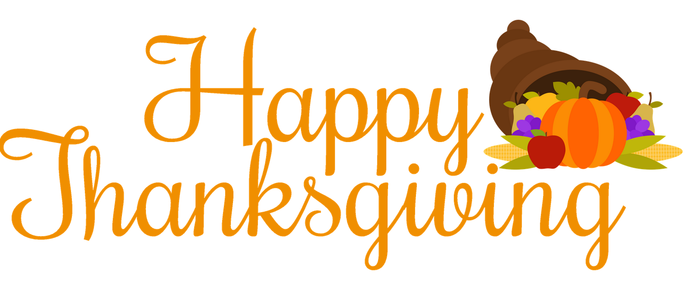 | November 26  No School | Elementary & MS/HS  Free  Milk -$.50 – without buying breakfast meal
 | November 29  No School | November 30  Funnel Cake  Juice  Milk | December 1  Egg, Cheese &  Sausage  Sandwich  Fruit  Milk | December 2  Breakfast  Pizza  Juice  Milk | December 3  Cereal  Muffin  Juice  Milk | 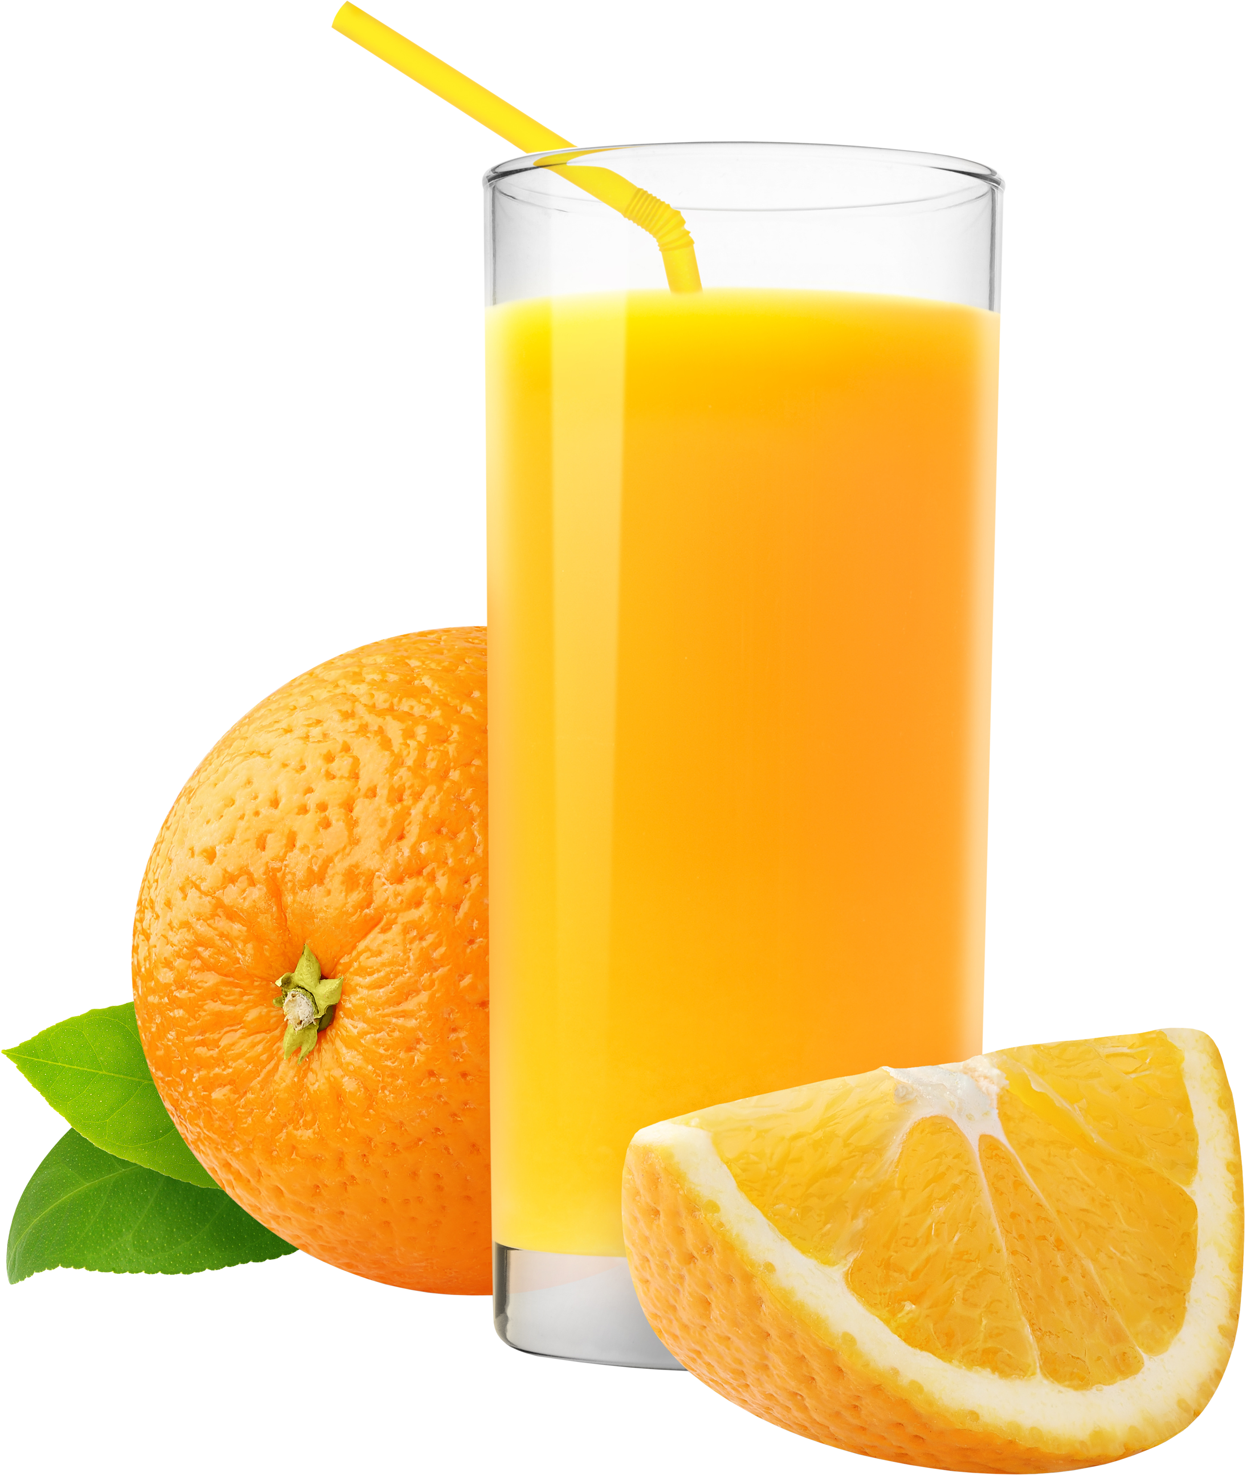
To manage accounts: www.myschoolaccount.com No breakfast on 2 hour delays *Menu Subject to Change

