Fannett-Metal School District – Middle – High School November 2021
USDA Nondiscrimination Statement and Complaint Procedure
The U.S Department of Agriculture prohibits discrimination against its customers, employees, and applicants for employment on the bases of race, color, national origin, age, disability, sex, gender identity, religion, reprisal, and where applicable, political beliefs, marital status, familial or parental status, sexual orientation, or if all or part of an individual's income is derived from any public assistance program, or protected genetic information in employment or in any program or activity conducted or funded by the Department. (Not all prohibited bases will apply to all programs and/or employment activities.)
If you wish to file a Civil Rights program complaint of discrimination, complete the USDA Program Discrimination Complaint Form, found online at http://www.ascr.usda.gov/complaint_filing_cust.html, or at any USDA office, or call (866) 632-9992 to request the form. You may also write a letter containing all of the information requested in the form. Send your completed complaint form or letter to us by mail at U.S. Department of Agriculture, Director, Office of Adjudication, 1400 Independence Avenue, S.W., Washington, D.C. 20250-9410, by fax (202) 690-7442 or email at program.intake@usda.gov .
Individuals who are deaf, hard of hearing or have speech disabilities may contact USDA through the Federal Relay Service at (800) 877-8339; or (800) 845-6136 (Spanish
Fannett-Metal is an equal opportunity provider

SUNDAY | MONDAY | TUESDAY | WEDNESDAY | THURSDAY | FRIDAY | SATURDAY
November | November 1  Chicken Tenders  W/ Roll  Or  Pulled Pork Sandwich  Corn  Fruit / Milk | November 2  Mashed Potato Bowl  Roll  Or  Ham & Cheese  Hoagie  Peas  Fruit / Milk | November 3  Cheeseburger  Or  Hot Dog  Baked Beans  Fruit  Milk | November 4  General Tso Chicken  Roll  Or  Grilled Ham Cheese Sandwich  Broccoli  Fruit / Milk | November 5  Spicy Chicken Patty  Or  Stuffed Shells Roll  Tossed Salad  Fruit  Milk | Offer verses serve -  Students must take  3 of 5 items to count as a lunch & one must be a fruit or vegetable.
 | November 8  Hamburger Steak  Brown Gravy / Roll  Or  Chicken Patty  Mashed Potatoes  Fruit / Milk | November 9  Walking Taco  Or  Calzone  Refried Beans  Fruit  Milk | November 10  Cheeseburger Mac  Roll  Or  Cheese Steak  Broccoli  Fruit / Milk | November 11 | November 12  Cheese Pizza  Or  Turkey & Cheese  Flatbread  Corn  Fruit / Milk
All Meals are  served with 1% milk, fat free chocolate, fat free vanilla, fat free strawberry and skim | November 15  Pepperoni Grilled Cheese  Or  Lasagna Roll  Peas  Fruit / Milk | November 16  Roast Turkey  Gravy / Roll  Or  Grilled Ham & Cheese  Mashed Potatoes  Fruit / Milk | November 17  Shrimp Poppers Roll  OR  Chicken Fajita  Cheesy Broccoli  Fruit  Milk | November 18  Baked Spaghetti  Roll  Or  Chicken Cheese Steak  Baby Carrots  Fruit / Milk | November 19  Pepperoni Pizza  Or  Buffalo Chicken Wrap  Grape Tomatoes  Fruit  Milk
No breakfast on two hour delays | November 22  Tomato Soup  Grilled Cheese  Or  Grilled Chicken Salad  Corn  Fruit / Milk | November 23  Walking Taco  Or  Turkey Club Wrap  Refried Beans  Fruit  Milk | November 24  Spicy Chicken Patty  Or  Nacho Grande  Grape Tomatoes  Fruit  Milk | November 25  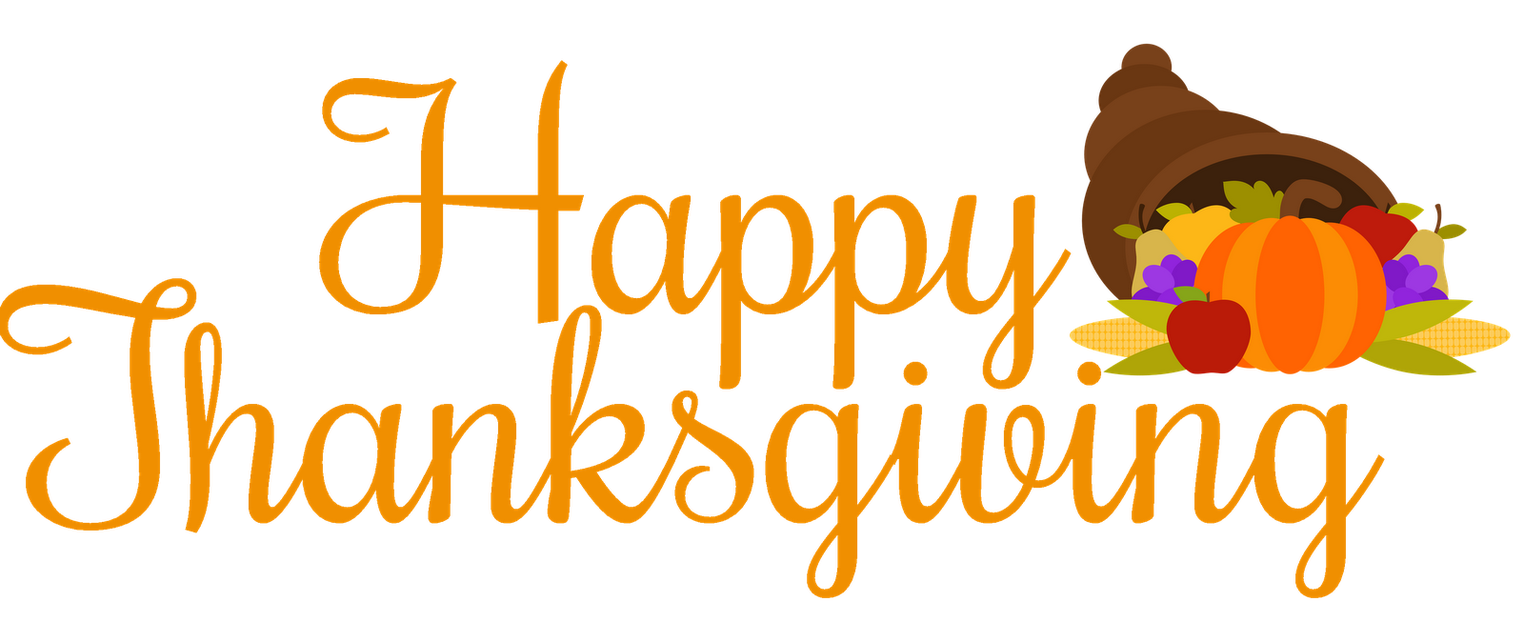 | November 26  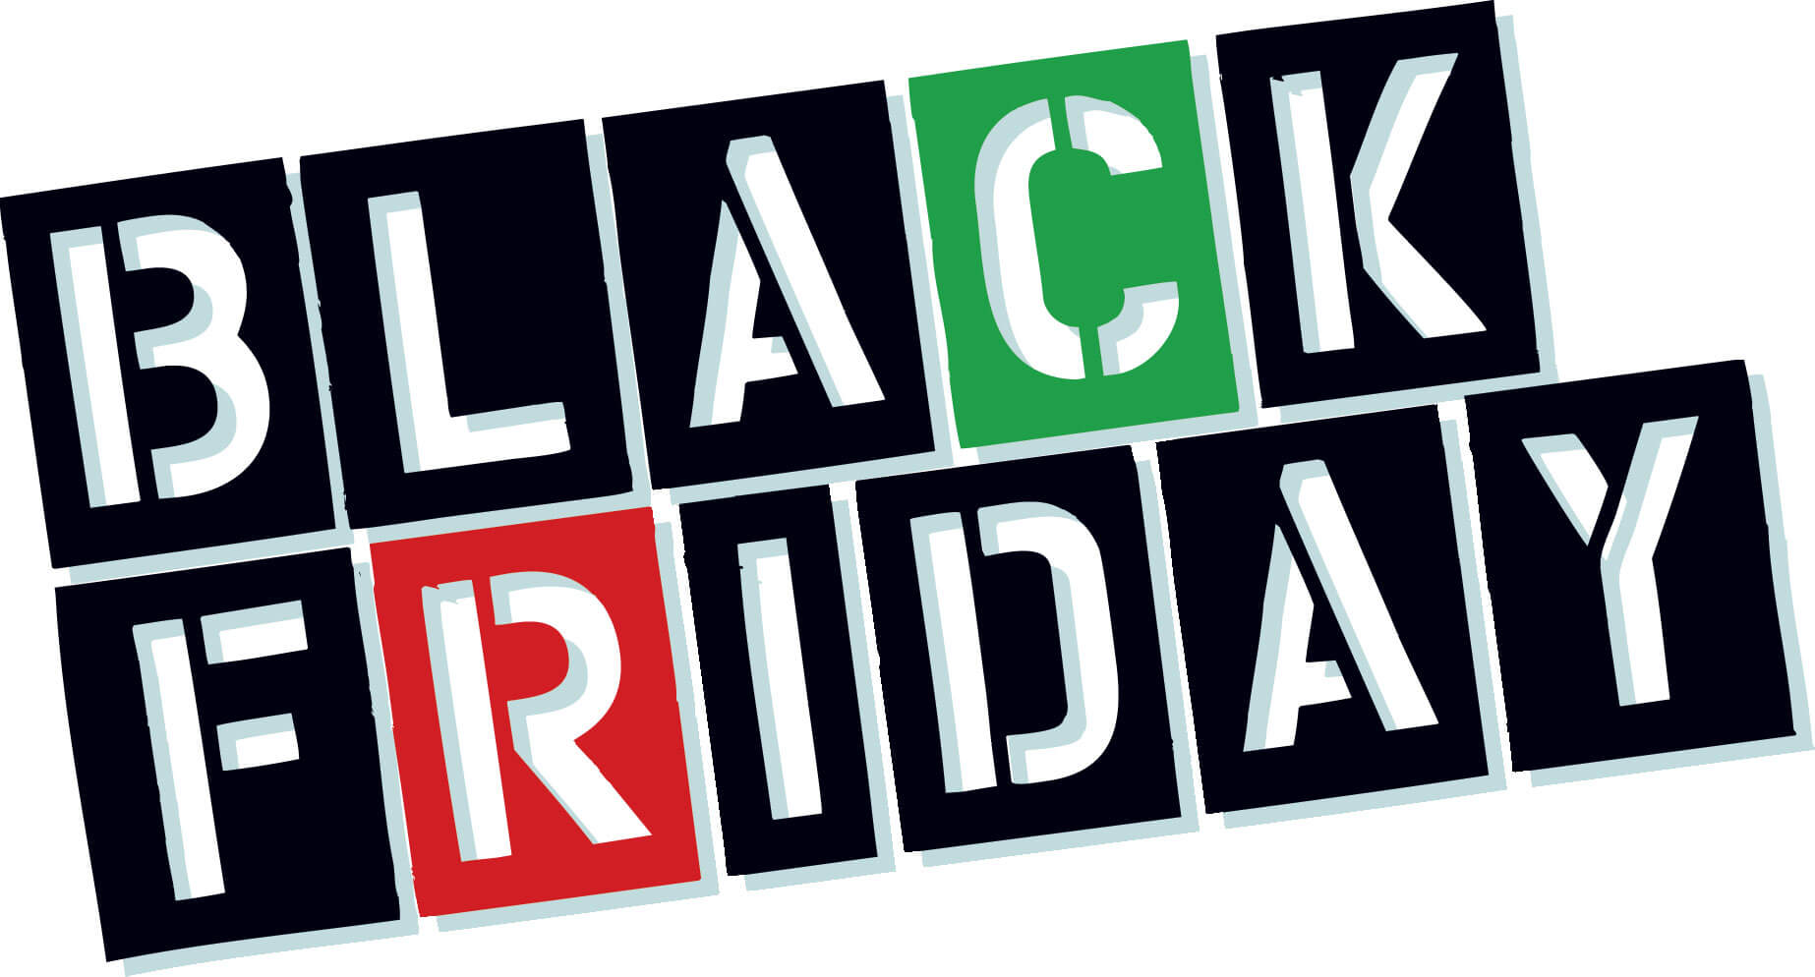 | High School Lunch-  Free  Milk - .50 – without buying a school lunch
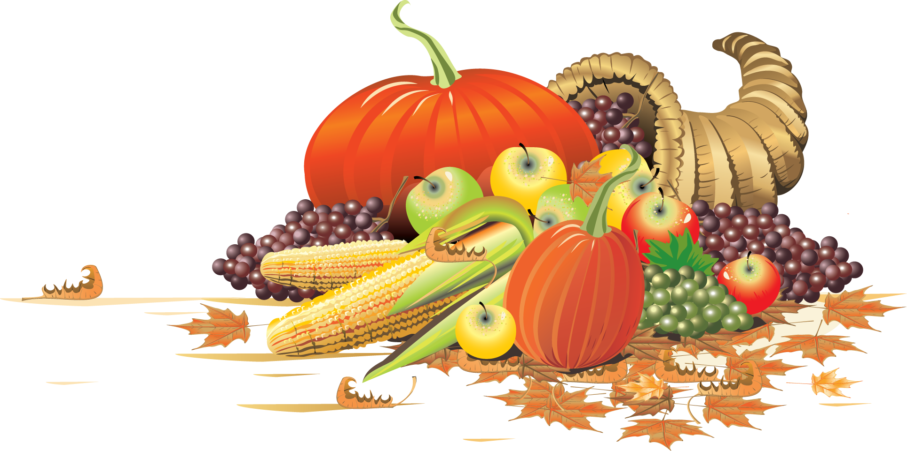 | November 29  No School | November 30  Cheeseburger Sliders  Or  Hot Dog  Baked Beans  Fruit  Milk | December 1  Pulled Pork Fries  Or  Ham & Cheese  Hoagie  Peas  Fruit / Milk | December 2  Chicken Alfredo  Roll  Or  Calzone  Carrots  Fruit / Milk | December 3  Chef Salad  Roll  Or  Soft Shell Taco  Green Beans  Fruit  Milk | Menu subject to change

