FANNETT-METAL SCHOOL DISTRICT – October 2021 Breakfast Menu

Fannett-Metal School District is an equal opportunity provider
SUNDAY | MONDAY | TUESDAY | WEDNESDAY | THURSDAY | FRIDAY | SATURDAY
October |  |  |  |  | October 1  Cereal  Muffin  Juice  Milk | 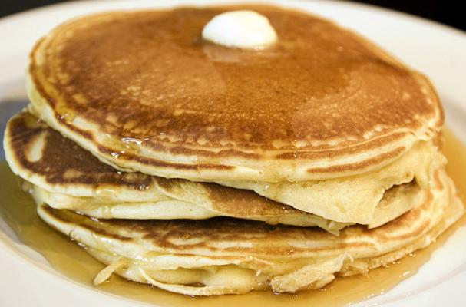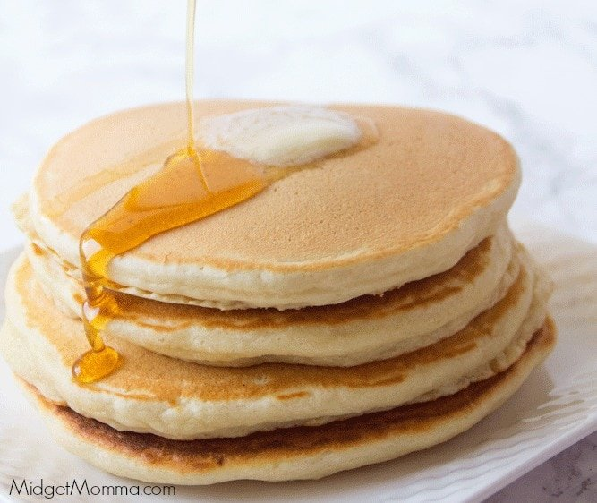
 | October 4  French Toast  Sticks  Fruit  Milk | October 5  Cereal  Muffin  Juice  Milk | October 6  Pancakes  Sausage  Fruit  Milk | October 7  Breakfast  Pizza  Juice  Milk | October 8  Cereal  Muffin  Juice  Milk
All Meals are  served with 1% milk, fat free chocolate, fat free vanilla, fat free strawberry and skim | October 11  No School | October 12  Cereal  Muffin  Juice  Milk | October 13  Pancakes  Sausage  Fruit  Milk | October 14  Breakfast  Pizza  Juice  Milk | October 15  Cereal  Muffin  Juice  Milk
 | October 18  French Toast  Sticks  Fruit  Milk | October 19  Cereal  Muffin  Juice  Milk | October 20  Pancakes  Sausage  Fruit  Milk | October 21  Breakfast  Pizza  Juice  Milk | October 22  Cereal  Muffin  Fruit  Milk | Elementary & MS/HS  Free  Milk -$.50 – without buying breakfast meal
 | October 25  French Toast  Sticks  Fruit  Milk | October 26  Cereal  Muffin  Juice  Milk | October 27  Pancakes  Sausage  Fruit  Milk | October 28  Breakfast  Pizza  Juice  Milk | October 29  No School | 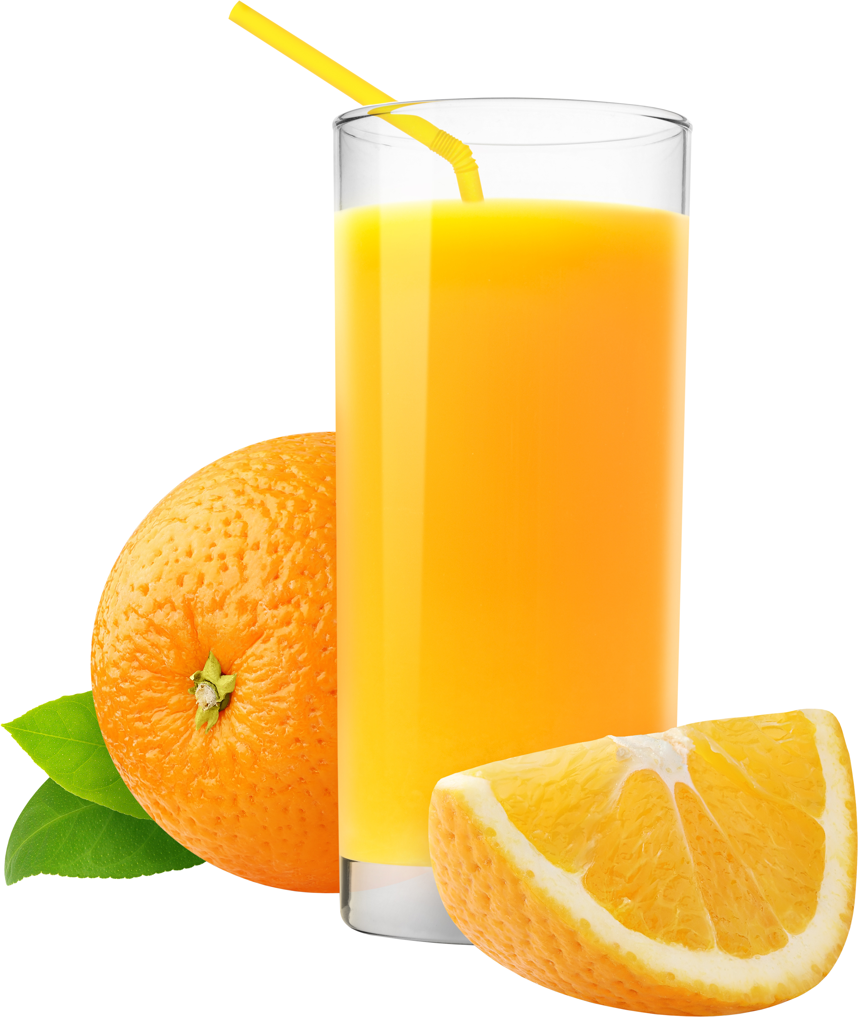
To manage accounts: www.myschoolaccount.com No breakfast on 2 hour delays *Menu Subject to Change

