Fannett-Metal School District – Middle – High School May 2021
USDA Nondiscrimination Statement and Complaint Procedure
The U.S Department of Agriculture prohibits discrimination against its customers, employees, and applicants for employment on the bases of race, color, national origin, age, disability, sex, gender identity, religion, reprisal, and where applicable, political beliefs, marital status, familial or parental status, sexual orientation, or if all or part of an individual's income is derived from any public assistance program, or protected genetic information in employment or in any program or activity conducted or funded by the Department. (Not all prohibited bases will apply to all programs and/or employment activities.)
If you wish to file a Civil Rights program complaint of discrimination, complete the USDA Program Discrimination Complaint Form, found online at http://www.ascr.usda.gov/complaint_filing_cust.html, or at any USDA office, or call (866) 632-9992 to request the form. You may also write a letter containing all of the information requested in the form. Send your completed complaint form or letter to us by mail at U.S. Department of Agriculture, Director, Office of Adjudication, 1400 Independence Avenue, S.W., Washington, D.C. 20250-9410, by fax (202) 690-7442 or email at program.intake@usda.gov .
Individuals who are deaf, hard of hearing or have speech disabilities may contact USDA through the Federal Relay Service at (800) 877-8339; or (800) 845-6136 (Spanish
Fannett-Metal is an equal opportunity provider

SUNDAY | MONDAY | TUESDAY | WEDNESDAY | THURSDAY | FRIDAY | SATURDAY
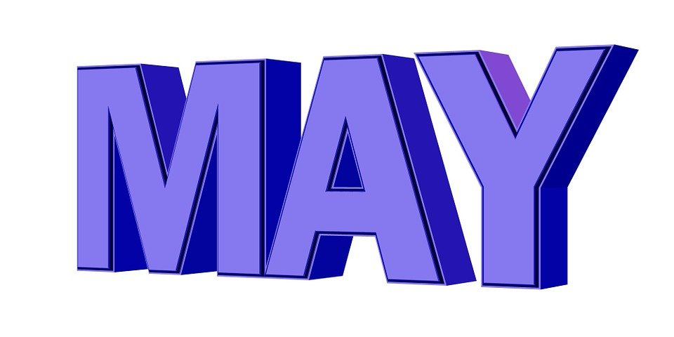 | May 3  Choice 1  Cheeseburger  Choice 2  Spicy Chicken Patty  Baby Carrots  Fruit / Milk | May 4  Choice 1  Chicken Patty  Choice 2  Cheese Steak  Peas  Fruit / Milk | May 5  Choice 1  Grilled Cheese  Sandwich  Choice 2  Calzone  Steamed Carrots  Fruit / Milk | May 6  Choice 1  Pancakes & Sausage  Choice 2  Turkey Club Wrap  Broccoli  Fruit / Milk | May 7  Choice 1  Chicken Tenders / Roll  Choice 2  Buffalo Chicken Wrap  Broccoli  Fruit  Milk | Offer verses serve -  Students must take  3 of 5 items to count as a lunch & one must be a fruit or vegetable.
 | May 10  Choice 1  Popcorn Chicken  Roll  Choice 2  Pulled Pork  Baby Carrots  Fruit / Milk | May 11  Choice 1  Turkey & cheese  Sandwich  Choice 2  Cheeseburger  Broccoli  Fruit / Milk | May 12  Choice 1  Chicken Patty  Choice 2  Grilled Cheese  Corn  Fruit  Milk | May 13  Choice 1  Walking Taco  Roll  Choice 2  Fish Nuggets / Roll  Steamed Carrots  Fruit / Milk | May 14  Choice 1  Pizza  Choice 2  Meatball Sub  Peas  Fruit / Milk | All Meals are  served with 1% milk, fat free chocolate
 | May 17  Choice 1  Chicken Tenders  Roll  Choice 2  Cheese Steak  Vegetable  Fruit / Milk | May 18  Choice 1  Cheeseburger Sub  Choice 2  Grilled Ham & Cheese  Vegetable  Fruit / Milk | May 19  Choice 1  Lasagna / Roll  Choice 2  Turkey & Cheese  Flatbread  Vegetable  Fruit / Milk | May 20  Choice 1  Chicken Patty  Choice 2  Calzone  Vegetable  Fruit / Milk | May 21  Choice 1  Fish Sandwich  Choice 2  Crispy Chicken Wrap  Vegetable  Fruit / Milk
3rd Choice Everyday  Peanut Butter  And Jelly  Sandwich | May 24  Choice 1  BBQ Rib Sandwich  Roll  Choice 2  Grilled Cheese  Vegetable  Fruit / Milk | May 25  Choice 1  Chicken Variety / Roll  Or  Cheeseburger  Vegetable  Fruit  Milk | May 26  Choice 1  Spicy Chicken Patty  Choice 2  Hot Dog  Vegetable  Fruit  Milk | May 27  Last day  Of  School | May 28 | High School Lunch-  FREE  Milk - .50
Menu subject to change | May 31

