Fannett-Metal School District - Elementary School May 2021

Breakfast Menu

Fannett-Metal is an equal opportunity provider

SUNDAY | MONDAY | TUESDAY | WEDNESDAY | THURSDAY | FRIDAY | SATURDAY
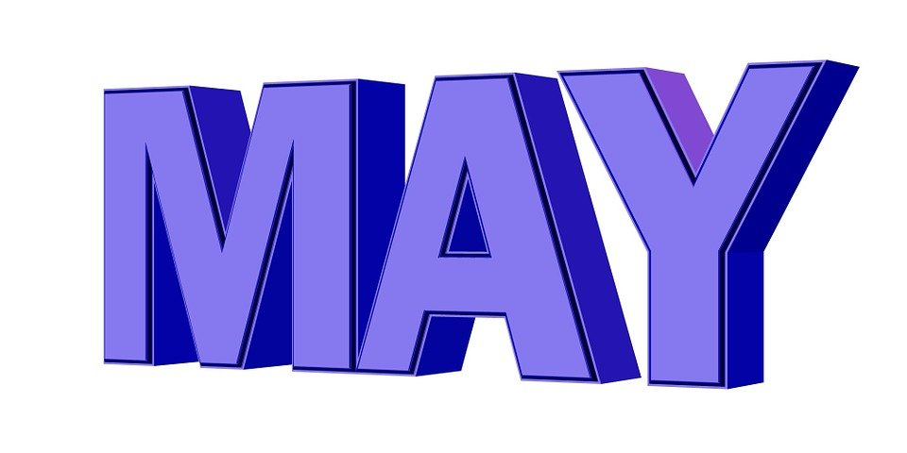 | May 3  Cereal  Muffin  Fruit  Milk | May 4  Pancake  on a Stick  Juice  Milk | May 5  French Toast  Sticks  Fruit  Milk | May 6  Breakfast Pizza  Fruit  Milk | May 7  Mini Pancakes  Juice  Milk | Elementary  Breakfast - FREE  Milk -$.50
 | May 10  Cereal  Muffin  Fruit  Milk | May 11  Pancake  on a Stick  Juice  Milk | May 12  French Toast  Sticks  Fruit  Milk | May 13  Breakfast Pizza  Fruit  Milk | May 14  Mini Pancakes  Juice  Milk | 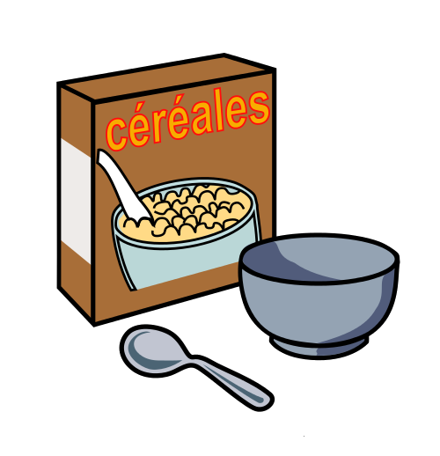
 | May 17  Cereal  Muffin  Fruit  Milk | May 18  Pancake  on a Stick  Juice  Milk | May 19  French Toast  Sticks  Fruit  Milk | May 20  Breakfast Pizza  Fruit  Milk | May 21  Mini Pancakes  Juice  Milk | Pre-K alternative meal –  Tuesdays -  Mini Pancakes  Fridays –  Cereal
 | May 24  Cereal  Muffin  Fruit  Milk | May 25  Cereal  Muffin  Juice  Milk | May 26  Breakfast  Variety  Juice  Milk | May 27 | May 28  Pre-K  Mini Pancakes  Fruit  Milk
 | May 31 | June 1  Pre-K  Cereal  Fruit  Milk | June 2  Pre-K  Virtual School | June 3  Pre-K  Mini Pancakes  Fruit  Milk | June 4  Pre-K  Cereal  Fruit  Milk | All Meals are  served with 1% milk, fat free chocolate, fat free vanilla, fat free strawberry
To manage accounts: www.myschoolaccount.com No breakfast on 2 hour delays *Menu Subject to Change

