Fannett-Metal School District – Middle – High School April 2021
USDA Nondiscrimination Statement and Complaint Procedure
The U.S Department of Agriculture prohibits discrimination against its customers, employees, and applicants for employment on the bases of race, color, national origin, age, disability, sex, gender identity, religion, reprisal, and where applicable, political beliefs, marital status, familial or parental status, sexual orientation, or if all or part of an individual's income is derived from any public assistance program, or protected genetic information in employment or in any program or activity conducted or funded by the Department. (Not all prohibited bases will apply to all programs and/or employment activities.)
If you wish to file a Civil Rights program complaint of discrimination, complete the USDA Program Discrimination Complaint Form, found online at http://www.ascr.usda.gov/complaint_filing_cust.html, or at any USDA office, or call (866) 632-9992 to request the form. You may also write a letter containing all of the information requested in the form. Send your completed complaint form or letter to us by mail at U.S. Department of Agriculture, Director, Office of Adjudication, 1400 Independence Avenue, S.W., Washington, D.C. 20250-9410, by fax (202) 690-7442 or email at program.intake@usda.gov .
Individuals who are deaf, hard of hearing or have speech disabilities may contact USDA through the Federal Relay Service at (800) 877-8339; or (800) 845-6136 (Spanish
Fannett-Metal is an equal opportunity provider

SUNDAY | MONDAY | TUESDAY | WEDNESDAY | THURSDAY | FRIDAY | SATURDAY
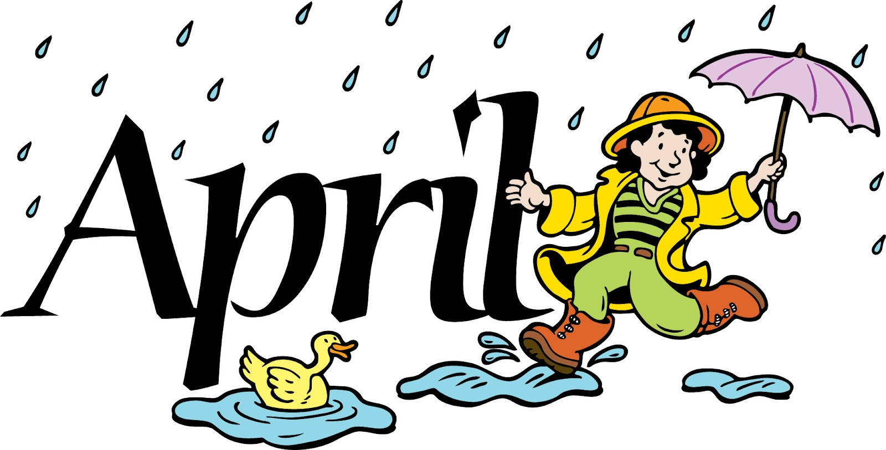 |  |  |  | April 1  Choice 1  Pancakes & Sausage  Choice 2  Turkey Club Wrap  Broccoli  Fruit / Milk | April 2  No School | Offer verses serve -  Students must take  3 of 5 items to count as a lunch & one must be a fruit or vegetable.
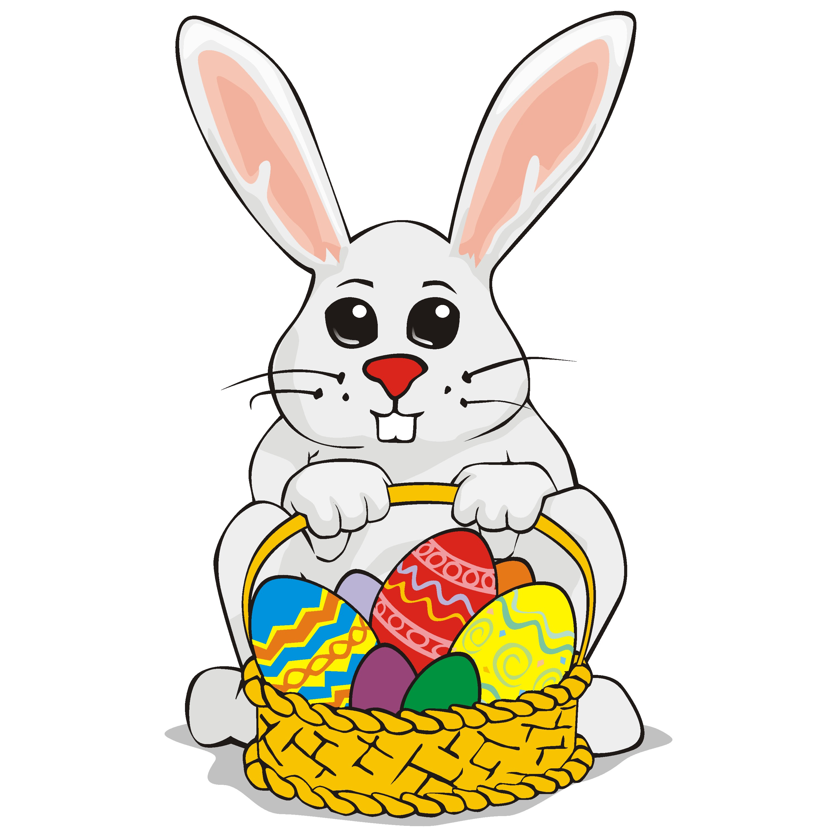 | April 5  No School | April 6  Choice 1  Popcorn Chicken  Roll  Choice 2  Grilled Cheese  Cheesy Broccoli  Fruit / Milk | April 7  Choice 1  Chicken Patty  Choice 2  Cheeseburger  Green Beans  Fruit / Milk | April 8  Choice 1  Spaghetti & Meatballs  Roll  Choice 2  Fish Nuggets / Roll  Steamed Carrots  Fruit / Milk | April 9  Choice 1  Cheese Pizza  Choice 2  Meatball Sub  Peas  Fruit / Milk | All Meals are  served with 1% milk, fat free chocolate
 | April 12  Choice 1  Chicken Tenders  Roll  Choice 2  Cheese Steak  Cheesy Broccoli  Fruit / Milk | April 13  Choice 1  Mac & Cheese  Bread Stick  Choice 2  Cheeseburger  Peas & Carrots  Fruit / Milk | April 14  Choice 1  Shrimp Poppers  Choice 2  Turkey & Cheese  Flatbread  Baked Beans  Fruit / Milk | April 15  Choice 1  Chicken Patty  Choice 2  BBQ Rib Sandwich  Peas  Fruit / Milk | April 16  Choice 1  Pepperoni Pizza  Choice 2  Buffalo Chicken Wrap  Steamed Carrots  Fruit / Milk
3rd Choice Everyday  Peanut Butter  And Jelly  Sandwich | April 19  Choice 1  Popcorn Chicken  Roll  Choice 2  Grilled Cheese  Broccoli  Fruit / Milk | April 20  Choice 1  Waffles &  Sausage  Or  Cheeseburger  Peas  Fruit / Milk | April 21  Choice 1  Spicy Chicken Patty  Choice 2  Calzone  Steamed Carrots  Fruit / Milk | April 22  Choice 1  Walking Taco  Choice 2  Grilled Ham & Cheese  Pretzel Roll  Refried Beans  Fruit / Milk | April 23  Choice 1  Pepperoni Pizza  Choice 2  Fish Sandwich  Carrots & Peas  Fruit / Milk | High School Lunch-  FREE  Milk - .50
Menu subject to change | April 26  Choice 1  Cheeseburger  Choice 2  Spicy Chicken Patty  Green Beans  Fruit / Milk | April 27  Choice 1  Pulled Pork Sandwich  Choice 2  Turkey Club Wrap  Baked Beans  Fruit / Milk | April 28  Choice 1  Chicken Patty  Choice 2  Cheese Steak  Peas  Fruit / Milk | April 29  Choice 1  Pizza  Choice 2  Meatball Sub  Peas & Carrots  Fruit / Milk | April 30  Choice 1  Chicken Tenders / Roll  Choice 2  Turkey & Cheese  Hoagie  Broccoli  Fruit / Milk

