Fannett-Metal School District – Middle – High School April 2021
USDA Nondiscrimination Statement and Complaint Procedure
The U.S Department of Agriculture prohibits discrimination against its customers, employees, and applicants for employment on the bases of race, color, national origin, age, disability, sex, gender identity, religion, reprisal, and where applicable, political beliefs, marital status, familial or parental status, sexual orientation, or if all or part of an individual's income is derived from any public assistance program, or protected genetic information in employment or in any program or activity conducted or funded by the Department. (Not all prohibited bases will apply to all programs and/or employment activities.)
If you wish to file a Civil Rights program complaint of discrimination, complete the USDA Program Discrimination Complaint Form, found online at http://www.ascr.usda.gov/complaint_filing_cust.html, or at any USDA office, or call (866) 632-9992 to request the form. You may also write a letter containing all of the information requested in the form. Send your completed complaint form or letter to us by mail at U.S. Department of Agriculture, Director, Office of Adjudication, 1400 Independence Avenue, S.W., Washington, D.C. 20250-9410, by fax (202) 690-7442 or email at program.intake@usda.gov .
Individuals who are deaf, hard of hearing or have speech disabilities may contact USDA through the Federal Relay Service at (800) 877-8339; or (800) 845-6136 (Spanish
Fannett-Metal is an equal opportunity provider

SUNDAY | MONDAY | TUESDAY | WEDNESDAY | THURSDAY | FRIDAY | SATURDAY
 |  |  |  | April 1  Breakfast Pizza  Juice  Milk | April 2  No School | Offer verses serve -  Students must take  3 of 5 items to count as a lunch & one must be a fruit or vegetable.
 | April 5  No School | April 6  Sausage  Egg & Cheese  Sandwich  Juice  Milk | April 7  Cereal  Muffin  Juice  Milk | April 8  Breakfast Pizza  Juice  Milk | April 9  Cereal  Muffin  Juice  Milk | Menu subject to change
 | April 12  French Toast  Sticks  Juice  Milk | April 13  Sausage  Egg & Cheese  Sandwich  Juice  Milk | April 14  Cereal  Muffin  Juice  Milk | April 15  Breakfast Pizza  Juice  Milk | April 16  Cereal  Muffin  Juice  Milk | 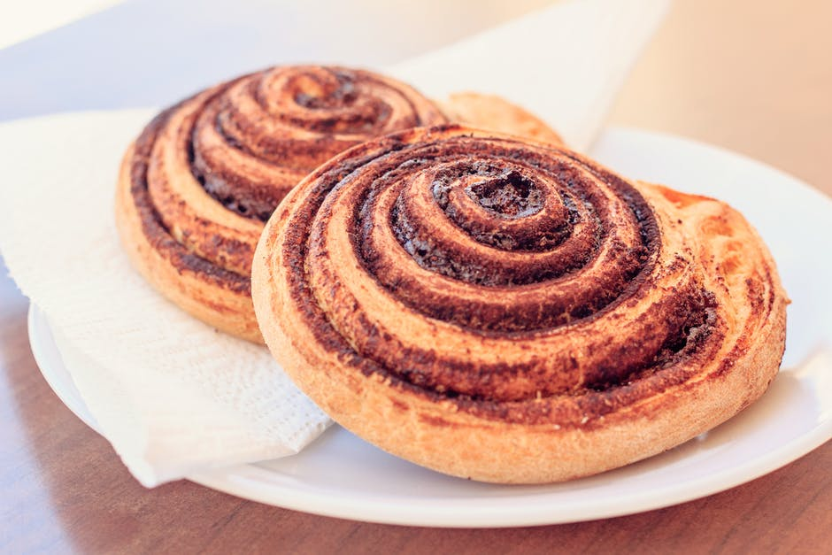
 | April 19  French Toast  Sticks  Juice  Milk | April 20  Sausage  Egg & Cheese  Sandwich  Juice  Milk | April 21  Cereal  Muffin  Juice  Milk | April 22  Breakfast Pizza  Juice  Milk | April 23  Cereal  Muffin  Juice  Milk | High School Breakfast  FREE  Milk - .50
No breakfast on two hour delays | April 26  French Toast  Sticks  Juice  Milk | April 27  Sausage  Egg & Cheese  Sandwich  Juice  Milk | April 28  Cereal  Muffin  Juice  Milk | April 29  Breakfast Pizza  Juice  Milk | April 30  Cereal  Muffin  Juice  Milk | All Meals are  served with 1% milk, fat free chocolate, fat free vanilla, fat free strawberry and skim

