Fannett-Metal School District - Elementary School April 2021

Lunch Menu

Fannett-Metal is an equal opportunity provider

SUNDAY | MONDAY | TUESDAY | WEDNESDAY | THURSDAY | FRIDAY | SATURDAY
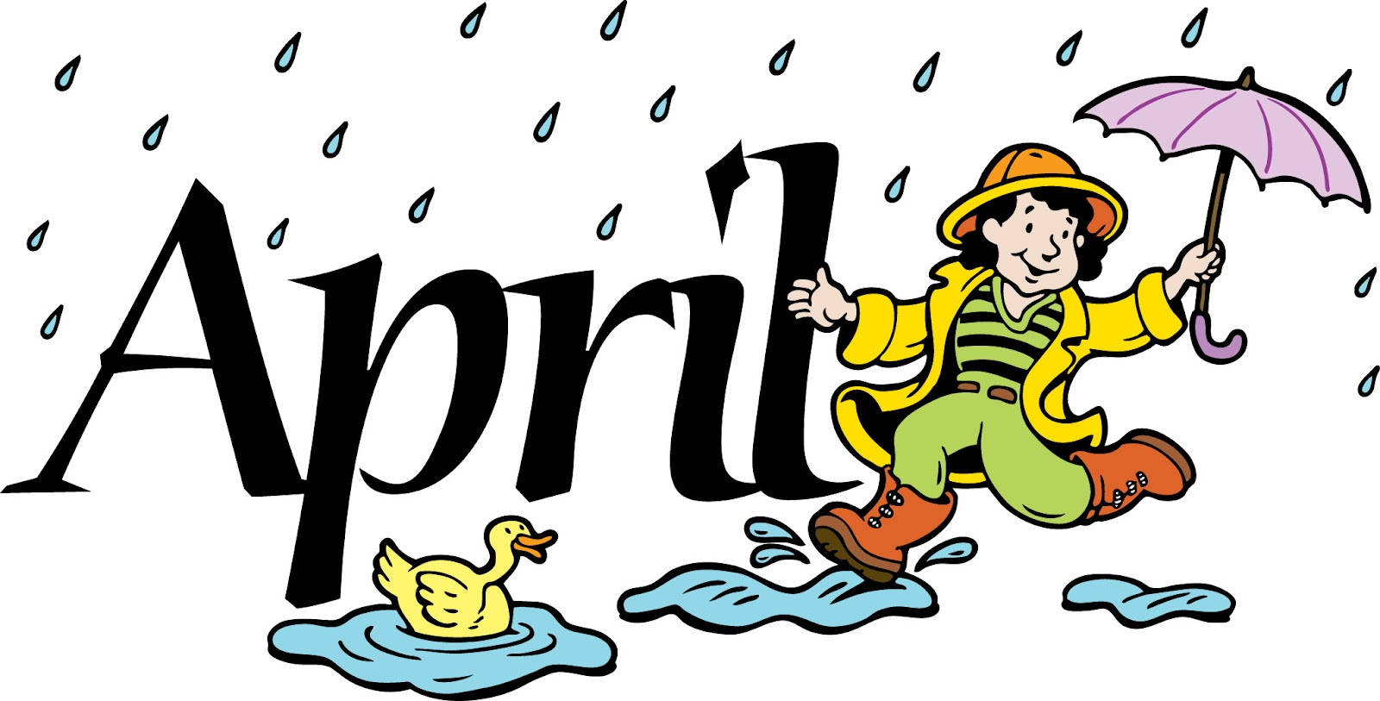 |  |  |  | April 1  Cheese Pizza  Or  Cheese Steak  Broccoli  Fruit  Milk | ^{April 2}  ^{No School} | Offer verses serve -  Students must take  3 of 5 items to count as a lunch & one must be a fruit or vegetable.
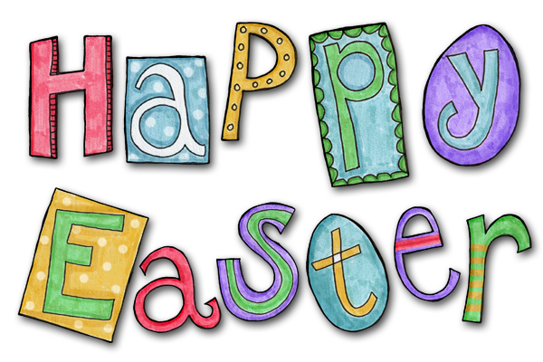 | April 5  No School | April 6  Cheeseburger  Or  Shrimp Poppers  Roll  Baked Beans  Fruit  Milk | April 7  Chicken Patty  Or  Grilled Cheese  Sandwich  Peas  Fruit  Milk | April 8  Chicken Nuggets  Roll  Or  Turkey & Cheese  Flatbread  Corn  Fruit / Milk | April 9  Pizza  Or  Fish Nuggets  Roll  Broccoli  Fruit  Milk | Pre-K Alternative  April 27th – Calzone
 | April 12  Chicken Drum Stick  Roll  Or  Cheese Steak  Steamed Carrots  Fruit  Milk | April 13  Popcorn Chicken  Roll  Or  Calzone  Baked Beans  Fruit  Milk | April 14  Chicken Tenders  Roll  Or  Cheeseburger  Peas  Fruit  Milk | April 15  Roast Turkey W/ Gravy  Roll  Or  Grilled Cheese Sandwich  Mashed Potatoes  Fruit  Milk | April 16  Pepperoni Pizza  Or  Fish Sandwich  Broccoli  Fruit  Milk
All Meals are  served with 1% milk, fat free chocolate, fat free vanilla, fat free strawberry | April 19  Cheeseburger Sub  Or  Fish Nuggets  Roll  Baked Beans  Fruit  Milk | April 20  Soft Taco  Or  Ham & Cheese  Hoagie  Broccoli  Fruit  Milk | April 21  Lasagna  Roll  Or  Grilled Chicken Sandwich  Green Beans  Fruit / Milk | April 22  Chicken Patty  Or  BBQ Rib Sandwich  Peas  Fruit  Milk | April 23  Chicken Nuggets  Roll  Or  Grilled Cheese Sandwich  Steamed Carrots  Fruit  Milk | Elementary  Lunch- FREE  Milk - .50
No breakfast on two hour delays | April 26  Chicken Tenders  Roll  Or  Ham & Cheese Wrap  Steamed Carrots  Fruit  Milk | April 27  Grilled Chicken Sandwich  Or  Hot Dog  Peas  Fruit / Milk | April 28  Popcorn Chicken  Roll  Or  Calzone  Baked Beans  Fruit  Milk | April 29  Chicken Drum Stick  Roll  Or  Cheeseburger  Mashed Potatoes  Fruit  Milk | April 30  Pepperoni Pizza  Or  Soft Taco  Broccoli  Fruit  Milk
Menu Subject to Change

