Fannett-Metal School District - Elementary School April 2021

Breakfast Menu

Fannett-Metal is an equal opportunity provider

SUNDAY | MONDAY | TUESDAY | WEDNESDAY | THURSDAY | FRIDAY | SATURDAY
April |  |  |  | April 1  Breakfast Pizza  Juice  Milk | April 2  No School | Elementary  Breakfast - FREE  Milk -$.50
 | April 5  No School | April 6  Pancake  on a Stick  Juice  Milk | April 7  French Toast  Sticks  Fruit  Milk | April 8  Breakfast Pizza  Juice  Milk | April 9  Mini Pancakes  Juice  Milk | 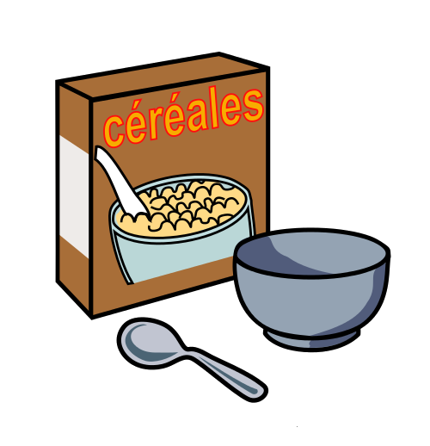
 | April 12  Cereal  Muffin  Fruit  Milk | April 13  Pancake  on a Stick  Juice  Milk | April 14  French Toast  Sticks  Fruit  Milk | April 15  Breakfast Pizza  Juice  Milk | April 16  Mini Pancakes  Juice  Milk | Pre-K alternative meal –  Tuesdays -  Mini Pancakes  Fridays –  Cereal
 | April 19  Cereal  Muffin  Fruit  Milk | April 20  Pancake  On a Stick  Juice  Milk | April 21  French Toast  Sticks  Fruit  Milk | April 22  Breakfast Pizza  Juice  Milk | April 23  Mini Pancakes  Juice  Milk
 | April 26  Cereal  Muffin  Fruit  Milk | April 27  Pancakes  On a Stick  Juice  Milk | April 28  French Toast  Sticks  Fruit  Milk | April 29  Breakfast Pizza  Juice  Milk | April 30  Mini Pancakes  Juice  Milk | All Meals are  served with 1% milk, fat free chocolate, fat free vanilla, fat free strawberry
To manage accounts: www.myschoolaccount.com No breakfast on 2 hour delays *Menu Subject to Change

