This school year has certainly been different than any other year. Between having specials in their regular classroom and working virtually at times, it has been a challenge. But the FM Elementary students have done a WONDERFUL job, creating fantastic artwork through it all!!!
Here are a few samples of things these students accomplished:
Kindergarten: Fishy Hand- Decorating with patterns.
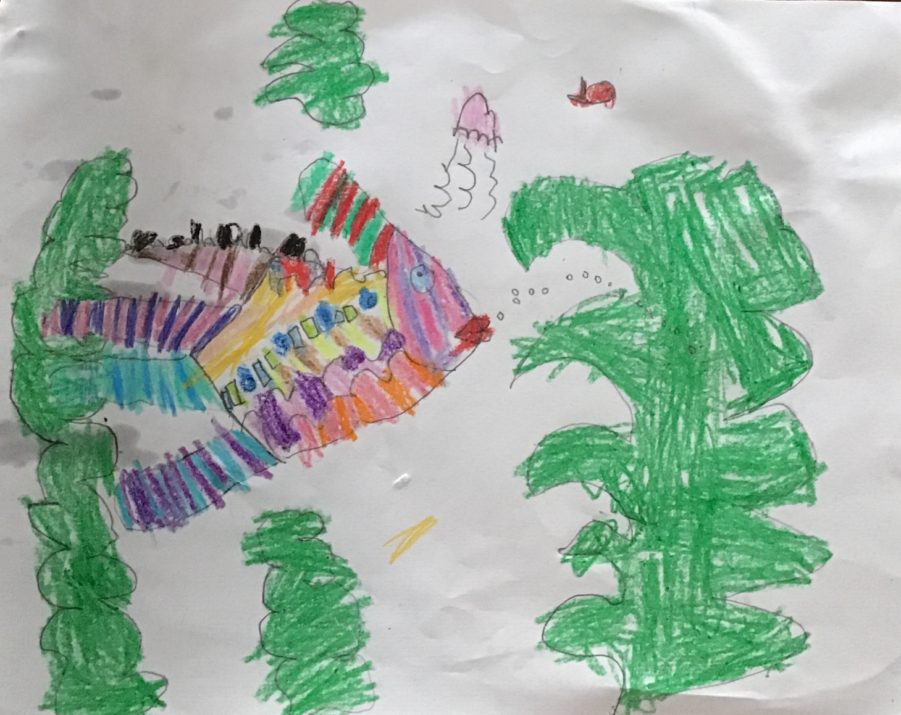

1st Grade: Winter Landscape- Drawing with realism and perspective.
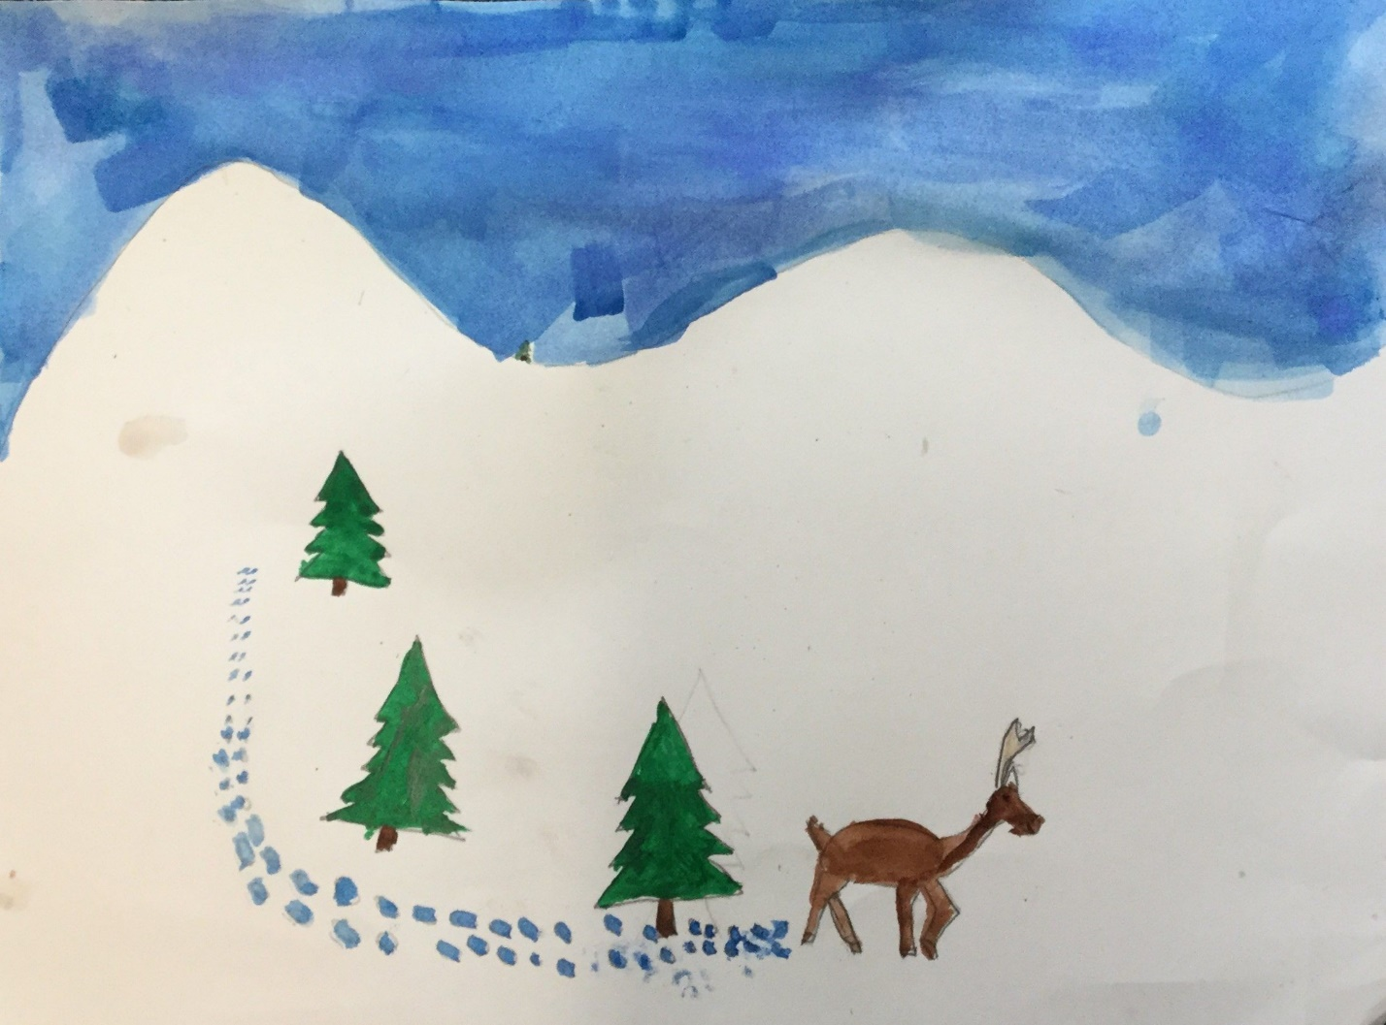

2nd Grade- Deciduous Tree Painting- Drawing with Realism
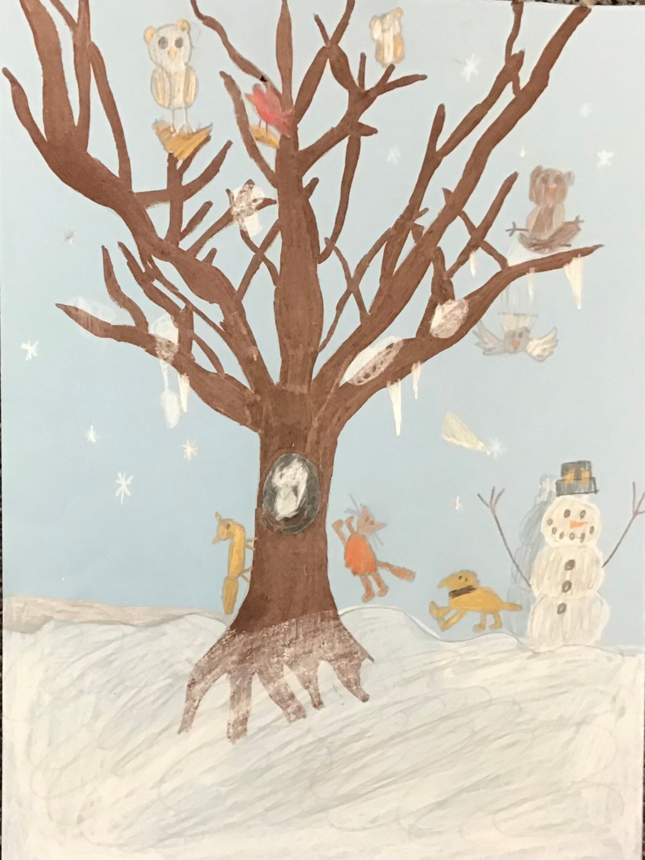

3rd Grade: Winter Cardinal- Realism, Texture and Watercolor Techniques
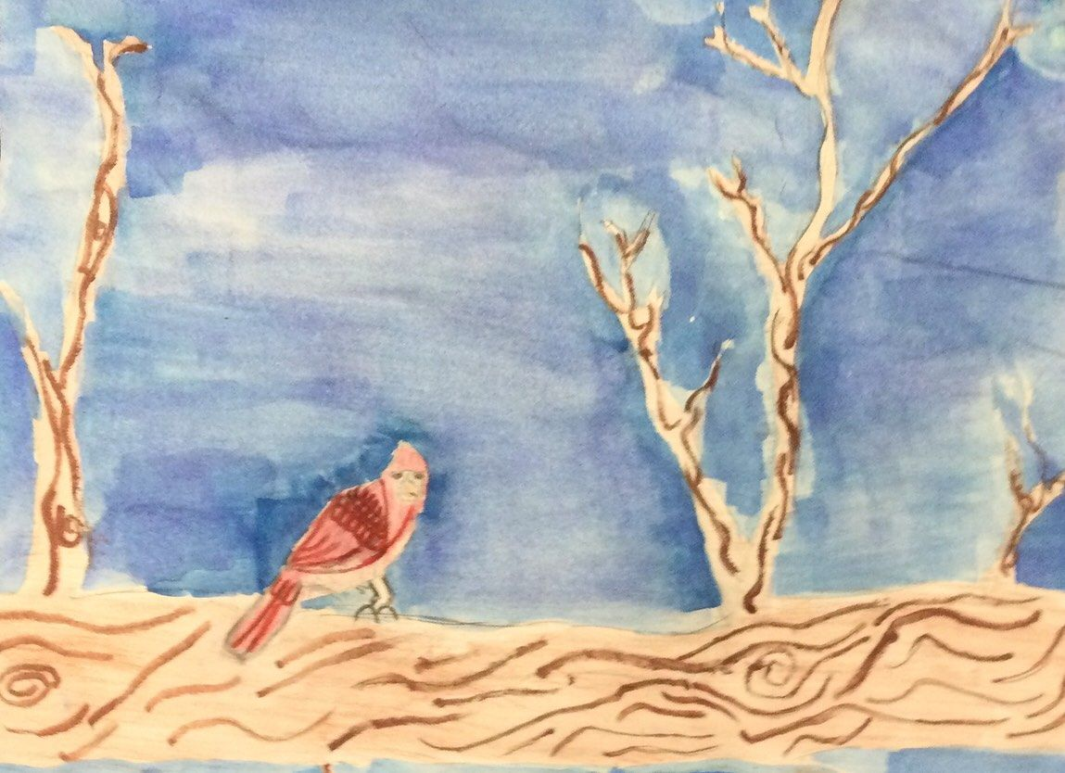

4th Grade: Sgraffito Owl- Multi-Media, Texture and Pattern
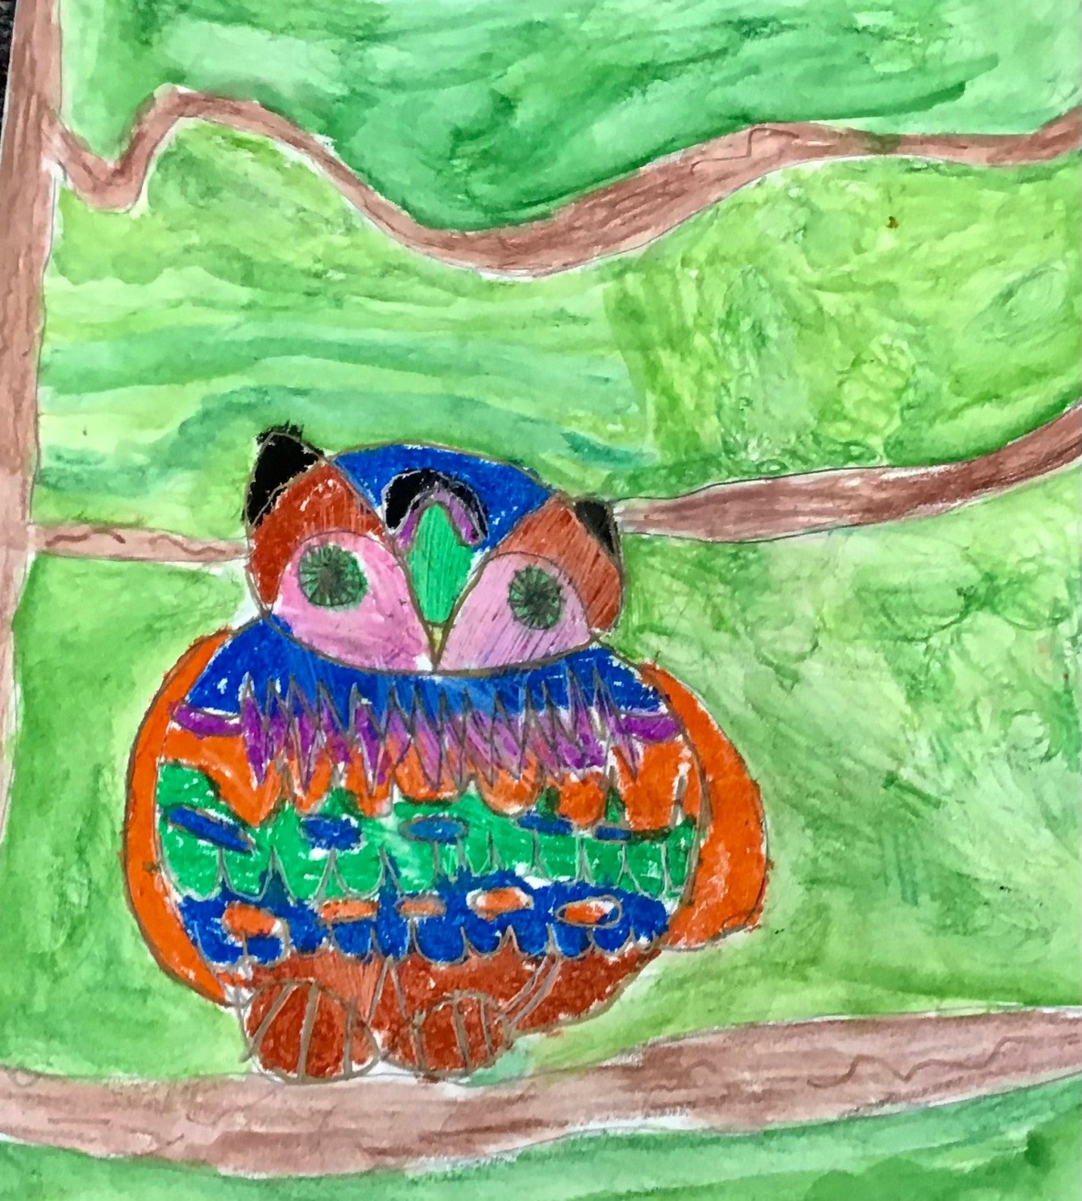

5th Grade: Superhero Selfie-Drawing a Human
