Fannett-Metal School District - Elementary School February 2021

Breakfast Menu

Fannett-Metal is an equal opportunity provider

SUNDAY | MONDAY | TUESDAY | WEDNESDAY | THURSDAY | FRIDAY | SATURDAY
 | February 1  French Toast  Sticks  Fruit  Milk | February 2  Mini Pancakes  Juice  Milk | February 3  Cereal  Muffin  Fruit  Milk | February 4  Breakfast Pizza  Juice  Milk | February 5  Cereal  Muffin  Fruit  Milk
 | February 8  French Toast  Sticks  Fruit  Milk | February 9  Mini Pancakes  Juice  Milk | February 10  Cereal  Muffin  Fruit  Milk | February 11  Breakfast Pizza  Juice  Milk | February 12  Cereal  Muffin  Fruit  Milk | 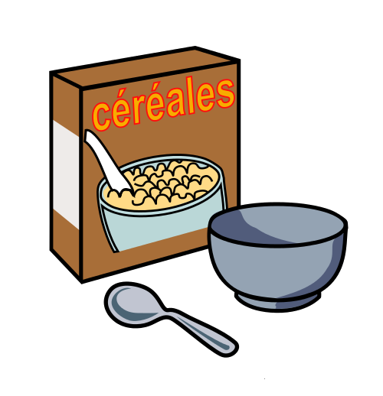
 | February 15  No School | February 16  Mini Pancakes  Juice  Milk | February 17  Cereal  Muffin  Fruit  Milk | February 18  Breakfast Pizza  Juice  Milk | February 19  Cereal  Muffin  Fruit  Milk | All Meals are  served with 1% milk, fat free chocolate, fat free vanilla, fat free strawberry
 | February 22  French Toast  Sticks  Fruit  Milk | February 23  Mini Pancakes  Juice  Milk | February 24  Cereal  Muffin  Fruit  Milk | February 25  Breakfast Pizza  Juice  Milk | February 26  Cereal  Muffin  Fruit  Milk | Elementary & MS/HS  Breakfast - FREE  Milk -$.50
 |  |  |  |  |  | 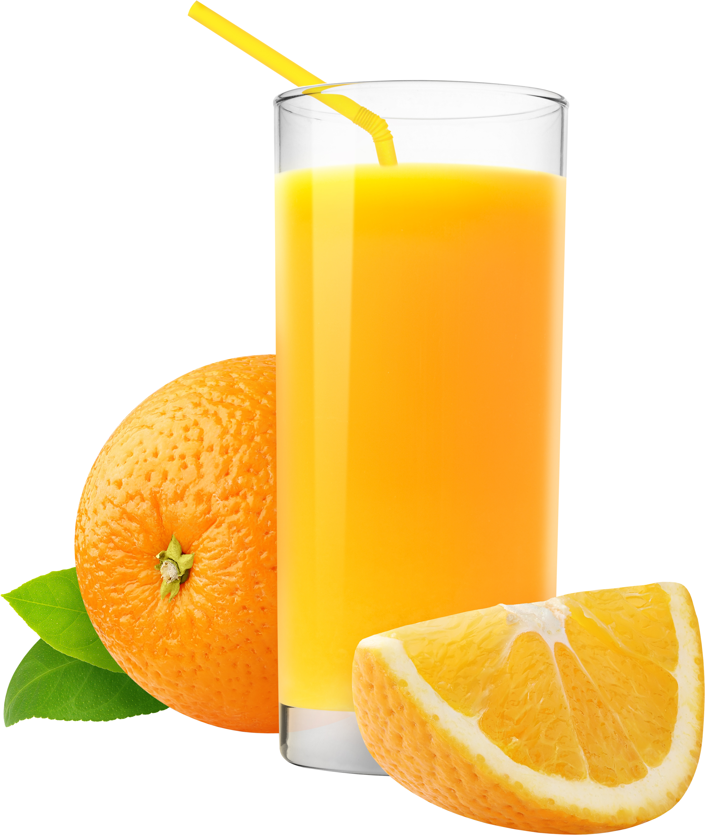
To manage accounts: www.myschoolaccount.com No breakfast on 2 hour delays *Menu Subject to Change

