Fannett-Metal School District – Middle – High School November 2020
USDA Nondiscrimination Statement and Complaint Procedure
The U.S Department of Agriculture prohibits discrimination against its customers, employees, and applicants for employment on the bases of race, color, national origin, age, disability, sex, gender identity, religion, reprisal, and where applicable, political beliefs, marital status, familial or parental status, sexual orientation, or if all or part of an individual's income is derived from any public assistance program, or protected genetic information in employment or in any program or activity conducted or funded by the Department. (Not all prohibited bases will apply to all programs and/or employment activities.)
If you wish to file a Civil Rights program complaint of discrimination, complete the USDA Program Discrimination Complaint Form, found online at http://www.ascr.usda.gov/complaint_filing_cust.html, or at any USDA office, or call (866) 632-9992 to request the form. You may also write a letter containing all of the information requested in the form. Send your completed complaint form or letter to us by mail at U.S. Department of Agriculture, Director, Office of Adjudication, 1400 Independence Avenue, S.W., Washington, D.C. 20250-9410, by fax (202) 690-7442 or email at program.intake@usda.gov .
Individuals who are deaf, hard of hearing or have speech disabilities may contact USDA through the Federal Relay Service at (800) 877-8339; or (800) 845-6136 (Spanish
Fannett-Metal is an equal opportunity provider

SUNDAY | MONDAY | TUESDAY | WEDNESDAY | THURSDAY | FRIDAY | SATURDAY
 | November 2  Choice 1  Chicken Tenders / Roll  Choice 2  Cheese Steak  Baked Beans  Fruit  Milk | November 3  Choice 1  Tomato Soup  Grilled Cheese  Choice  Pulled Pork Sandwich  Peas  Fruit / Milk | November 4  Choice 1  Chicken Patty  Choice 2  Turkey Club Wrap  Steamed Carrots  Fruit  Milk | November 5  Choice 1  Lasagna  Roll  Choice 2  Chef Salad / Roll  Broccoli  Fruit / Milk | November 6  Choice 1  Pepperoni Pizza  Choice 2  Hamburger  Tossed Salad  Fruit  Milk | Offer verses serve -  Students must take  3 of 5 items to count as a lunch & one must be a fruit or vegetable.
 | November 9  Choice 1  Grilled Chicken Salad  Choice 2  Hot Ham &  Cheese Sub  Cheesy Broccoli  Fruit / Milk | November 10  Choice 1  Baked Spaghetti / Roll  Choice 2  Fish Sandwich  Steamed Carrots  Fruit  Milk | November 11  No School | November 12  Choice 1  Hot Chicken Sandwich  W / Gravy  Choice 2  BBQ Rib Sandwich  Peas  Fruit / Milk | November 13  Choice 1  Popcorn Chicken / Roll  Choice 2  Fish Nuggets / Roll  Baked Beans  Fruit  Milk
All Meals are  served with 1% milk, fat free chocolate | November 16  Choice 1  Mashed Potato Bowl  Roll  Choice 2  Chicken Cheese Steak  Broccoli  Fruit / Milk | November 17  Choice 1  General Tso Chicken  Rice / Roll  Choice 2  Turkey & Cheese Hoagie  Steamed Carrots  Fruit / Milk | November 18  Choice 1  Shrimp Poppers  Roll  Choice 2  Meatball Sub  Baked Beans  Fruit / Milk | November 19  Choice 1  Roast Turkey & Gravy  Roll  Choice 2  Calzone  Mashed Potatoes  Fruit / Milk | November 20  Choice 1  Pepperoni Pizza  Choice 2  Buffalo Chicken Wrap  Peas  Fruit  Milk | 3rd Choice Everyday  Peanut Butter  And Jelly  Sandwich
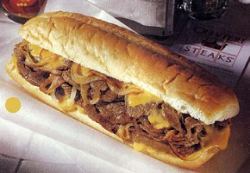 | November 23  Choice 1  Pancakes & Sausage  Choice 2  BBQ Rib Sandwich  Broccoli  Fruit  Milk | November 24  Choice 1  Pulled Pork Sandwich  Choice 2  Cheeseburger Sub  Baked Beans  Fruit  Milk | November 25  Choice 1  Pepperoni Pizza  Choice 2  Chicken Fajita  Peas  Fruit  Milk | November 26  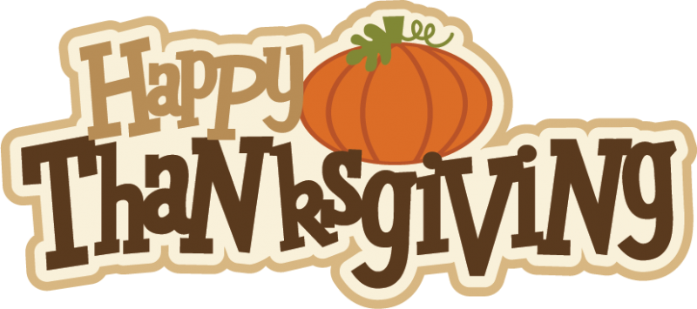 | November 27  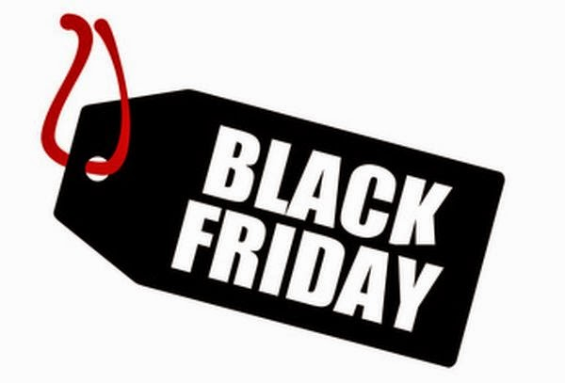 | High School Lunch-  $ 2.90  Milk - .50  Reduced - .40
Menu subject to change | November 30  No School | December 1  No School | December 2  Choice 1  Cheese Steak  Choice 2  Buffalo Chicken Wrap  Tossed Salad  Fruit  Milk | December 3  Choice 1  Chicken Alfredo  Roll  Choice 2  BBQ Rib Sandwich  Baby Carrots  Fruit / Milk | December 4  Choice 1  Taco Salad  Choice 2  Calzone  Refried Beans  Fruit  Milk | 