Fannett-Metal School District - Elementary School November 2020

Lunch Menu

Fannett-Metal is an equal opportunity provider

SUNDAY | MONDAY | TUESDAY | WEDNESDAY | THURSDAY | FRIDAY | SATURDAY
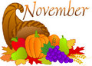 | November 2  Mini Pancakes  Sausage  Or  Cheese Steak  Broccoli  Fruit  Milk | November 3  Chicken Patty  Or  Calzone  Baked Beans  Fruit  Milk | November 4  Beef & Noodle  Pasta / Roll  Or  Chicken Cheese Steak  Peas  Fruit  Milk | November 5  Lasagna  Bread Stick  Or  Fish Sandwich  Tossed Salad  Fruit  Milk | November 6  Cheeseburger  Or  Ham & Cheese Sandwich  Corn  Fruit  Milk | Offer verses serve -  Students must take  3 of 5 items to count as a lunch & one must be a fruit or vegetable.
All Meals are  served with 1% milk, fat free chocolate, fat free vanilla, fat free strawberry and skim | November 9  Grilled Chicken Salad  Roll  Or  Grilled Cheese Sandwich  Peas  Fruit / Milk | November 10  Hot Chicken  Sandwich W / Gravy  Or  Fish Nuggets / Roll  Steamed Carrots  Fruit  Milk | November 11  No School  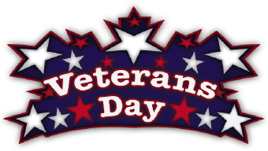 | November 12  Spaghetti & Meatballs  Breadstick  Or  Grilled Chicken Breast  Sandwich  Tossed Salad  Fruit / Milk | November 13  Pepperoni Pizza  Or  Meatball Sub  Broccoli  Fruit  Milk | Pre-K Alternative Meal  November 17th – Hamburger
 | November 16  Taco Salad  Or  Ham & Cheese Wrap  Refried Beans  Fruit  Milk | November 17  Chicken Alfredo  Roll  Or  Corn Dog  Baby Carrots  Fruit  Milk | November 18  Chicken Drum Stick  Roll  Or  BBQ Rib Sandwich  Peas  Fruit  Milk | November 19  Roast Turkey & Gravy  Roll  Or  Calzone  Mashed Potatoes  Fruit  Milk | November 20  Cheese Pizza  Or  Fish Sandwich  Broccoli  Fruit  Milk | Menu Subject to Change
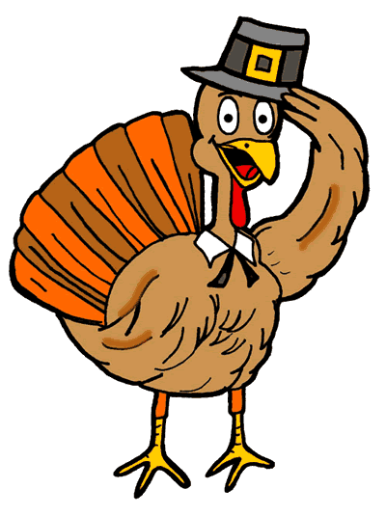 | November 23  Stuffed Shells  Roll  Or  Chicken Cheese Steak  Broccoli  Fruit  Milk | November 24  Popcorn Chicken  Roll  Or  BBQ Rib Sandwich  Peas  Fruit  Milk | November 25  Chef Salad  Roll  Or  Cheeseburger  Baked Beans  Fruit  Milk | November 26  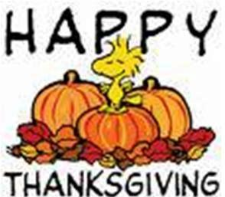 | November 27  No School | Elementary  Lunch- $2.75  Milk - .50  Reduced - .40
No breakfast on two hour delays | November 30  No School | December 1  No School | December 2  Chicken Nuggets  Roll  Or  Cheese Steak  Broccoli  Fruit  Milk | December 3  Lasagna  Bread Stick  Or  Chicken Patty  Tossed Salad  Fruit  Milk | December 4  Pepperoni Pizza  Or  Cheeseburger  Baby Carrots  Fruit  Milk

