Fannett-Metal School District - Elementary School November 2020

Breakfast Menu

Fannett-Metal is an equal opportunity provider

SUNDAY | MONDAY | TUESDAY | WEDNESDAY | THURSDAY | FRIDAY | SATURDAY
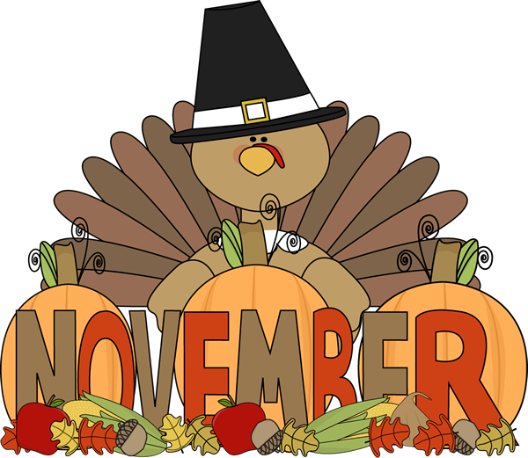 | November 2  French Toast  Sticks  Fruit  Milk | November 3  Mini Pancakes  Juice  Milk | November 4  Trix Cereal  Muffin  Fruit  Milk | November 5  Breakfast Pizza  Juice  Milk | ^{November 6}  Cinnamon Toast  Crunch Cereal  Muffin  Fruit  Milk
 | November 9  French Toast  Sticks  Fruit  Milk | November 10  Mini Pancakes  Juice  Milk | November 11  No School | November 12  Breakfast Pizza  Juice  Milk | November 13  Lucky Charms  Cereal  Muffin  Fruit  Milk | 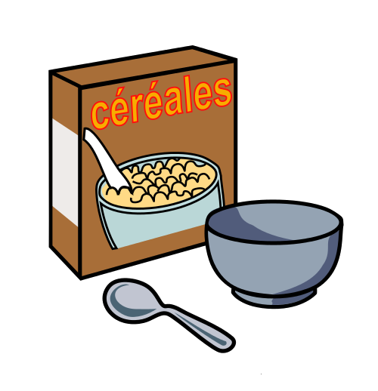
All Meals are  served with 1% milk, fat free chocolate, fat free vanilla, fat free strawberry | November 16  French Toast  Sticks  Fruit  Milk | November 17  Mini Pancakes  Juice  Milk | November 18  Trix Cereal  Muffin  Fruit  Milk | November 19  Breakfast Pizza  Juice  Milk | November 20  Cinnamon Toast  Crunch Cereal  Muffin  Fruit  Milk
 | November 23  French Toast  Sticks  Fruit  Milk | November 24  Mini Pancakes  Juice  Milk | November 25  Cocoa Puffs Cereal  Muffin  Fruit  Milk | November 26 | November 27  No School | Elementary & MS/HS  Breakfast-$ 1.55  Milk -$.50  Reduced -$.25
 | November 30  No School | December 1  No School | December 2  Trix Cereal  Muffin  Fruit  Milk | December 3  Breakfast Pizza  Juice  Milk | December 4  Cinnamon Toast  Crunch Cereal  Muffin  Fruit  Milk | 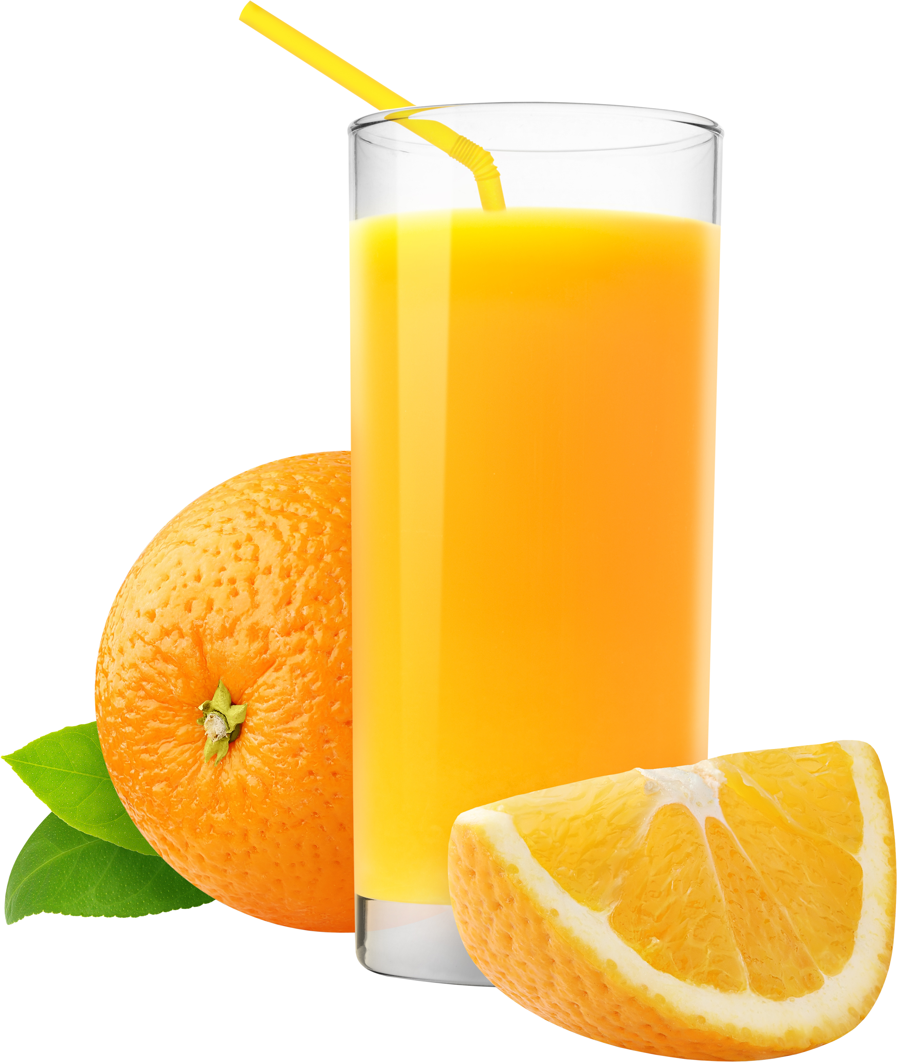
To manage accounts: www.myschoolaccount.com No breakfast on 2 hour delays *Menu Subject to Change

