Fannett-Metal School District – Middle – High School October 2020
USDA Nondiscrimination Statement and Complaint Procedure
The U.S Department of Agriculture prohibits discrimination against its customers, employees, and applicants for employment on the bases of race, color, national origin, age, disability, sex, gender identity, religion, reprisal, and where applicable, political beliefs, marital status, familial or parental status, sexual orientation, or if all or part of an individual's income is derived from any public assistance program, or protected genetic information in employment or in any program or activity conducted or funded by the Department. (Not all prohibited bases will apply to all programs and/or employment activities.)
If you wish to file a Civil Rights program complaint of discrimination, complete the USDA Program Discrimination Complaint Form, found online at http://www.ascr.usda.gov/complaint_filing_cust.html, or at any USDA office, or call (866) 632-9992 to request the form. You may also write a letter containing all of the information requested in the form. Send your completed complaint form or letter to us by mail at U.S. Department of Agriculture, Director, Office of Adjudication, 1400 Independence Avenue, S.W., Washington, D.C. 20250-9410, by fax (202) 690-7442 or email at program.intake@usda.gov .
Individuals who are deaf, hard of hearing or have speech disabilities may contact USDA through the Federal Relay Service at (800) 877-8339; or (800) 845-6136 (Spanish
Fannett-Metal is an equal opportunity provider

SUNDAY | MONDAY | TUESDAY | WEDNESDAY | THURSDAY | FRIDAY | SATURDAY
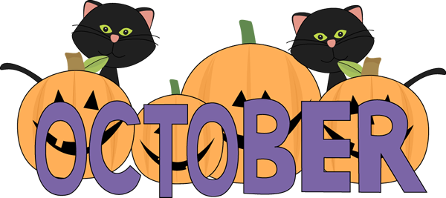 |  |  |  | October 1  Choice 1  Lasagna  Roll  Choice 2  PB & J Sandwich  Baby Carrots  Fruit / Milk | October 2  Choice 1  Pepperoni Pizza  Choice 2  Hamburger  Broccoli  Fruit  Milk | Offer verses serve -  Students must take  3 of 5 items to count as a lunch & one must be a fruit or vegetable.
Menu subject to change | October 5  Choice 1  Chicken Tenders / Roll  Choice 2  Cheese Steak  Peas  Fruit  Milk | October 6  Choice 1  Spicy Chicken Patty  Choice 2  Pulled Pork Sandwich  Green Beans  Fruit  Milk | October 7  Choice 1  Bacon & Ranch Chicken  On Pretzel Roll  Choice 2  Turkey Club Wrap  Corn  Fruit / Milk | October 8  Choice 1  Chef Salad  Roll  Choice 2  Chicken Fajita  Steamed Carrots  Fruit / Milk | October 9  Choice 1  Popcorn Chicken / Roll  Choice 2  Cheeseburger  Tossed Salad  Fruit  Milk | 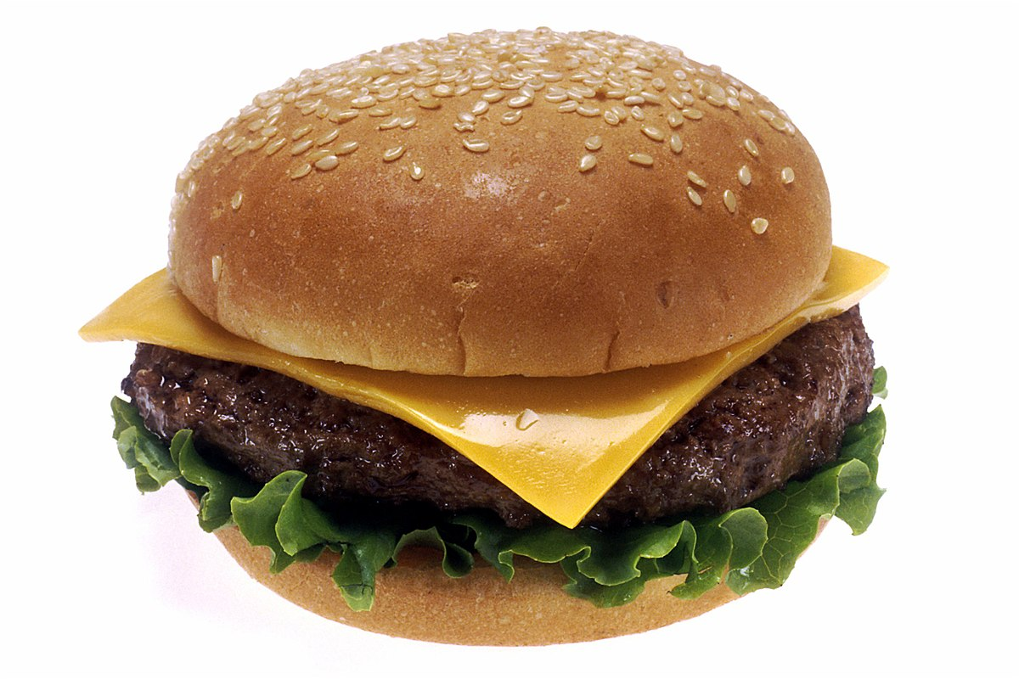
All Meals are  served with 1% milk, fat free chocolate, fat free vanilla, fat free strawberry | October 12  No School | October 13  Choice 1  Baked Spaghetti / Roll  Choice 2  Fish Nuggets / Roll  Steamed Carrots  Fruit / Milk | October 14  Choice 1  Grilled Chicken Salad  Choice 2  Ham & Cheese on  Pretzel Roll  Corn  Fruit / Milk | October 15  Choice 1  General Tso Chicken  Rice / Roll  Choice 2  Hot Dog  Tossed Salad  Fruit / Milk | October 16  Choice 1  Pepperoni Pizza  Choice 2  Buffalo Chicken Wrap  Scalloped Potatoes  Fruit  Milk | 3rd Choice Everyday  Peanut Butter  And Jelly  Sandwich
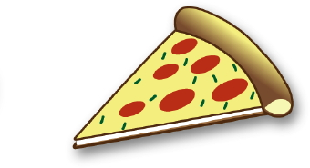 | October 19  Choice 1  Mashed Potato Bowl  Roll  Choice 2  Cheese Steak  Broccoli  Fruit / Milk | October 20  Choice 1  Chicken Alfredo  Bread Stick  Choice 2  Turkey & Cheese Flatbread  Peas  Fruit  Milk  Fruit / Milk | October 21  Choice 1  Shrimp Poppers  Roll  Choice 2  Meatball Sub  Peas  Fruit / Milk | October 22  Choice 1  Roast Turkey & Gravy  Roll  Choice 2  Calzone  Mashed Potatoes  Fruit / Milk | October 23  Choice 1  BBQ Rib Sandwich  Choice 2  Rotisserie Chicken Wrap  Baked Beans  Fruit  Milk | High School Lunch-  $ 2.90  Milk - .50  Reduced - .40
No breakfast on two hour delays | October 26  Choice 1  Hot Chicken Sandwich  W/ Gravy  Choice 2  BBQ Rib Sandwich  Baby Carrots  Fruit / Milk  Milk | October 27  Choice 1  Pulled Pork Sandwich  Choice 2  Ham & Cheese Flatbread  Peas  Fruit / Milk | October 28  Choice 1  Taco Salad  Choice 2  Hamburger  Refried Beans  Fruit  Milk | October 29  Choice 1  Cheese Steak  Roll  Choice 2  Buffalo Chicken Wrap  Tossed Salad  Fruit / Milk | October 30  No School

