Fannett-Metal School District – Middle – High School October 2020
USDA Nondiscrimination Statement and Complaint Procedure
The U.S Department of Agriculture prohibits discrimination against its customers, employees, and applicants for employment on the bases of race, color, national origin, age, disability, sex, gender identity, religion, reprisal, and where applicable, political beliefs, marital status, familial or parental status, sexual orientation, or if all or part of an individual's income is derived from any public assistance program, or protected genetic information in employment or in any program or activity conducted or funded by the Department. (Not all prohibited bases will apply to all programs and/or employment activities.)
If you wish to file a Civil Rights program complaint of discrimination, complete the USDA Program Discrimination Complaint Form, found online at http://www.ascr.usda.gov/complaint_filing_cust.html, or at any USDA office, or call (866) 632-9992 to request the form. You may also write a letter containing all of the information requested in the form. Send your completed complaint form or letter to us by mail at U.S. Department of Agriculture, Director, Office of Adjudication, 1400 Independence Avenue, S.W., Washington, D.C. 20250-9410, by fax (202) 690-7442 or email at program.intake@usda.gov .
Individuals who are deaf, hard of hearing or have speech disabilities may contact USDA through the Federal Relay Service at (800) 877-8339; or (800) 845-6136 (Spanish
Fannett-Metal is an equal opportunity provider

SUNDAY | MONDAY | TUESDAY | WEDNESDAY | THURSDAY | FRIDAY | SATURDAY
 |  |  |  | October 1  French Toast Sticks  Cereal  Muffin  Juice  Milk | ^{October 2}  Cocoa Puffs  Cereal  Muffin  Juice  Milk | Offer verses serve -  Students must take  3 of 5 items to count as a lunch & one must be a fruit or vegetable.
 | October 5  French Toast  Sticks  Muffin  Juice  Milk | October 6  Sausage  Egg & Cheese  Bagel  Juice  Milk | October 7  Cereal Variety  Muffin  Juice  Milk | October 8  Breakfast Pizza  Juice  Milk | October 9  Cereal Variety  Muffin  Juice  Milk | Menu subject to change
All Meals are  served with 1% milk, fat free chocolate, fat free vanilla, fat free strawberry and skim | October 12  No School | October 13  Sausage Egg  & Cheese  Bagel  Juice  Milk | October 14  Cereal Variety  Muffin  Juice  Milk | October 15  Breakfast Pizza  Juice  Milk | October 16  Cereal Variety  Muffin  Juice  Milk | 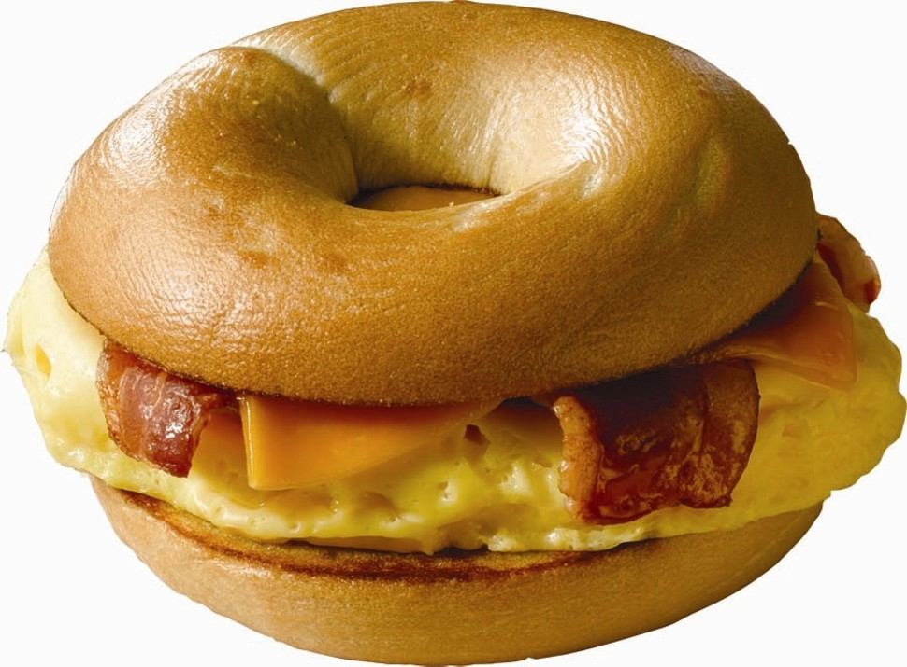
 | October 19  French Toast  Sticks  Cereal  Muffin  Juice  Milk | October 20  Sausage  Egg & Cheese  Bagel  Juice  Milk | October 21  Cereal Variety  Muffin  Juice  Milk | October 22  Breakfast Pizza  Juice  Milk | October 23  Cereal Variety  Muffin  Juice  Milk | High School Breakfast  $ 1.55  Milk - .50  Reduced - .40
No breakfast on two hour delays | October 26  French Toast  Sticks  Cereal  Muffin  Juice  Milk | October 27  Sausage  Egg & Cheese  Bagel  Juice  Milk | October 28  Cereal Variety  Muffin  Juice  Milk | October 29  Breakfast Pizza  Juice  Milk | October 30  No School

