Fannett-Metal School District - Elementary School October 2020

Breakfast Menu

Fannett-Metal is an equal opportunity provider

SUNDAY | MONDAY | TUESDAY | WEDNESDAY | THURSDAY | FRIDAY | SATURDAY
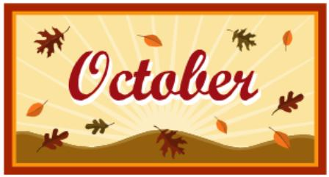 |  |  |  | October 1  Cereal Bar  Yogurt  Juice  Milk | ^{October 2}  Cinnamon Toast  Crunch Cereal  Muffin  Fruit  Milk
 | October 5  French Toast  Sticks  Fruit  Milk | October 6  Pancake  on a Stick  Juice  Milk | October 7  Cocoa Puffs Cereal  Muffin  Fruit  Milk | October 8  Breakfast Pizza  Juice  Milk | October 9  Lucky Charms  Cereal  Muffin  Fruit  Milk | 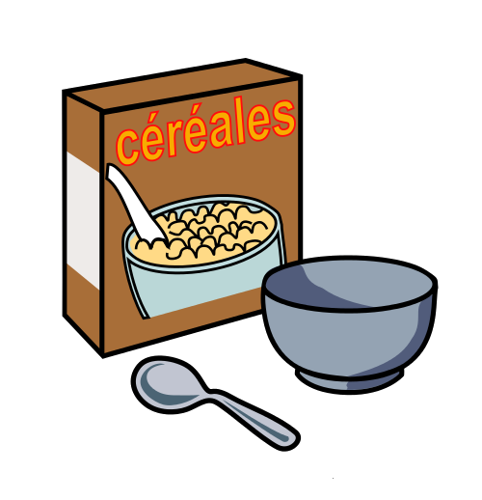
All Meals are  served with 1% milk, fat free chocolate, fat free vanilla, fat free strawberry | October 12  No School | October 13  Pancake  on a Stick  Juice  Milk | October 14  Trix Cereal  Muffin  Fruit  Milk | October 15  Breakfast Pizza  Juice  Milk | October 16  Cinnamon Toast  Crunch Cereal  Muffin  Fruit  Milk
 | October 19  French Toast  Sticks  Fruit  Milk | October 20  Pancake  on a Stick  Juice  Milk | October 21  Cocoa Puffs Cereal  Muffin  Fruit  Milk | October 22  Breakfast Pizza  Juice  Milk | October 23  Lucky Charms  Cereal  Muffin  Fruit  Milk | Elementary & MS/HS  Breakfast-$ 1.55  Milk -$.50  Reduced -$.25
 | October 26  French Toast  Sticks  Fruit  Milk | October 27  Pancake  on a Stick  Juice  Milk | October 28  Trix Cereal  Muffin  Fruit  Milk | October 29  Breakfast Pizza  Juice  Milk | October 30  No School
To manage accounts: www.myschoolaccount.com No breakfast on 2 hour delays *Menu Subject to Change

