Fannett-Metal School District - Elementary School March 2020

Fannett-Metal is an equal opportunity provider

SUNDAY | MONDAY | TUESDAY | WEDNESDAY | THURSDAY | FRIDAY | SATURDAY
 | March 2  Popcorn Chicken  W / Roll  Or  Chef Salad W / Roll  Cheesy Broccoli  Red Peppers  Choice of Fruit / Milk | March 3  Shrimp Poppers  Roll  Or  Hot Dog  Baby Carrots  Peas  Choice of Fruit / Milk | March 4  Chicken Patty  Or  Turkey Hoagie  Baked Beans  Tossed Salad  Choice of Fruit / Milk | March 5  Macaroni & Cheese  Or  Hamburger  Grape Tomatoes  Steamed Carrots  Choice of Fruit / Milk | ^{March 6}  Pepperoni Pizza  Or  Fish Nuggets / Roll  Corn  Cucumbers W / Dip  Choice of Fruit / Milk | Offer verses serve -  Students must take  3 of 5 items to count as a lunch & one must be a fruit or vegetable.
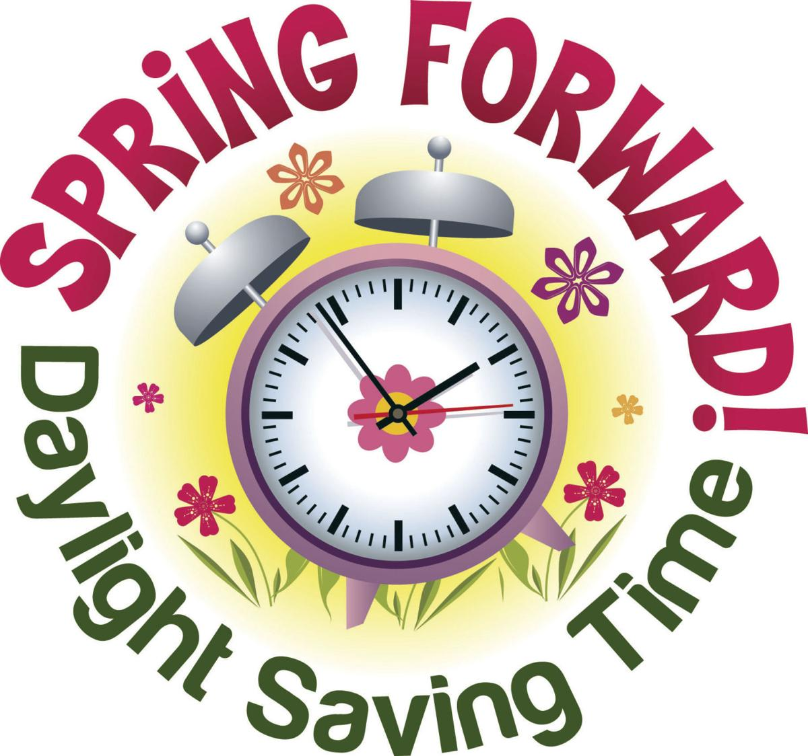 | March 9  Chicken Drum Stick  W / Roll  Or  Calzone  Tatar Tots  Grape Tomatoes  Choice of Fruit / Milk | March 10  Tomato Soup  Grilled Cheese Sandwich  Or  BBQ Rib Sandwich  Cheesy Broccoli  Baby Carrots  Choice of Fruit / Milk | March 11  Hot Chicken Sandwich  W / Gravy  Or  Fish Sandwich  Mashed Potatoes  Tossed Salad  Choice of Fruit / Milk | March 12  Chicken Taco  Or  Turkey & Cheese  Flatbread Sandwich  Refried Beans  Cucumbers  Choice of Fruit / Milk | March 13  Chicken Nuggets  W/ Roll  Or  Meatball Sub  Peas  Baby Carrots  Choice of Fruit / Milk | Pre-K Alternative Lunch  March 3rd – Chicken Sticks W / Roll  March 31st – Chicken Nuggets W / Roll
All Meals are  served with 1% milk, fat free chocolate, fat free vanilla, fat free strawberry and skim | March 16  No School | March 17  Salisbury Steak  Breadstick  Or  Chicken Cheese Steak  Mashed Potatoes  Red Peppers  Choice of Fruit / Milk | March 18  Walking Taco  Or  Calzone  Refried Beans  Grape Tomatoes  Choice of Fruit / Milk | March 19  Chicken Alfredo  Roll  Or  BBQ Rib Sandwich  Tossed Salad  Broccoli  Choice of Fruit / Milk | March 20  French Bread Pizza  Or  Fish Nuggets W/ Roll  Peas  Baby Carrots  Choice of Fruit / Milk
 | March 23  Spaghetti & Meatballs  Breadstick  Or  BBQ Chicken Sandwich  Tossed Salad  Baby Carrots  Choice of Fruit / Milk | March 24  Chicken and Waffles  W / Gravy  Or  Cheese Steak  Broccoli  Grape Tomatoes  Choice of Fruit / Milk | March 25  Loaded Nachos  W / Roll  Or  Meatball Sub  Steamed Carrots  Cucumbers W / Dip  Choice of Fruit / Milk | March 26  Chicken Patty  Or  Cheeseburger  Baked Beans  Grape Tomatoes  Choice of Fruit / Milk | March 27  Pepperoni Pizza  Or  Fish Sandwich  Peas  Baby Carrots  Choice of Fruit / Milk | Elementary Lunch-  $ 2.65  Milk - .50  Reduced - .40
No breakfast on two hour delays | March 30  Orange Chicken  W / Roll  Or  Chef Salad W / Roll  Rice  Oriental Vegetables  Choice of Fruit / Milk | March 31  Shrimp Poppers  Roll  Or  Hot Dog  Baby Carrots  Peas  Choice of Fruit / Milk | April 1  Chicken Patty  Or  Turkey Hoagie  Baked Beans  Red Peppers W / Dip  Choice of Fruit / Milk | April 2  Italian Chicken  Texas Toast  Or  Cheeseburger Sub  Tossed Salad  Steamed Carrots  Choice of Fruit / Milk | April 3  Pepperoni Pizza  Or  Fish Nuggets / Roll  Cheesy Broccoli  Cucumbers W / Dip  Choice of Fruit / Milk
Menu Subject to Change

