Fannett-Metal School District – Middle – High School February 2020
USDA Nondiscrimination Statement and Complaint Procedure
The U.S Department of Agriculture prohibits discrimination against its customers, employees, and applicants for employment on the bases of race, color, national origin, age, disability, sex, gender identity, religion, reprisal, and where applicable, political beliefs, marital status, familial or parental status, sexual orientation, or if all or part of an individual's income is derived from any public assistance program, or protected genetic information in employment or in any program or activity conducted or funded by the Department. (Not all prohibited bases will apply to all programs and/or employment activities.)
If you wish to file a Civil Rights program complaint of discrimination, complete the USDA Program Discrimination Complaint Form, found online at http://www.ascr.usda.gov/complaint_filing_cust.html, or at any USDA office, or call (866) 632-9992 to request the form. You may also write a letter containing all of the information requested in the form. Send your completed complaint form or letter to us by mail at U.S. Department of Agriculture, Director, Office of Adjudication, 1400 Independence Avenue, S.W., Washington, D.C. 20250-9410, by fax (202) 690-7442 or email at program.intake@usda.gov .
Individuals who are deaf, hard of hearing or have speech disabilities may contact USDA through the Federal Relay Service at (800) 877-8339; or (800) 845-6136 (Spanish
Fannett-Metal is an equal opportunity provider

SUNDAY | MONDAY | TUESDAY | WEDNESDAY | THURSDAY | FRIDAY | SATURDAY
Offer verses serve -
Students must take
3 of 5 items to count as a lunch & one must be a fruit or vegetable.
 | February 3  French Toast Sticks  Or  Cereal  Whole Grain Bread  Fruit / Vegetable  Milk / Juice | February 4  Sausage, Egg &  Cheese Sandwich  Or  Cereal  Whole Grain Bread  Fruit / Vegetable  Milk / Juice | February 5  Pancakes &  Sausage Links  Or  Cereal  Whole Grain Bread  Fruit / Vegetable  Milk / Juice 1 | February 6  Breakfast Pizza  Or  Cereal  Whole Grain Bread  Fruit / Vegetable  Milk / Juice | February 7  Cinnamon Bun  Or  Cereal  Whole Grain Bread  Fruit / Vegetable  Milk / Juice | Menu subject to change
All Meals are  served with 1% milk, fat free chocolate, fat free vanilla, fat free strawberry and skim | February 10  French Toast Sticks  Or  Cereal  Whole Grain Bread  Fruit / Vegetable  Milk / Juice | February 11  Sausage, Egg & Cheese Sandwich  Or  Cereal  Whole Grain Bread  Fruit / Vegetable  Milk / Juice | February 12  Pancakes &  Sausage Links  Or  Cereal  Whole Grain Bread  Fruit / Vegetable  Milk / Juice | February 13  Breakfast Pizza  Or  Cereal  Whole Grain Bread  Fruit / Vegetable  Milk / Juice | February 14  Cinnamon Bun  Or  Cereal  Whole Grain Bread  Fruit / Vegetable  Milk / Juice | 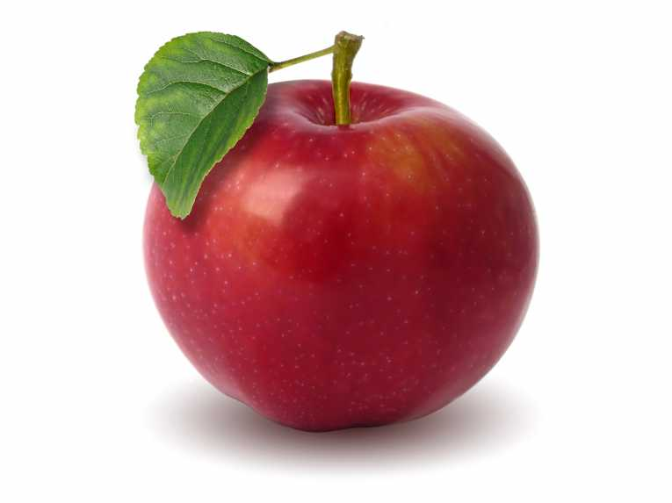
 | February 17  No School | February 18  Sausage, Egg & Cheese Sandwich  Or  Cereal  Whole Grain Bread  Fruit / Vegetable  Milk / Juice | February 19  Pancakes &  Sausage Links  Or  Cereal  Whole Grain Bread  Fruit / Vegetable  Milk / Juice | February 20  Breakfast Pizza  Or  Cereal  Whole Grain Bread  Fruit / Vegetable  Milk / Juice 3 | February 21  Cinnamon Bun  Or  Cereal  Whole Grain Bread  Fruit / Vegetable  Milk / Juice
No breakfast on two hour delays | February 24  French Toast Sticks  Or  Cereal  Whole Grain Bread  Fruit / Vegetable  Milk / Juice | February 25  Sausage, Egg & Cheese Sandwich  Or  Cereal  Whole Grain Bread  Fruit / Vegetable  Milk / Juice | February 26  Pancakes &  Sausage Links  Or  Cereal  Whole Grain Bread  Fruit / Vegetable  Milk / Juice | February 27  Breakfast Pizza  Or  Cereal  Whole Grain Bread  Fruit / Vegetable  Milk / Juice | February 28  Cinnamon Bun  Or  Cereal  Whole Grain Bread  Fruit / Vegetable  Milk / Juice

