Fannett-Metal School District - High School / Middle School February 2020

Fannett-Metal is an equal opportunity provider

SUNDAY | MONDAY | TUESDAY | WEDNESDAY | THURSDAY | FRIDAY | SATURDAY
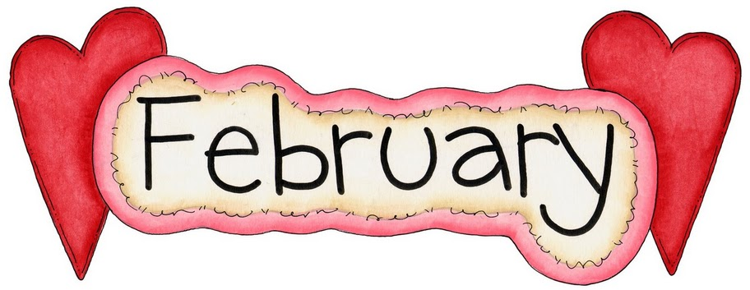 |  |  |  |  |  | Offer verses serve -  Students must take  3 of 5 items to count as a lunch & one must be a fruit or vegetable.
 | February 3  Chicken Patty  Or  BBQ Rib Sandwich  Cheesy Broccoli  Tossed Salad  Choice of Fruit / Milk | February 4  Orange Chicken  W / Roll  Or  Calzone  Noodles / Oriental Vegs  Baby Carrots  Choice of Fruit / Milk | February 5  Shrimp Poppers  W / Roll  Or  Chicken Cheese Steak  Baked Beans  Grape Tomatoes  Choice of Fruit / Milk | February 6  Stuffed Shells  Breadstick  Or  Hot Sausage Sandwich  Green Beans  Tossed Salad  Choice of Fruit / Milk | February 7  Pepperoni Pizza  Or  Fish Nuggets  W / Roll  Peas  Baby Carrots  Choice of Fruit / Milk | Daily Entrée options include:  Chef Or Taco Salad with whole grain roll Or Whole grain P B & J sandwich  Fruit, Vegetable & Milk are included
All Meals are  served with 1% milk, fat free chocolate, fat free vanilla and fat free strawberry | February 10  Spaghetti & Meatballs  Breadstick  Or  Hot Dog  Tossed Salad  Peas  Choice of Fruit / Milk | February 11  Chicken Alfredo  W / Roll  Or  Ham & Cheese Flatbread Carrots / Broccoli  Choice of Fruit / Milk | February 12  Popcorn Chicken W/ Roll  Or  Meatball Sub  Steamed Carrots  Cucumber W / Dip  Choice of Fruit / Milk | February 13  Walking Taco  Or  Fish Sandwich  Refried Beans  Grape Tomatoes  Choice of Fruit / Milk | February 14  Soft Shell Tacos  Or  Ham & Cheese Hoagie  Tossed Salad  Baby Carrots  Choice of Fruit / Milk
Menu subject to change | February 17  NO SCHOOL | February 18  Macaroni & Cheese  W / Roll  Or  Ham, Egg & Cheese  Sandwich  Peas / Tomatoes  Choice of Fruit / Milk | February 19  Mashed Potato Bowl  W / Roll  Or  Chicken, Bacon & Cheese Sandwich  Carrots / Red Peppers  Choice of Fruit / Milk | February 20  Loaded Nachos  W / Roll  Or  Pulled Pork Sandwich  Baked Beans  Baby Carrots  Choice of Fruit / Milk | February 21  Cheese Pizza  Or  Cheeseburger  Broccoli  Tossed Salad  Choice of Fruit / Milk | Middle/HS Lunch-  $ 2.80  Milk - .50  Reduced - .40
No breakfast on two hour delays | February 24  Lasagna  Breadstick  Or  Spicy Chicken Patty  Tossed Salad  Steamed Carrots  Choice of Fruit / Milk | February 25  Chicken & Waffles  W/ Gravy  Or  Hot Dog  Grape Tomatoes  Peas  Choice of Fruit / Milk | February 26  Cheese Steak  Or  Bacon  Cheeseburger  Baked Beans  Celery W / Dip  Choice of Fruit / Milk | February 27  General Tso’s Chicken  w/ W/G roll  Or  Turkey & Cheese Flatbread  Oriental Vegs/ Rice  Baby Carrots  Choice of Fruit / Milk | February 28  Pepperoni Pizza  Or  Chicken Fajita  Cheesy Broccoli  Tossed Salad  Choice of Fruit / Milk

