Fannett-Metal School District - High School / Middle School January 2020

Fannett-Metal is an equal opportunity provider

SUNDAY | MONDAY | TUESDAY | WEDNESDAY | THURSDAY | FRIDAY | SATURDAY
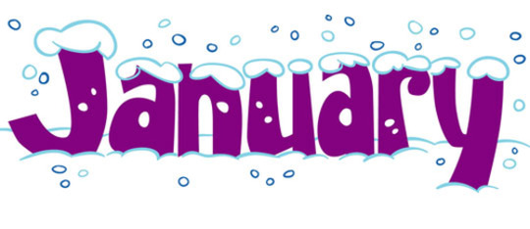 |  |  | January 1 | January 2  Cheese Ravioli  Breadstick  Or  Spicy chicken Patty  Steamed Carrots  Choice of Vegetable  Choice of Fruit / Milk | ^{January 3}  Cheeseburger  Or  Fish Sandwich  Peas  Choice of Vegetable  Choice of Fruit / Milk | Offer verses serve -  Students must take  3 of 5 items to count as a lunch & one must be a fruit or vegetable.
 | January 6  Chicken Patty  Or  BBQ Rib Sandwich  Cheesy Broccoli  Tossed Salad  Choice of Fruit / Milk | January 7  Orange Chicken  W / Roll  Or  Calzone  Noodles / Oriental Vegs  Baby Carrots  Choice of Fruit / Milk | January 8  Shrimp Poppers  W / Roll  Or  Chicken Cheese Steak  Baked Beans  Grape Tomatoes  Choice of Fruit / Milk | January 9  Stuffed Shells  Breadstick  Or  Hot Sausage Sandwich  Green Beans  Tossed Salad  Choice of Fruit / Milk | January 10  Pepperoni Pizza  Or  Fish Nuggets  W / Roll  Peas  Baby Carrots  Choice of Fruit / Milk | Daily Entrée options include:  Chef Or Taco Salad with whole grain roll Or Whole grain P B & J sandwich  Fruit, Vegetable & Milk are included
All Meals are  served with 1% milk, fat free chocolate, fat free vanilla and fat free strawberry | January 13  Spaghetti & Meatballs  Breadstick  Or  Hot Dog  Tossed Salad  Peas  Choice of Fruit / Milk | January 14  Chicken Alfredo  W / Roll  Or  Pepper Steak  Baby Carrots  Steamed Broccoli  Choice of Fruit / Milk | January 15  Popcorn Chicken W/ Roll  Or  Meatball Sub  Steamed Carrots  Cucumber W / Dip  Choice of Fruit / Milk | January 16  Walking Taco  Or  Fish Sandwich  Refried Beans  Grape Tomatoes  Choice of Fruit / Milk | January 17  No School
 | January 20  No School | January 21  Macaroni & Cheese  W / Roll  Or  Ham, Egg & Cheese  Sandwich  Peas / Tomatoes  Choice of Fruit / Milk | January 22  Mashed Potato Bowl  W / Roll  Or  Chicken, Bacon & Cheese Sandwich  Carrots / Red Peppers  Choice of Fruit / Milk | January 23  Roast Turkey  W / Gravy & Stuffing  Or  Ham & Cheese Hoagie  Mashed Potatoes  Corn  Choice of Fruit / Milk | January 24  Pulled Pork  Loaded Fries  Or  Cheeseburger  Broccoli  Tossed Salad  Choice of Fruit / Milk | Middle/HS Lunch-  $ 2.80  Milk - .50  Reduced - .40
No breakfast on two hour delays | January 27  Cheese Ravioli  Breadstick  Or  Spicy Chicken Patty  Tossed Salad  Steamed Carrots  Choice of Fruit / Milk | January 28  Buffalo Chicken or Cheese Pizza  Or  Hot Dog  Grape Tomatoes  Peas  Choice of Fruit / Milk | January 29  Cheese Steak  Or  Stuffed Peppers  Texas Toast  Baked Beans  Celery W / Dip  Choice of Fruit / Milk | January 30  General Tso’s Chicken  w/ W/G roll  Or  Turkey & Cheese Flatbread  Oriental Vegs/ Rice  Baby Carrots  Choice of Fruit / Milk | January 31  Pepperoni Pizza  Or  Chicken Fajita  Cheesy Broccoli  Tossed Salad  Choice of Fruit / Milk | Menu subject to change

