FANNETT-METAL SCHOOL DISTRICT – Elementary School –
January 2020
Breakfast Menu

Fannett-Metal School District is an equal opportunity provider
SUNDAY | MONDAY | TUESDAY | WEDNESDAY | THURSDAY | FRIDAY | SATURDAY
 |  |  | January 1 | January 2  Breakfast Pizza  Or  Cereal  Whole grain bread  Fruit / Vegetable  Milk / Juice | ^{January 3}  Mini Pancakes  Or  Cereal  Whole grain Bread  Fruit / Vegetable  Milk / Juice
 | January 6  French Toast Sticks  Or  Cereal  Whole grain bread  Fruit / Vegetable  Milk / Juice | January 7  Scrambled Eggs  Or  Cereal  Whole Grain Bread  Fruit / Vegetable  Milk / Juice | January 8  Waffle & Sausage Patty  Or  Cereal  Whole Grain Bread  Fruit / Vegetable  Milk / Juice | January 9  Breakfast Pizza  Or  Cereal  Whole grain bread  Fruit / Vegetable  Milk / Juice | January 10  Mini Pancakes  Or  Cereal  Whole grain Bread  Fruit / Vegetable  Milk / Juice
All Meals are  served with 1% milk, fat free chocolate, fat free vanilla, fat free strawberry and skim | January 13  French Toast Sticks  Or  Cereal  Whole grain bread  Fruit / Vegetable  Milk / Juice | January 14  Scrambled Eggs  Or  Cereal  Whole Grain Bread  Fruit / Vegetable  Milk / Juice | January 15  Waffle & Sausage Patty  Or  Cereal  Whole Grain Bread  Fruit / Vegetable  Milk / Juice | January 16  Breakfast Pizza  Or  Cereal  Whole grain bread  Fruit / Vegetable  Milk / Juice | January 17  No School
 | January 20  No School | January 21  Scrambled Eggs  Or  Cereal  Whole Grain Bread  Fruit / Vegetable  Milk / Juice | January 22  Waffle & Sausage Patty  Or  Cereal  Whole Grain Bread  Fruit / Vegetable  Milk / Juice | January 23  Breakfast Pizza  Or  Cereal  Whole grain bread  Fruit / Vegetable  Milk / Juice | January 24  Mini Pancakes  Or  Cereal  Whole grain Bread  Fruit / Vegetable  Milk / Juice | Elementary & MS/HS  Breakfast-$ 1.55  Milk -$.50  Reduced -$.25
 | January 27  French Toast Sticks  Or  Cereal  Whole grain bread  Fruit / Vegetable  Milk / Juice | January 28  Scrambled Eggs  Or  Cereal  Whole Grain Bread  Fruit / Vegetable  Milk / Juice | January 29  Waffle & Sausage Patty  Or  Cereal  Whole Grain Bread  Fruit / Vegetable  Milk / Juice | January 30  Breakfast Pizza  Or  Cereal  Whole grain bread  Fruit / Vegetable  Milk / Juice | January 31  Mini Pancakes  Or  Cereal  Whole grain Bread  Fruit / Vegetable  Milk / Juice | 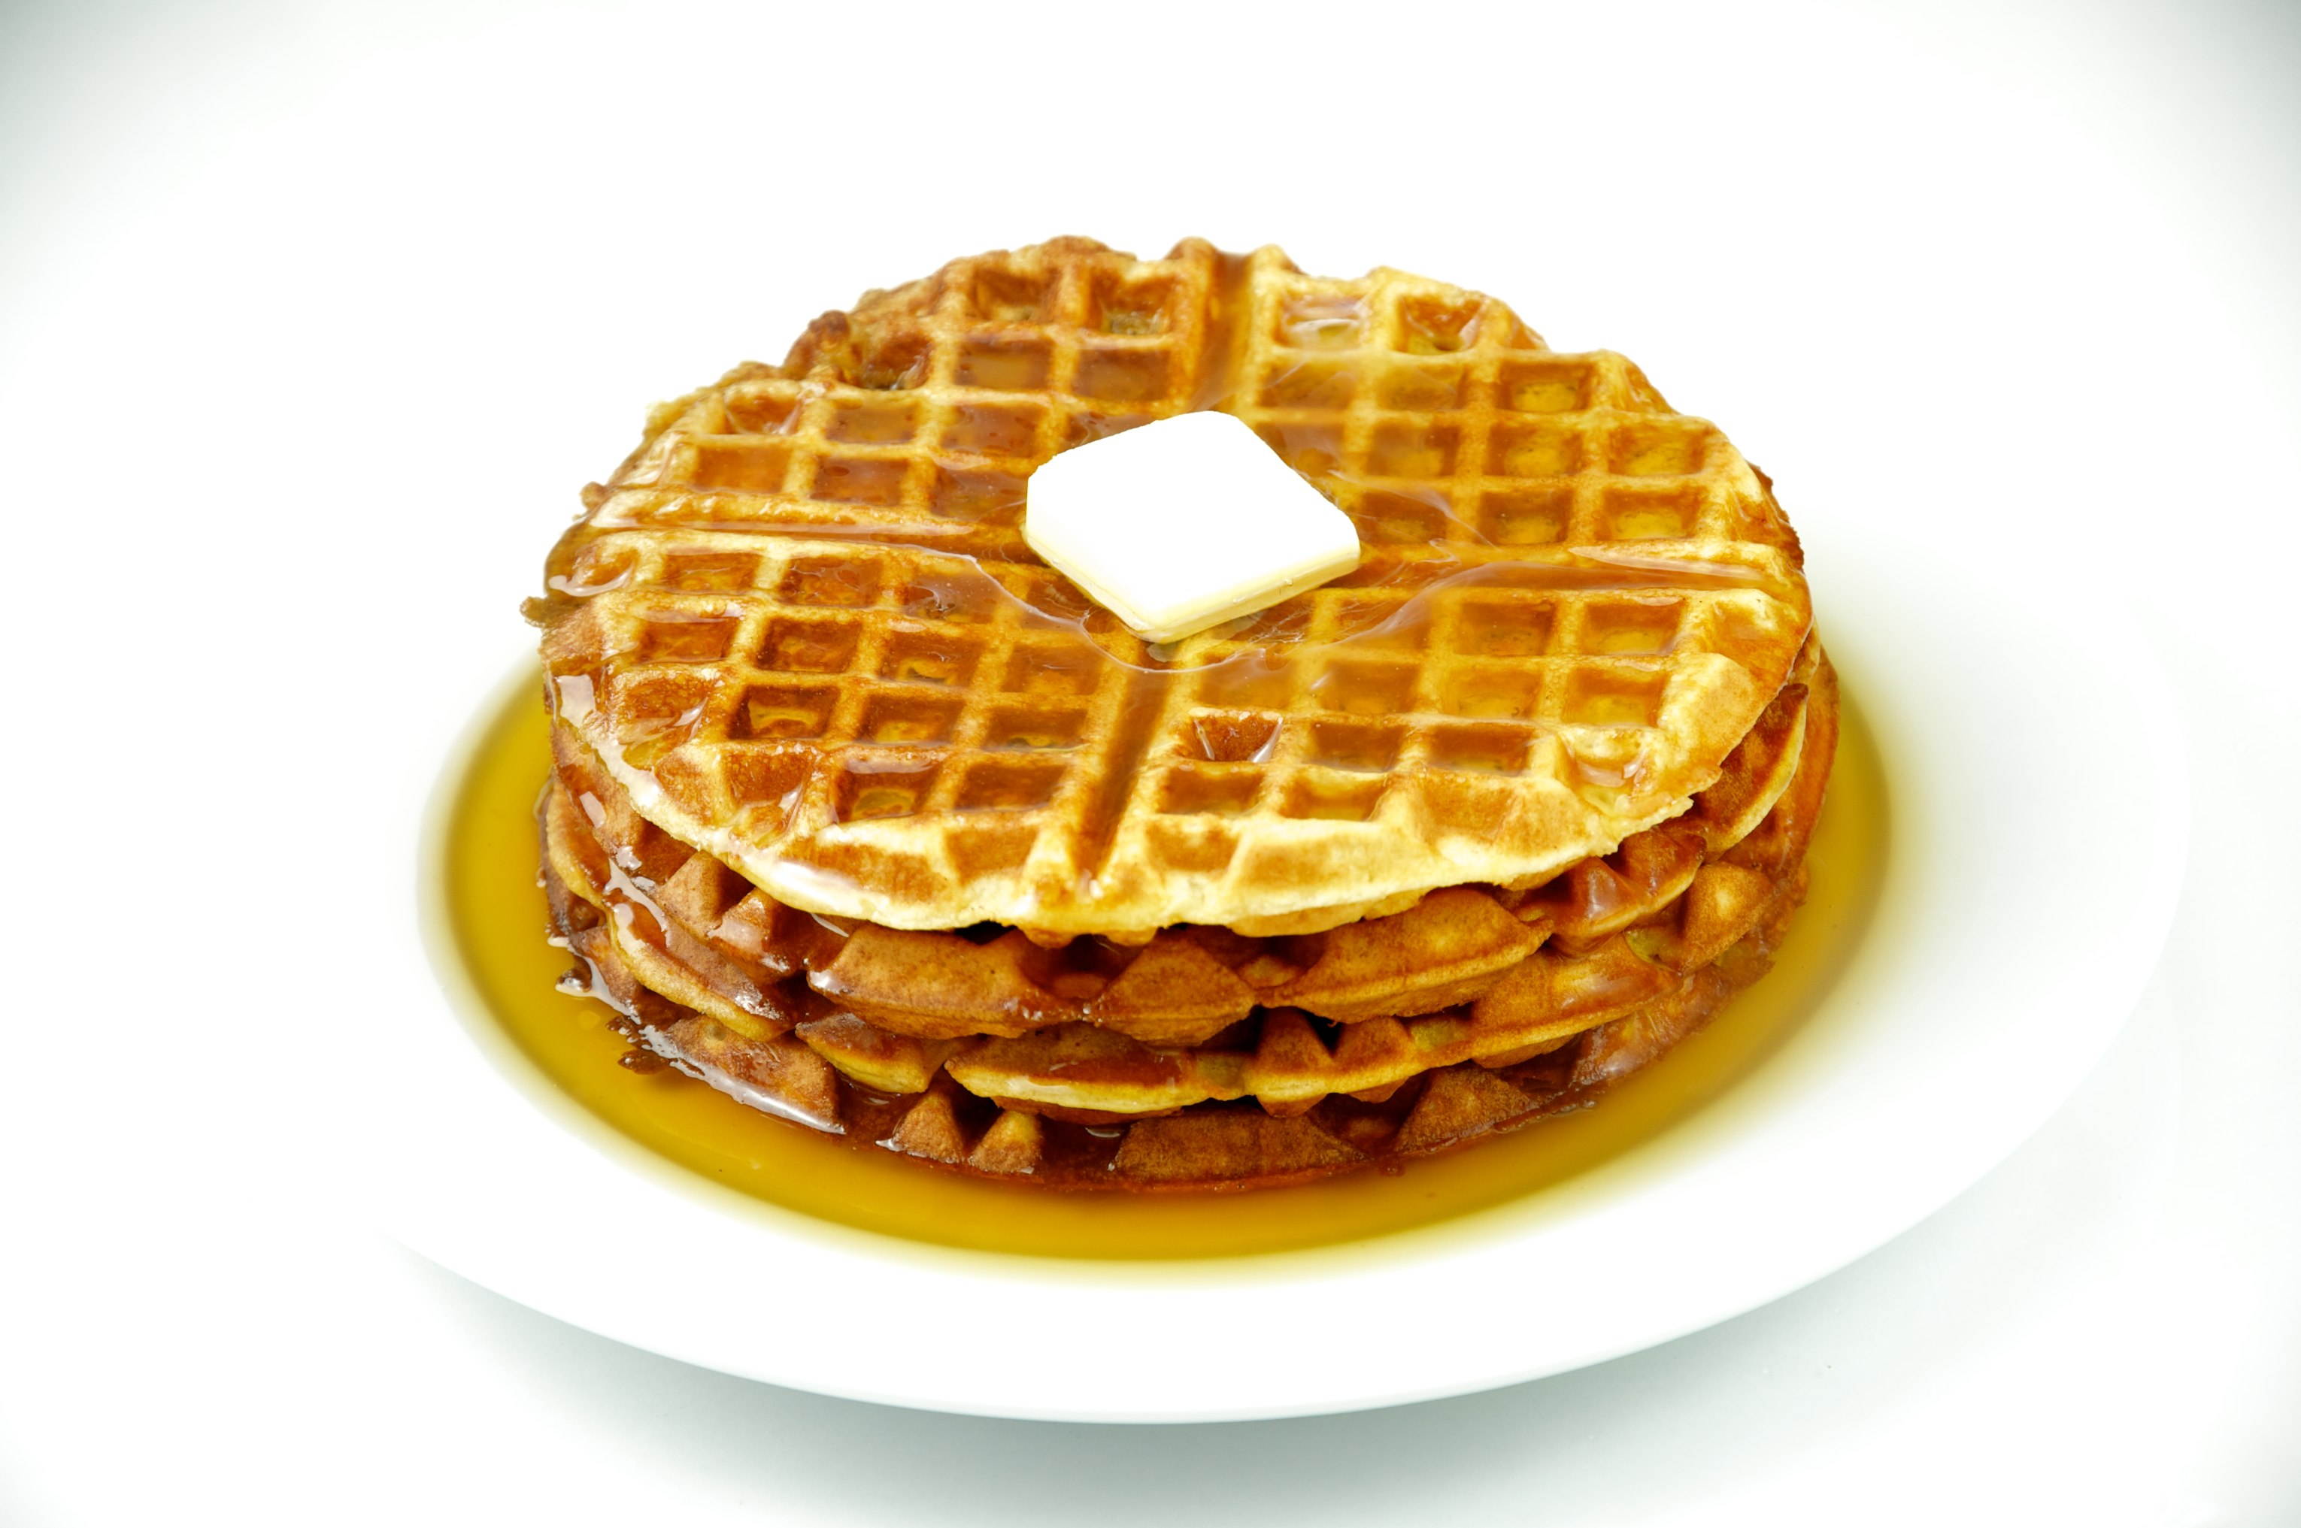
To manage accounts www.myschoolaccount.com No breakfast on 2 hour delays *Menu Subject to Change

