Fannett-Metal School District - High School / Middle School December 2019

Fannett-Metal is an equal opportunity provider

SUNDAY | MONDAY | TUESDAY | WEDNESDAY | THURSDAY | FRIDAY | SATURDAY
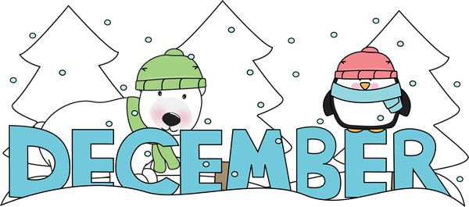 | December 2  No School | December 3  No School | December 4  Buffalo Chicken or Cheese Pizza  Or  Hot Dog  Grape Tomatoes  Peas  Choice of Fruit / Milk | December 5  General Tso’s Chicken  w/ W/G roll  Or  Turkey & Cheese Hoagie  Oriental Vegs/ Rice  Baby Carrots  Choice of Fruit / Milk | December 6  Pulled Pork Sandwich  Or  Ham & Cheese Flatbread  Steamed Carrots  Tossed Salad  Choice of Fruit / Milk | Offer verses serve -  Students must take  3 of 5 items to count as a lunch & one must be a fruit or vegetable.
 | December 9  Chicken Patty  Or  BBQ Rib Sandwich  Cheesy Broccoli  Tossed Salad  Choice of Fruit / Milk | December 10  Broccoli Cheddar Soup  Italian Sub  Or  Calzone  Scallop Potatoes  Grape Tomatoes  Choice of Fruit / Milk | December 11  Shrimp Poppers  W / Roll  Or  Chicken Cheese Steak  Baked Beans  Baby Carrots  Choice of Fruit / Milk | December 12  Stuffed Shells  Breadstick  Or  Spicy Chicken Patty  Green Beans  Tossed Salad  Choice of Fruit / Milk | December 13  Pepperoni Pizza  Or  Meatball Sub  Peas  Baby Carrots  Choice of Fruit / Milk | Daily Entrée options include:  Chef Or Taco Salad with whole grain roll Or Whole grain P B & J sandwich  Fruit, Vegetable & Milk are included
All Meals are  served with 1% milk, fat free chocolate, fat free vanilla and fat free strawberry | December 16  Baked Spaghetti  Texas Toast  Or  Turkey & Cheese  Pretzel Roll  Tossed Salad  Peas  Choice of Fruit / Milk | December 17  Chicken Alfredo  W / Roll  Or  BBQ Rib Sandwich  Baby Carrots  Steamed Broccoli  Choice of Fruit / Milk | December 18  Popcorn Chicken W/ Roll  Or  Turkey Club Wrap  Corn  Cucumber W / Dip  Choice of Fruit / Milk | December 19  Walking Taco  Or  Fish Nuggets  W / Roll  Refried Beans  Choice of Vegetables  Choice of Fruit / Milk | December 20  Soft Shell Tacos  Or  Ham & Cheese Hoagie or Flatbread  Choice of Vegetables  Choice of Fruit / Milk
 | December 23  No School | December 24  No School | December 25 | December 26  No School | December 27  No School | Middle/HS Lunch-  $ 2.80  Milk - .50  Reduced - .40
No breakfast on two hour delays | December 30  No School | December 31  No School | January 1 | January 2  Cheese Ravioli  Breadstick  Or  Spicy Chicken Patty  Steamed Carrots  Choice of Fruit / Milk | January 3  Cheeseburger  Or  Fish Sandwich  Peas  Choice of Fruit / Milk | Menu subject to change

