Fannett-Metal School District - Elementary School December 2019

Fannett-Metal is an equal opportunity provider

SUNDAY | MONDAY | TUESDAY | WEDNESDAY | THURSDAY | FRIDAY | SATURDAY
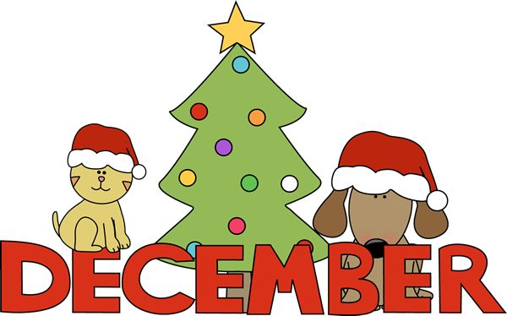 | December 2  No School | December 3  No School | December 4  Chicken Patty  Or  BBQ Rib Sandwich  Steamed Carrots  Red Peppers  Choice of Fruit / Milk | December 5  Spaghetti & Meatballs  Roll  Or  Turkey & Cheese Hoagie  Steamed Broccoli  Tossed Salad  Choice of Fruit / Milk | December 6  French Bread Pizza  Or  Meatball Sub  Peas  Baby Carrots  Choice of Fruit / Milk | Offer verses serve -  Students must take  3 of 5 items to count as a lunch & one must be a fruit or vegetable.
 | December 9  Popcorn Chicken  W / Roll  Or  Chef Salad W / Roll  Cheesy Broccoli  Red Peppers  Choice of Fruit / Milk | December 10  Walking Taco  Or  Hot Dog  Refried Beans  Peas  Choice of Fruit / Milk | December 11  Chicken Noodle Soup  Grilled Ham & Cheese  Or  Hamburger  Baby Carrots  Tossed Salad  Choice of Fruit / Milk | December 12  Macaroni & Cheese  Or  Shrimp Poppers  W / Roll  Celery W / Dip  Steamed Carrots  Choice of Fruit / Milk | December 13  Pepperoni Pizza  Or  Fish Nuggets / Roll  Corn  Cucumbers W / Dip  Choice of Fruit / Milk
All Meals are  served with 1% milk, fat free chocolate, fat free vanilla, fat free strawberry and skim | December 16  Chicken Drum Sticks  W / Roll  Or  Calzone  Scalloped Potatoes  Celery W / Dip  Choice of Fruit / Milk | December 17  Tomato Soup  Grilled Cheese Sandwich  Or  BBQ Rib Sandwich  Cheesy Broccoli  Baby Carrots  Choice of Fruit / Milk | December 18  Cheese Ravioli  Breadstick  Or  Grilled Chicken Sandwich  Tossed Salad/Tomatoes  Choice of Fruit / Milk | December 19  Chicken Patty  Or  Soft Shell Taco  Refried Beans  Choice of Vegetable  Choice of Fruit / Milk | December 20  French Bread Pizza  Or  Fish Sandwich  Peas  Choice of Vegetable  Choice of Fruit / Milk | Pre-K Alternative –  December 10th - Chicken Nuggets W/ Goldfish Crackers
 | December 23  No School | December 24 | December 25 | December 26  No School | December 27  No School | Elementary Lunch-  $ 2.65  Milk - .50  Reduced - .40
No breakfast on two hour delays | December 30  No School | December 31  No School | January 1 | January 2  Chicken Patty  Or  Cheeseburger  Baked Beans  Choice of Vegetable  Choice of Fruit / Milk | January 3  Cheese Pizza  Or  Meatball Sub  Peas  Choice of Vegetable  Choice of Fruit / Milk | Menu subject to change

