FANNETT-METAL SCHOOL DISTRICT – Elementary School –
December 2019
Breakfast Menu

Fannett-Metal School District is an equal opportunity provider
SUNDAY | MONDAY | TUESDAY | WEDNESDAY | THURSDAY | FRIDAY | SATURDAY
 | December 2  No School | December 3  No School | December 4  Waffle & Sausage Patty  Or  Cereal  Whole Grain Bread  Fruit / Vegetable  Milk / Juice | December 5  Breakfast Pizza  Or  Cereal  Whole grain bread  Fruit / Vegetable  Milk / Juice | ^{December 6}  Mini Pancakes  Or  Cereal  Whole grain Bread  Fruit / Vegetable  Milk / Juice
 | December 9  French Toast Sticks  Or  Cereal  Whole grain bread  Fruit / Vegetable  Milk / Juice | December 10  Scrambled Eggs  Or  Cereal  Whole Grain Bread  Fruit / Vegetable  Milk / Juice | December 11  Waffle & Sausage Patty  Or  Cereal  Whole Grain Bread  Fruit / Vegetable  Milk / Juice | December 12  Breakfast Pizza  Or  Cereal  Whole grain bread  Fruit / Vegetable  Milk / Juice | December 13  Mini Pancakes  Or  Cereal  Whole grain Bread  Fruit / Vegetable  Milk / Juice
All Meals are  served with 1% milk, fat free chocolate, fat free vanilla, fat free strawberry and skim | December 16  French Toast Sticks  Or  Cereal  Whole grain bread  Fruit / Vegetable  Milk / Juice | December 17  Scrambled Eggs  Or  Cereal  Whole Grain Bread  Fruit / Vegetable  Milk / Juice | December 18  Waffle & Sausage Patty  Or  Cereal  Whole Grain Bread  Fruit / Vegetable  Milk / Juice | December 19  Breakfast Pizza  Or  Cereal  Whole grain bread  Fruit / Vegetable  Milk / Juice | December 20  Mini Pancakes  Or  Cereal  Whole grain Bread  Fruit / Vegetable  Milk / Juice
 | December 23  No School | December 24  No School | December 25 | December 26  No School | December 27  No School | Elementary & MS/HS  Breakfast-$ 1.55  Milk -$.50  Reduced -$.25
 | December 30  No School | December 31  No School | January 1 | January 2  Breakfast Pizza  Or  Cereal  Whole grain bread  Fruit / Vegetable  Milk / Juice | January 3  Mini Pancakes  Or  Cereal  Whole grain Bread  Fruit / Vegetable  Milk / Juice | 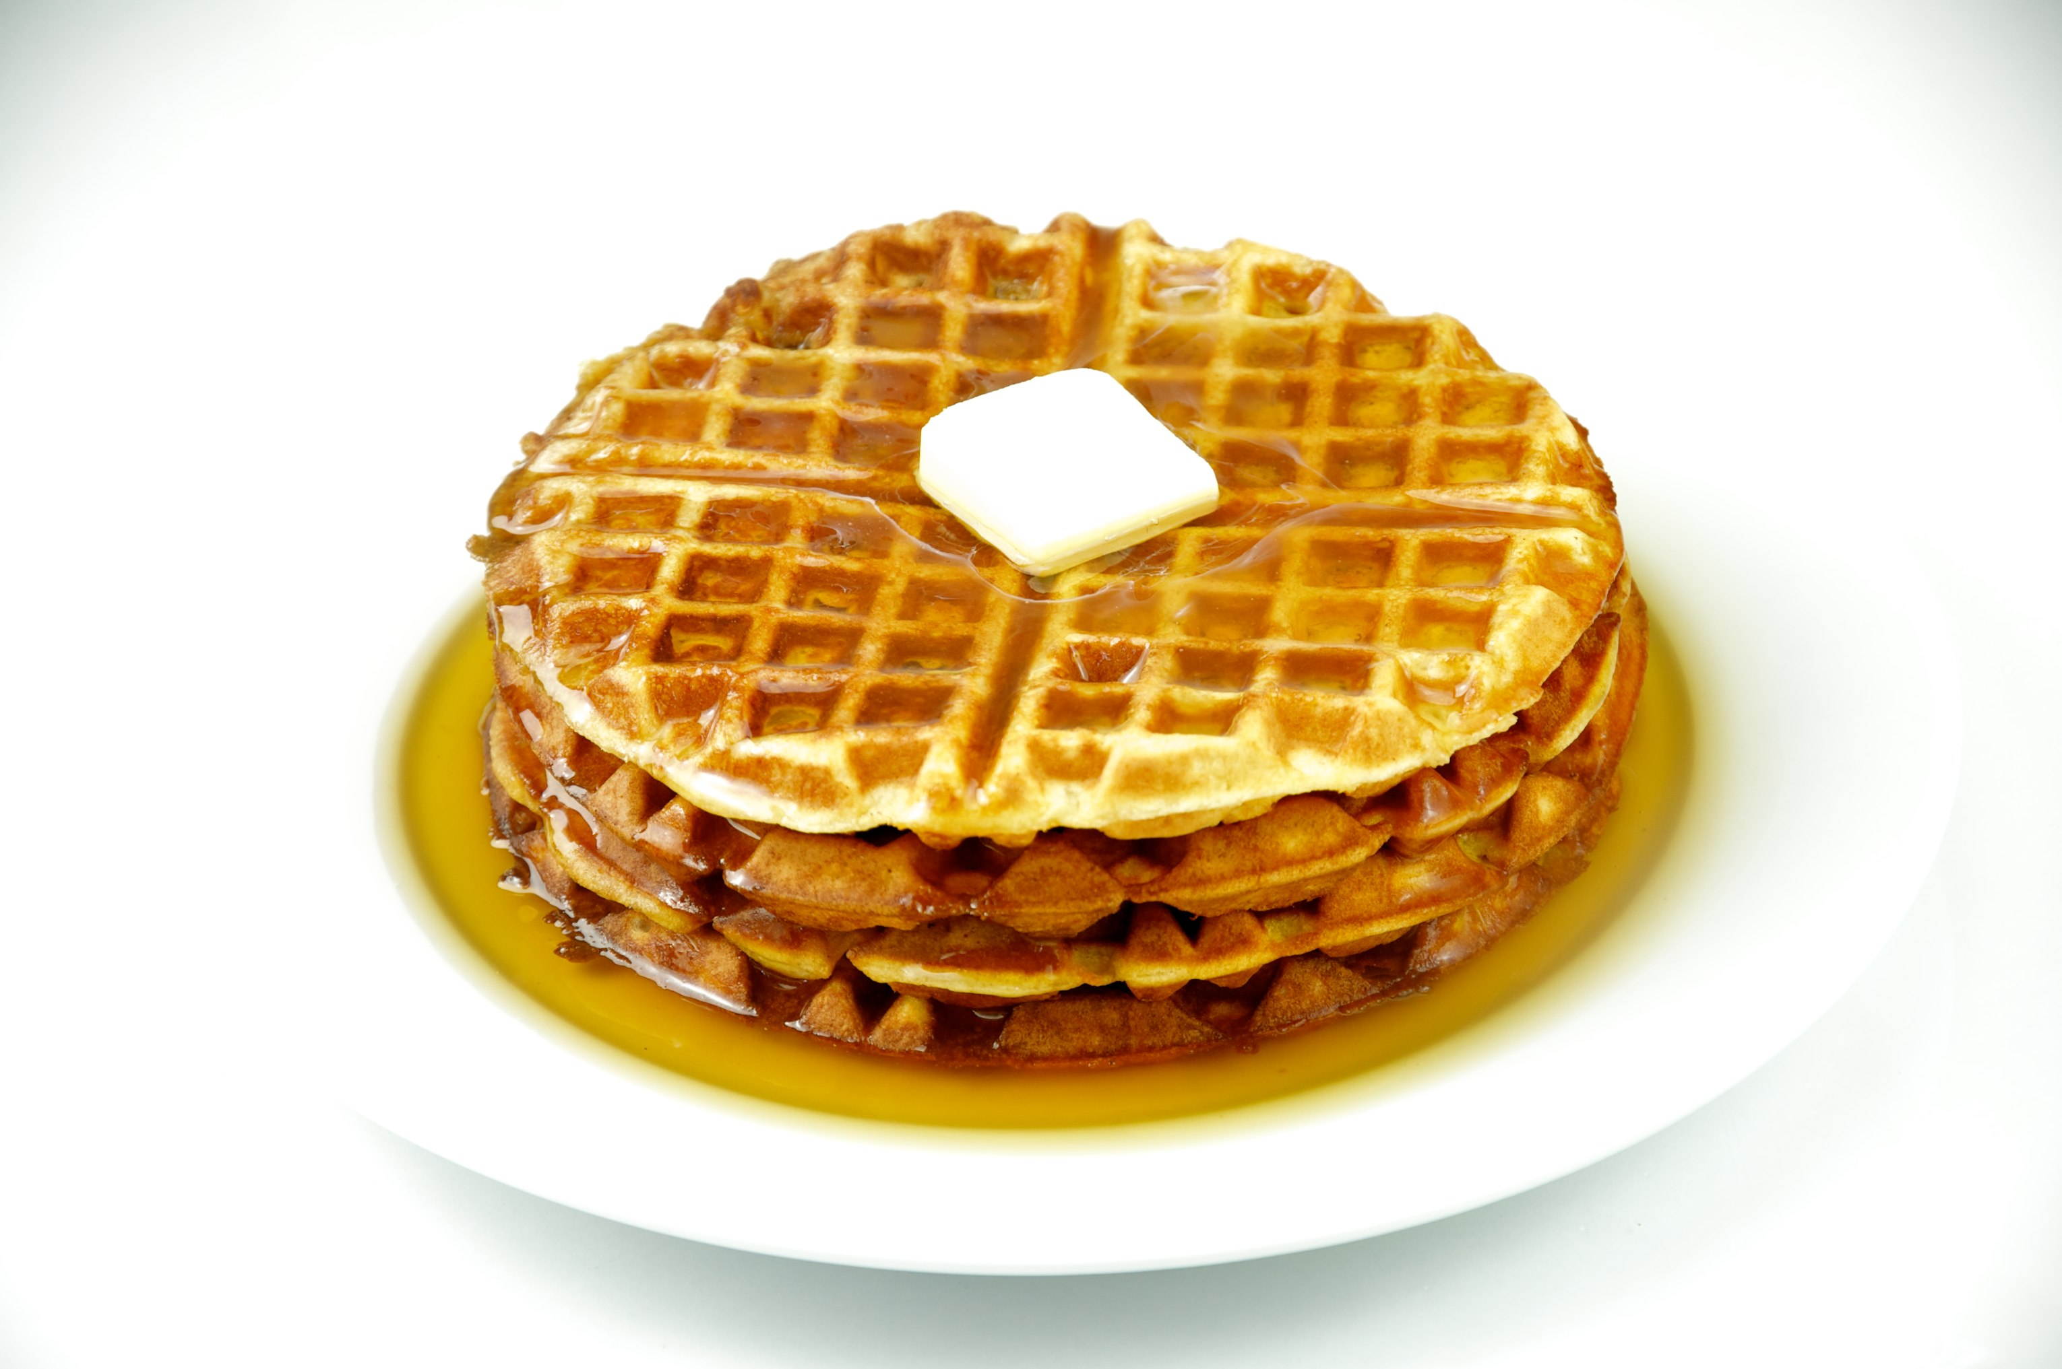
To manage accounts: www.myschoolaccount.com No breakfast on 2 hour delays *Menu Subject to Change

