Fannett-Metal School District - High School / Middle School November 2019

Fannett-Metal is an equal opportunity provider

SUNDAY | MONDAY | TUESDAY | WEDNESDAY | THURSDAY | FRIDAY | SATURDAY
 |  |  |  |  | November 1  Pepperoni Pizza  Or  Rotisserie Chicken Wrap  Broccoli w/ Cheese  Grape Tomatoes  Choice of Fruit / Milk | Offer verses serve -  Students must take  3 of 5 items to count as a lunch & one must be a fruit or vegetable.
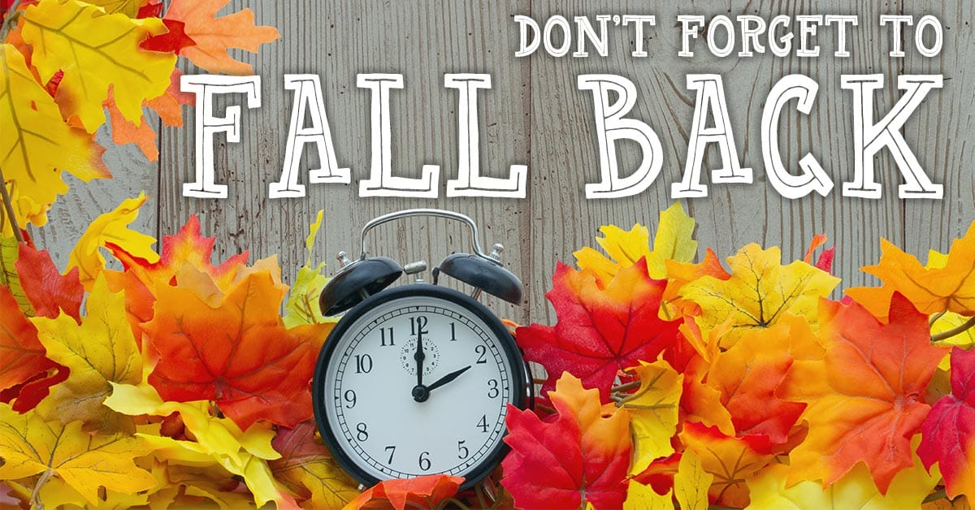 | November 4  Chicken Patty  Or  BBQ Rib Sandwich  Broccoli  French Fries  Choice of Fruit / Milk | November 5  Cheeseburger  Or  Fish Sandwich  Peas  Red Peppers W / Dip  Choice of Fruit / Milk | November 6  Buffalo Chicken or Cheese Pizza  Or  Hot Dog  Grape Tomatoes  Baked Beans  Choice of Fruit / Milk | November 7  General Tso’s Chicken  w/ W/G roll  Or  Turkey & Cheese Hoagie  Oriental Vegs/ Rice  Baby Carrots  Choice of Fruit / Milk | November 8  Pulled Pork Sandwich  Or  Turkey & Cheese Flatbread  Steamed Carrots  Tossed Salad  Choice of Fruit / Milk | Daily Entrée options include:  Chef Or Taco Salad with whole grain roll Or Whole grain P B & J sandwich  Fruit, Vegetable & Milk are included
All Meals are  served with 1% milk, fat free chocolate, fat free vanilla and fat free strawberry | November 11  No School | November 12  Chicken Noodle Soup  Italian Sub  Or  Calzone  Steamed Carrots  Grape Tomatoes  Choice of Fruit / Milk | November 13  Shrimp Poppers  W / Roll  Or  Chicken Cheese Steak  Baked Beans  Baby Carrots  Choice of Fruit / Milk | November 14  Stuffed Shells  Breadstick  Or  Spicy Chicken Patty  Broccoli  Tossed Salad  Choice of Fruit / Milk | November 15  Pepperoni Pizza  Or  Meatball Sub  Peas  French Fries  Choice of Fruit / Milk
 | November 18  Baked Spaghetti  Texas Toast  Or  Turkey & Cheese  Pretzel Roll  Tossed Salad  Peas  Choice of Fruit / Milk | November 19  Chicken Alfredo  W / Roll  Or  BBQ Rib Sandwich  Baby Carrots  Steamed Broccoli  Choice of Fruit / Milk | November 20  Popcorn Chicken W/ Roll  Or  Turkey Club Wrap  Baked Beans  Cucumber W / Dip  Choice of Fruit / Milk | November 21  Roast Turkey  Gravy & Stuffing Or Roll  Or  Calzone  Mashed Potatoes  Corn  Choice of Fruit / Milk | November 22  Soft Shell Tacos  Or  Ham & Cheese Hoagie  Tossed Salad  Steamed Carrots  Choice of Fruit / Milk | Middle/HS Lunch-  $ 2.80  Milk - .50  Reduced - .40
No breakfast on two hour delays | November 25  Tomato Soup  Grilled Cheese  Or  Chicken Fajita  Peas  Celery w/ Dip  Choice of Milk / Fruit | November 26  Walking Taco  Or  Fish Nuggets  W / Roll  Refried Beans  Baby Carrots  Choice of Fruit / Milk | November 27  Cheese Ravioli  Breadstick  Or  Spicy Chicken Patty  Choice of Vegetable  Choice of Fruit / Milk | November 28  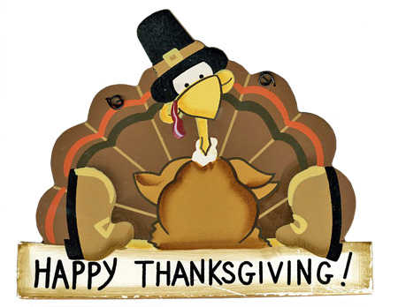 | November 29 | Menu subject to change

