FANNETT-METAL SCHOOL DISTRICT – Elementary School –
November 2019
Breakfast Menu

Fannett-Metal School District is an equal opportunity provider
SUNDAY | MONDAY | TUESDAY | WEDNESDAY | THURSDAY | FRIDAY | SATURDAY
^{November 1}
Mini Pancakes
Or
Cereal
Whole grain Bread
Fruit / Vegetable
Milk / Juice

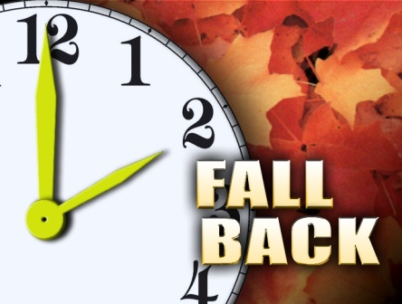 | November 4  French Toast Sticks  Or  Cereal  Whole grain bread  Fruit / Vegetable  Milk / Juice | November 5  Scrambled Eggs  Or  Cereal  Whole Grain Bread  Fruit / Vegetable  Milk / Juice | November 6  Waffle & Sausage Patty  Or  Cereal  Whole Grain Bread  Fruit / Vegetable  Milk / Juice | November 7  Breakfast Pizza  Or  Cereal  Whole grain bread  Fruit / Vegetable  Milk / Juice | November 8  Mini Pancakes  Or  Cereal  Whole grain Bread  Fruit / Vegetable  Milk / Juice
All Meals are  served with 1% milk, fat free chocolate, fat free vanilla, fat free strawberry and skim | November 11 | November 12  Scrambled Eggs  Or  Cereal  Whole Grain Bread  Fruit / Vegetable  Milk / Juice | November 13  Waffle & Sausage Patty  Or  Cereal  Whole Grain Bread  Fruit / Vegetable  Milk / Juice | November 14  Breakfast Pizza  Or  Cereal  Whole grain bread  Fruit / Vegetable  Milk / Juice | November 15  Mini Pancakes  Or  Cereal  Whole grain Bread  Fruit / Vegetable  Milk / Juice
 | November 18  French Toast Sticks  Or  Cereal  Whole grain bread  Fruit / Vegetable  Milk / Juice | November 19  Scrambled Eggs  Or  Cereal  Whole Grain Bread  Fruit / Vegetable  Milk / Juice | November 20  Waffle & Sausage Patty  Or  Cereal  Whole Grain Bread  Fruit / Vegetable  Milk / Juice | November 21  Breakfast Pizza  Or  Cereal  Whole grain bread  Fruit / Vegetable  Milk / Juice | ^{November 22}  Mini Pancakes  Or  Cereal  Whole grain Bread  Fruit / Vegetable  Milk / Juice | Elementary & MS/HS  Breakfast-$ 1.55  Milk -$.50  Reduced -$.25
 | November 25  French Toast Sticks  Or  Cereal  Whole grain bread  Fruit / Vegetable  Milk / Juice | November 26  Scrambled Eggs  Or  Cereal  Whole Grain Bread  Fruit / Vegetable  Milk / Juice | November 27  Waffle & Sausage Patty  Or  Cereal  Whole Grain Bread  Fruit / Vegetable  Milk / Juice | November 28  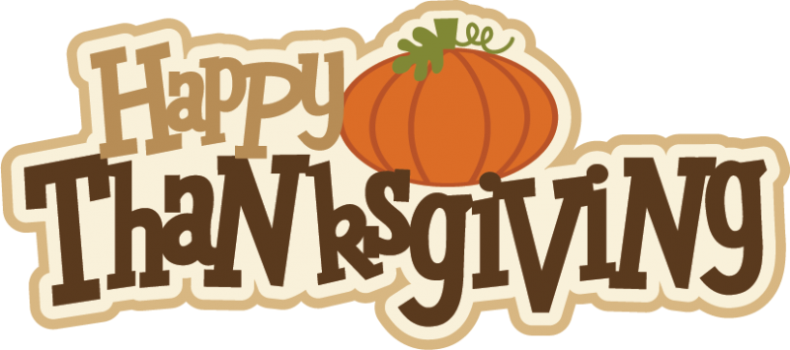 | ^{November 29}  No School | 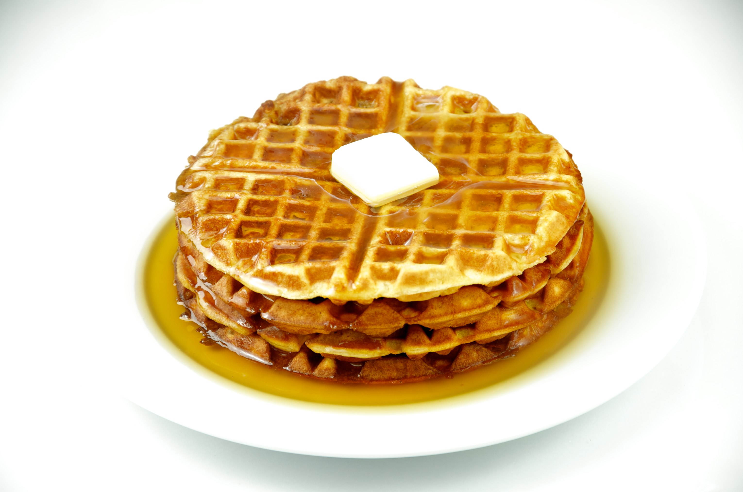
To manage accounts: www.myschoolaccount.com No breakfast on 2 hour delays *Menu Subject to Change

